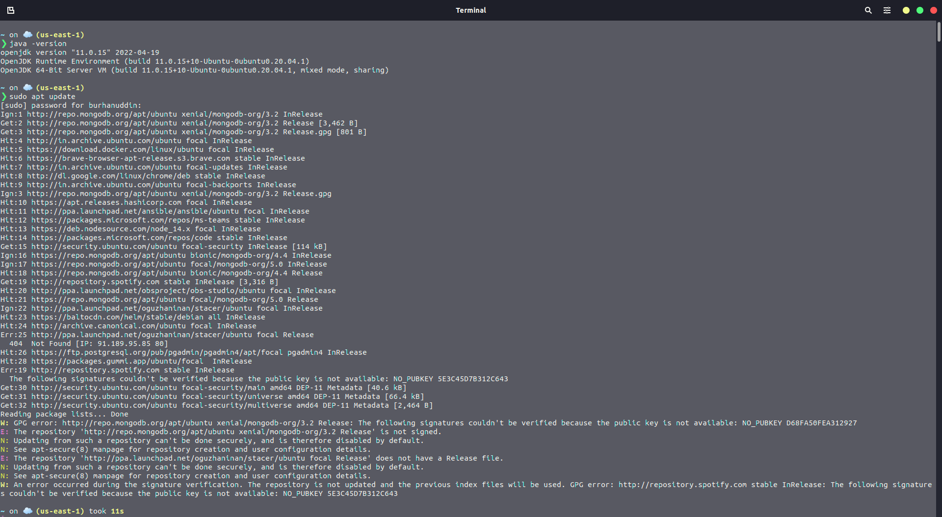

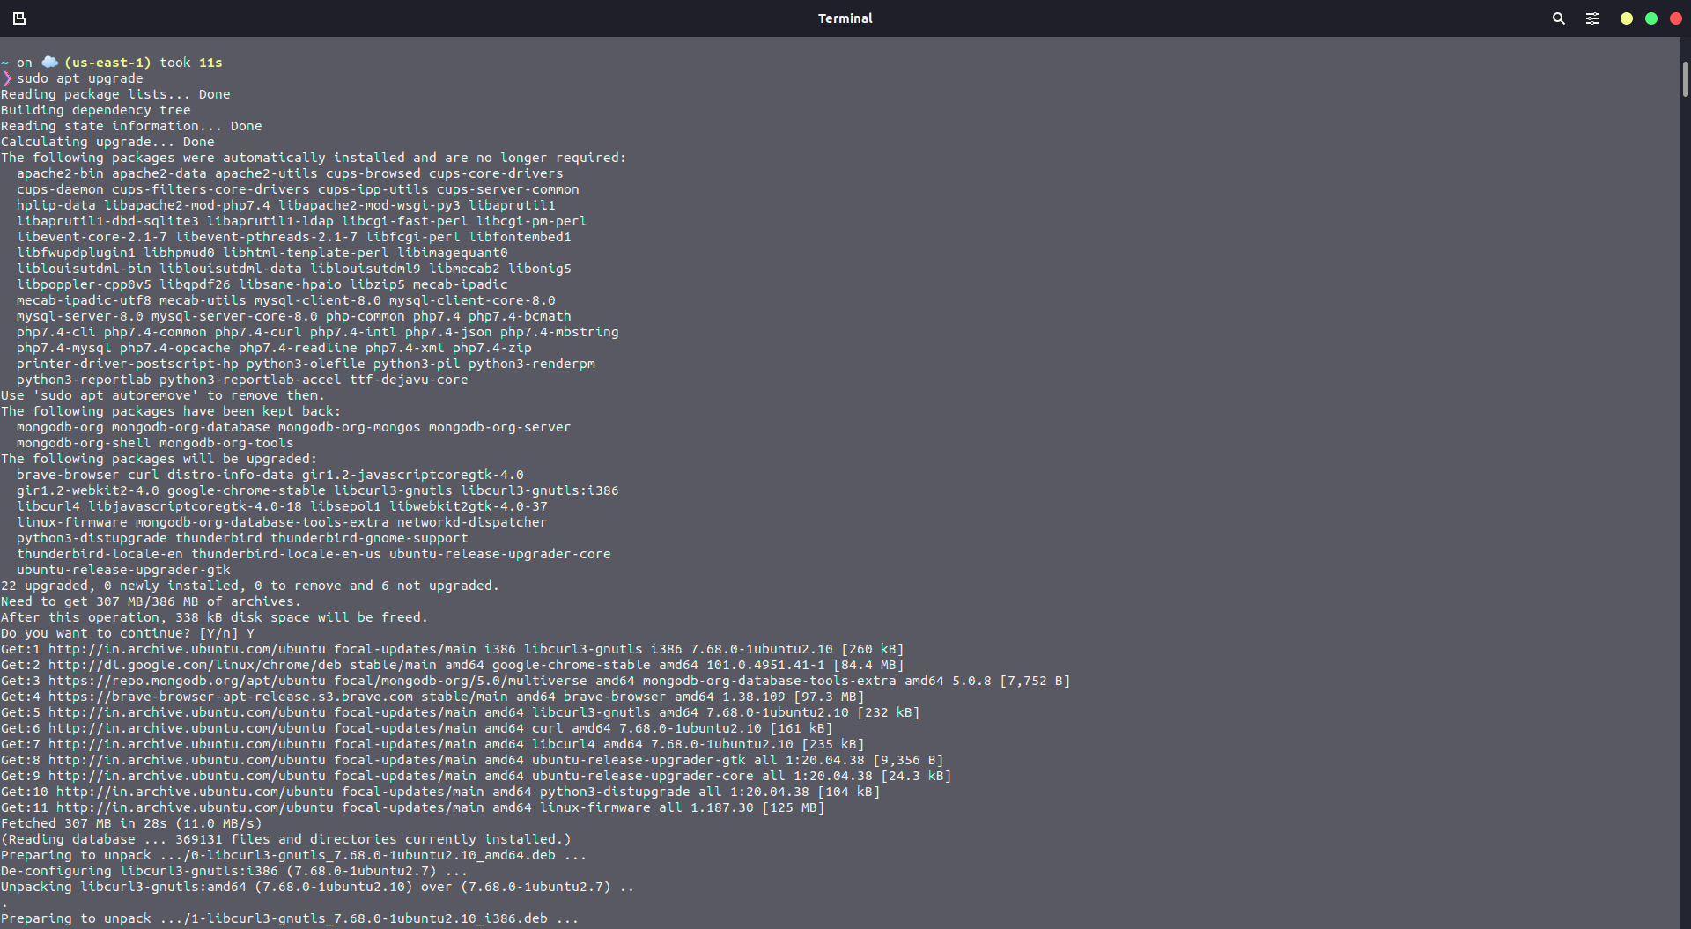

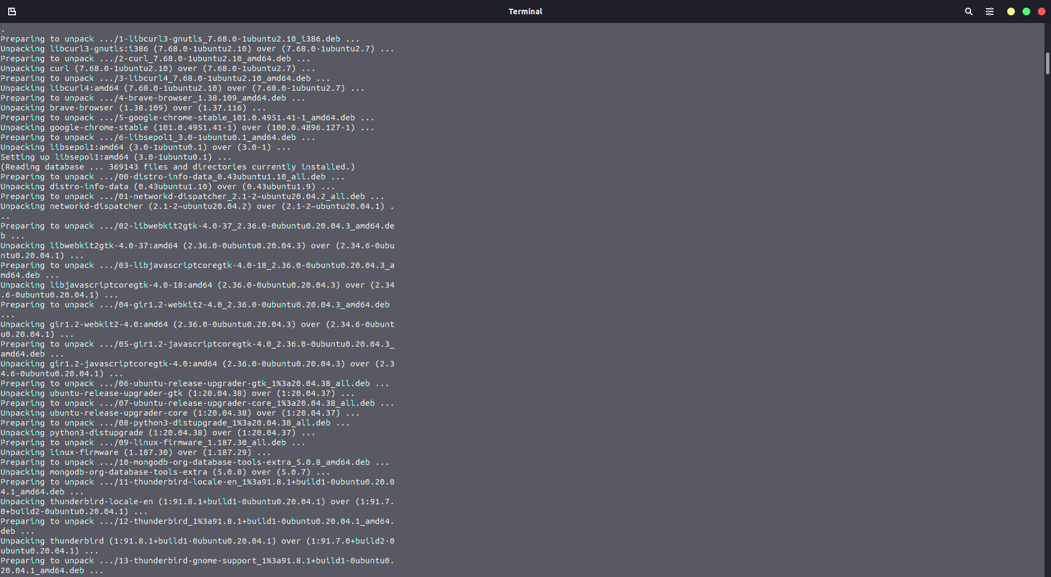

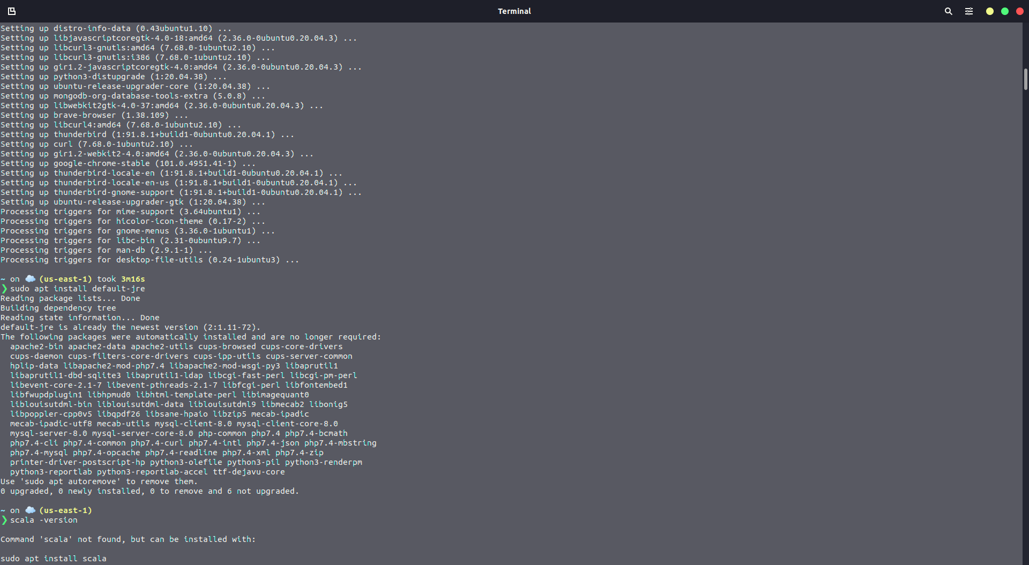

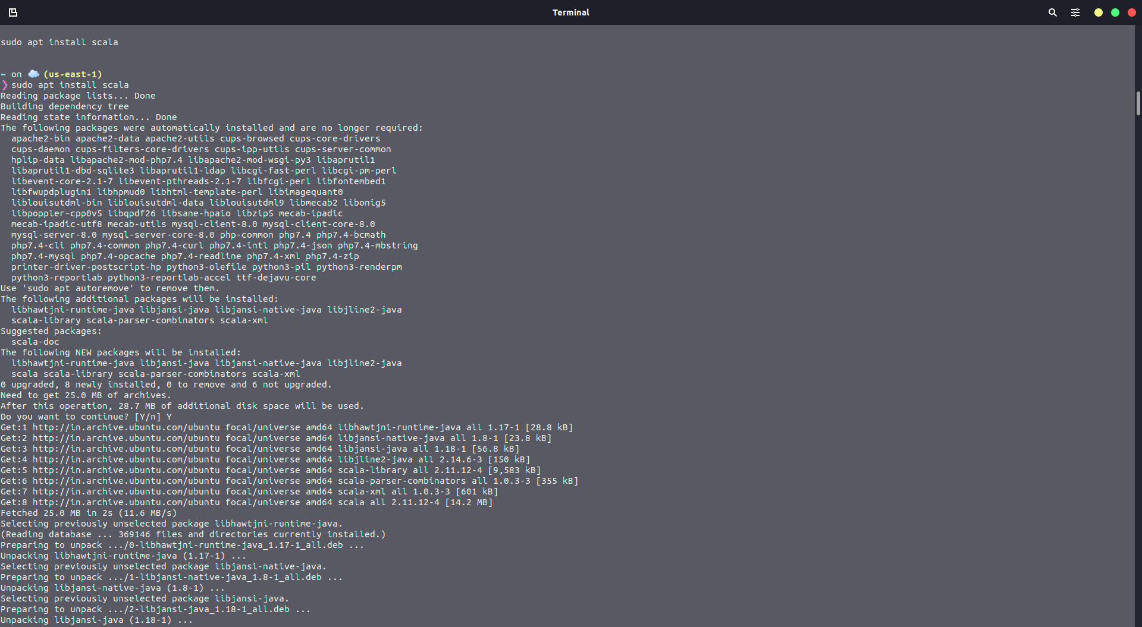

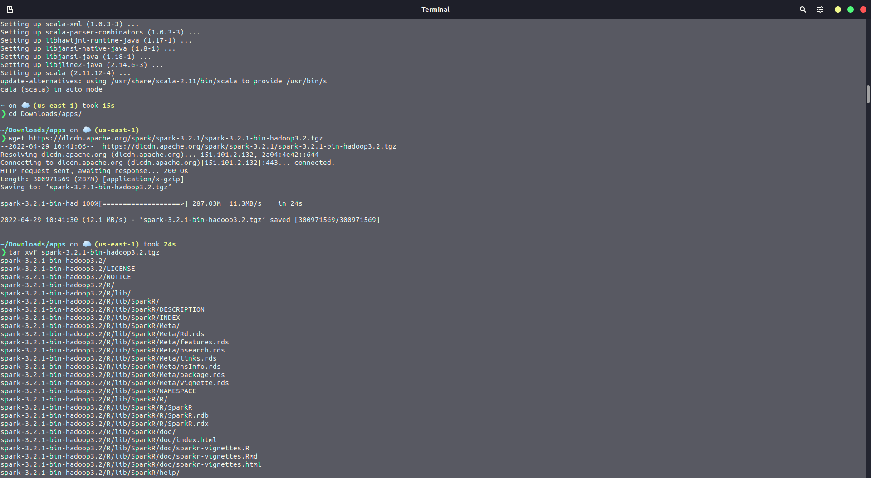

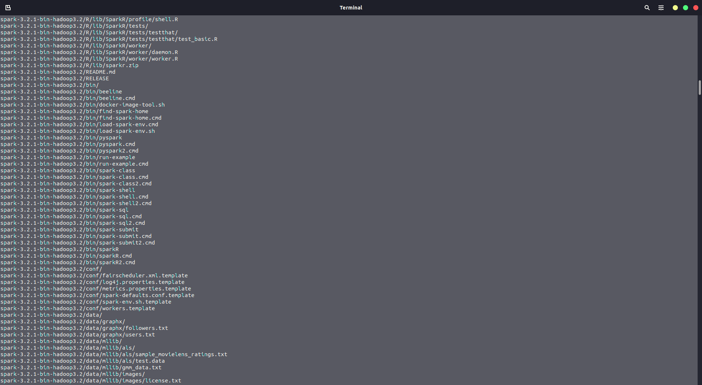

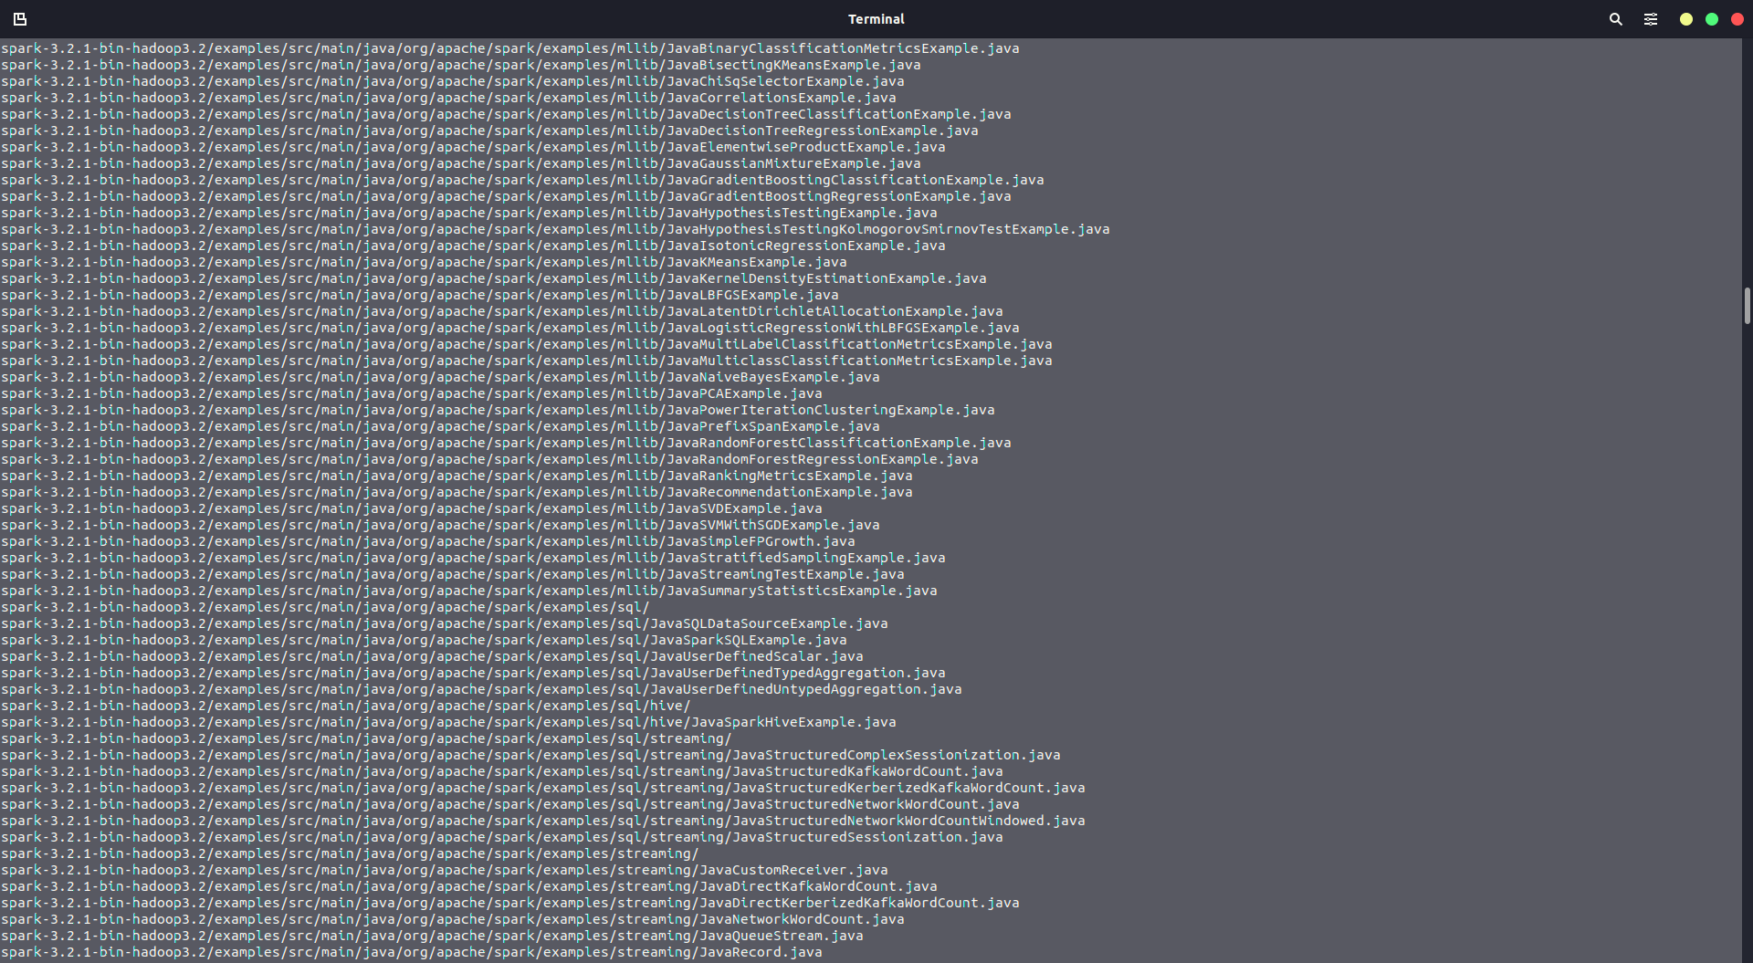

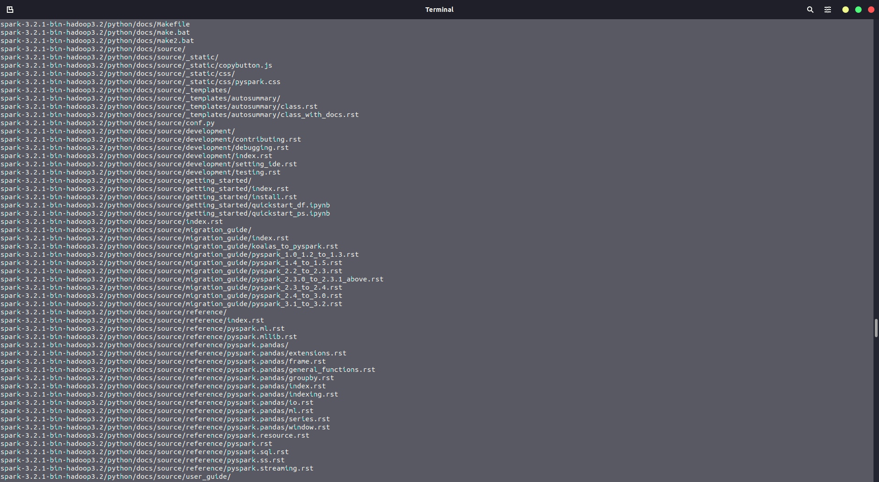

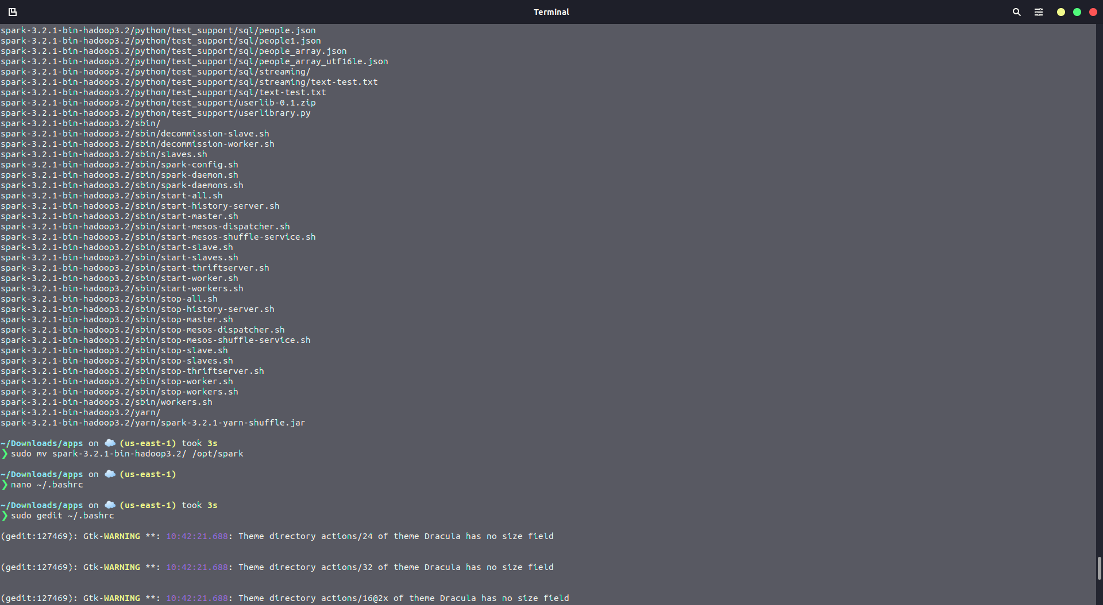

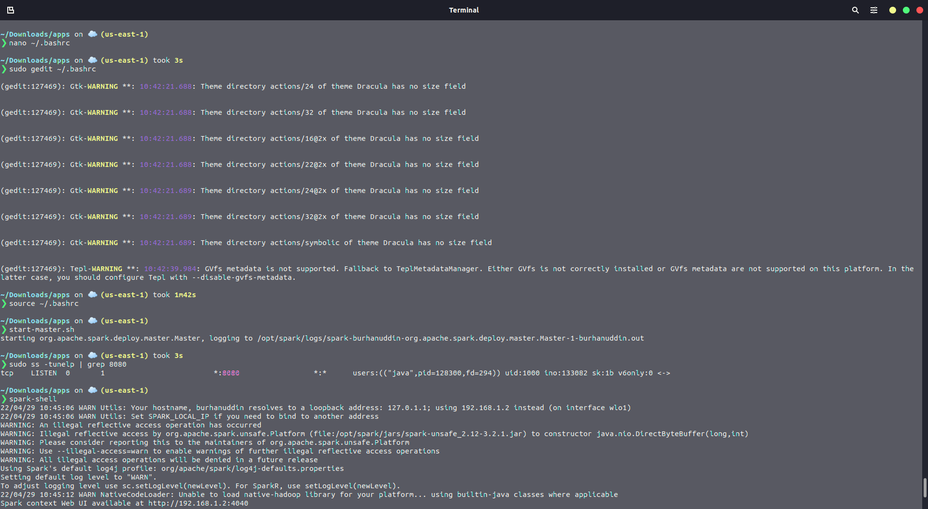

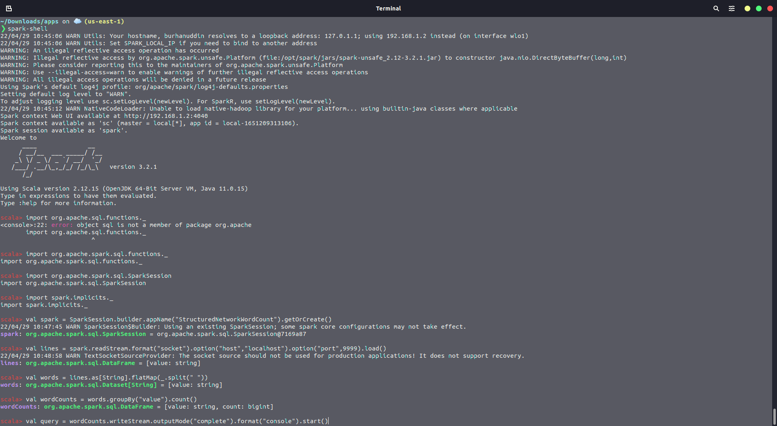

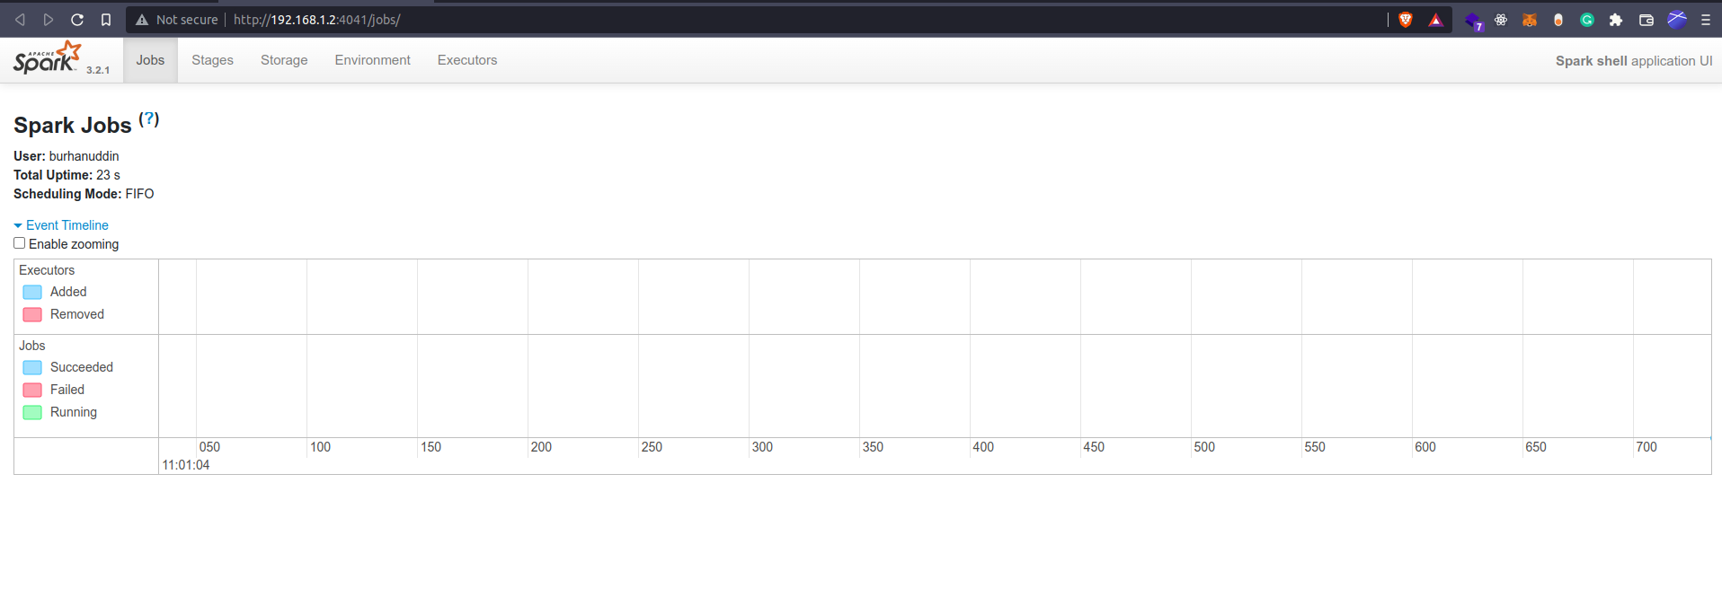

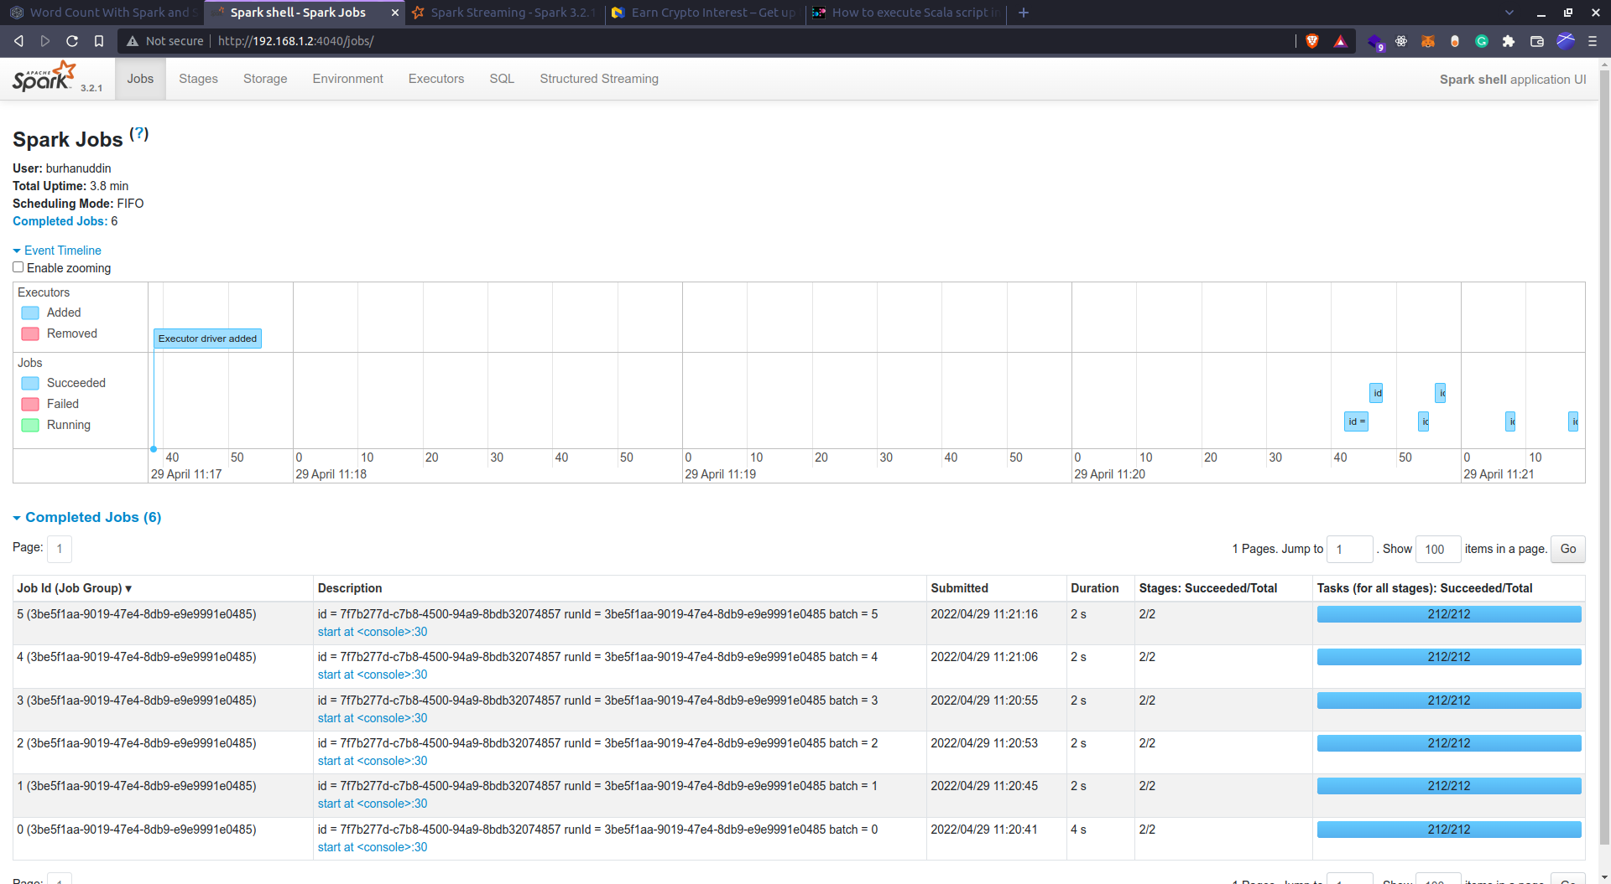

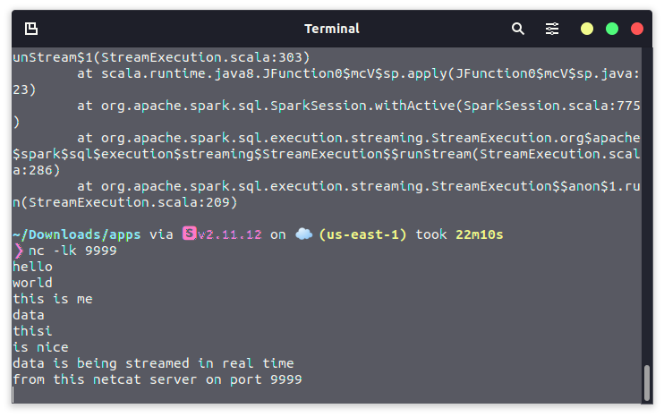

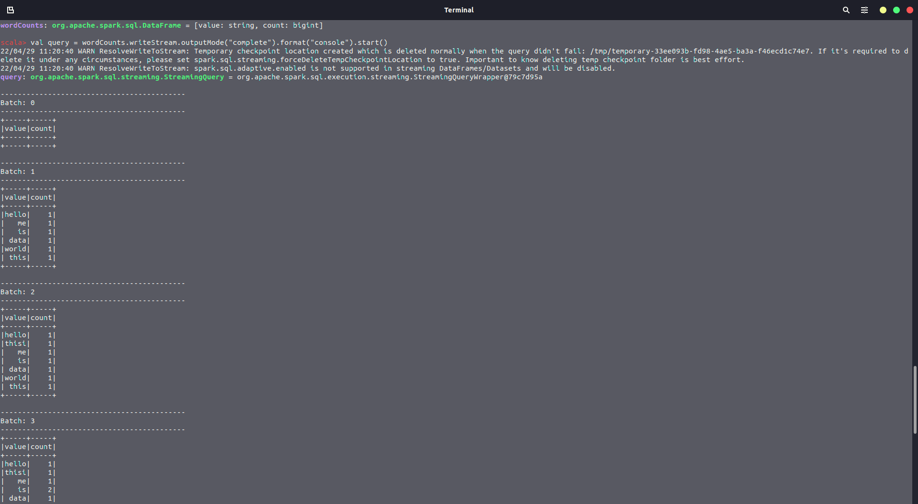

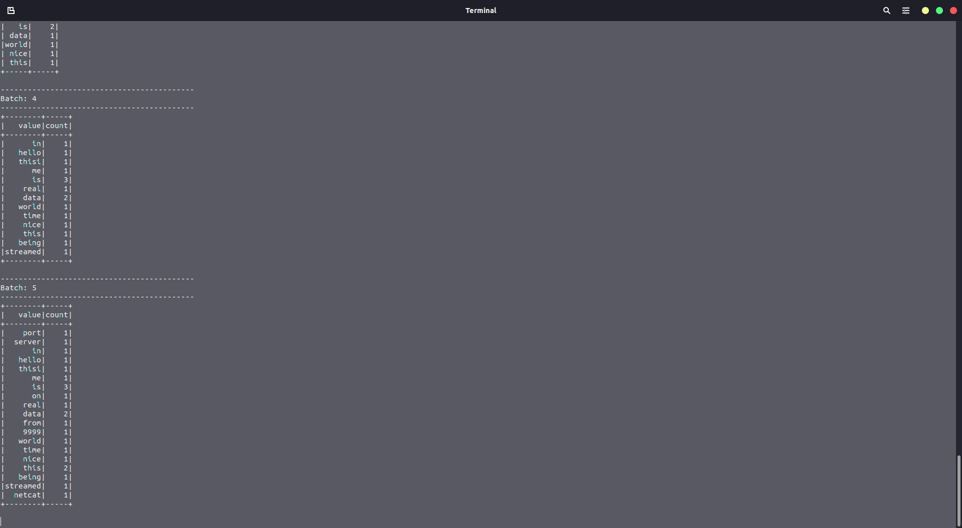



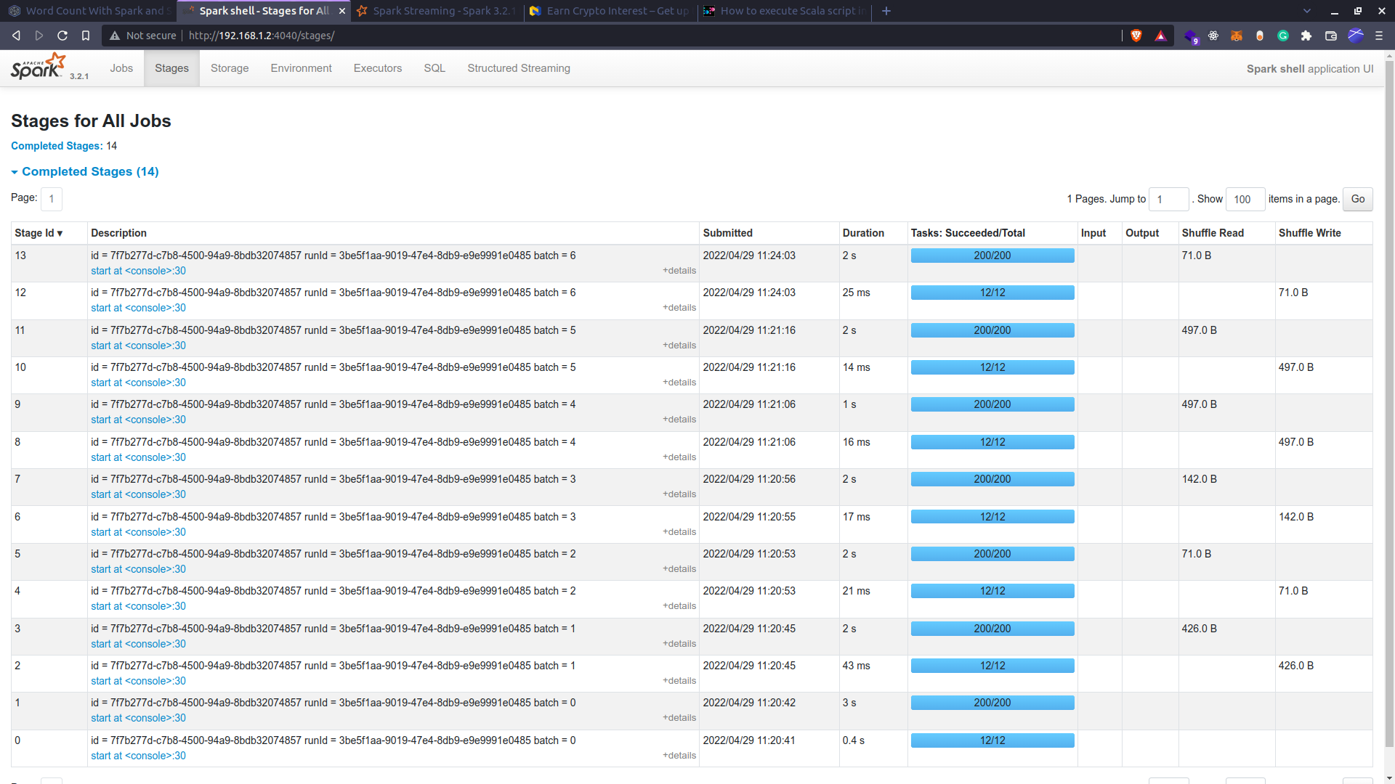

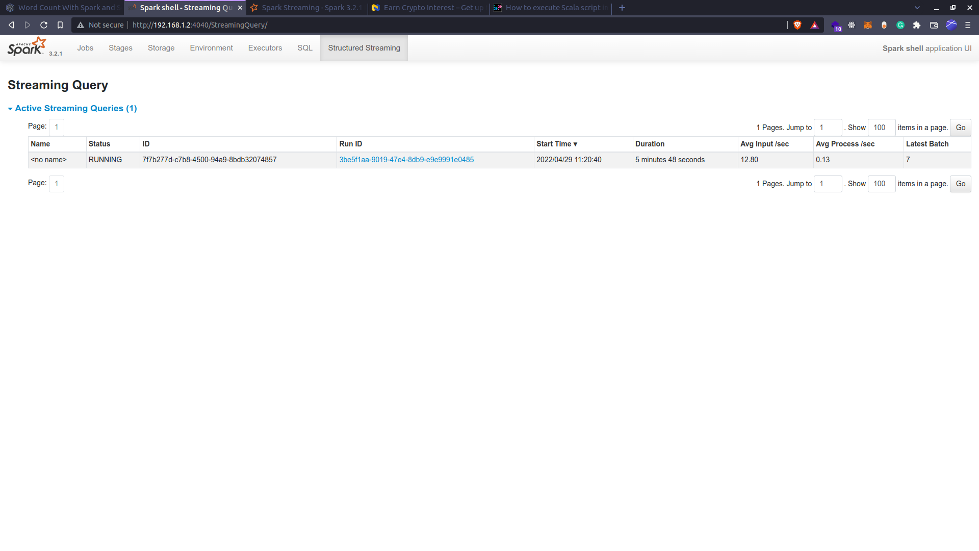

**Text Logs**

~ on ☁️ (us-east-1)

❯ java -version

openjdk version "11.0.15" 2022-04-19

OpenJDK Runtime Environment (build 11.0.15+10-Ubuntu-0ubuntu0.20.04.1)

OpenJDK 64-Bit Server VM (build 11.0.15+10-Ubuntu-0ubuntu0.20.04.1, mixed mode, sharing)

~ on ☁️ (us-east-1)

❯ sudo apt update

[sudo] password for burhanuddin:

Ign:1 http://repo.mongodb.org/apt/ubuntu xenial/mongodb-org/3.2 InRelease

Get:2 http://repo.mongodb.org/apt/ubuntu xenial/mongodb-org/3.2 Release [3,462 B]

Get:3 http://repo.mongodb.org/apt/ubuntu xenial/mongodb-org/3.2 Release.gpg [801 B]

Hit:4 http://in.archive.ubuntu.com/ubuntu focal InRelease

Hit:5 https://download.docker.com/linux/ubuntu focal InRelease

Hit:6 https://brave-browser-apt-release.s3.brave.com stable InRelease

Hit:7 http://in.archive.ubuntu.com/ubuntu focal-updates InRelease

Hit:8 http://dl.google.com/linux/chrome/deb stable InRelease

Hit:9 http://in.archive.ubuntu.com/ubuntu focal-backports InRelease

Ign:3 http://repo.mongodb.org/apt/ubuntu xenial/mongodb-org/3.2 Release.gpg

Hit:10 https://apt.releases.hashicorp.com focal InRelease

Hit:11 http://ppa.launchpad.net/ansible/ansible/ubuntu focal InRelease

Hit:12 https://packages.microsoft.com/repos/ms-teams stable InRelease

Hit:13 https://deb.nodesource.com/node_14.x focal InRelease

Hit:14 https://packages.microsoft.com/repos/code stable InRelease

Get:15 http://security.ubuntu.com/ubuntu focal-security InRelease [114 kB]

Ign:16 https://repo.mongodb.org/apt/ubuntu bionic/mongodb-org/4.4 InRelease

Ign:17 https://repo.mongodb.org/apt/ubuntu focal/mongodb-org/5.0 InRelease

Hit:18 https://repo.mongodb.org/apt/ubuntu bionic/mongodb-org/4.4 Release

Get:19 http://repository.spotify.com stable InRelease [3,316 B]

Hit:20 http://ppa.launchpad.net/obsproject/obs-studio/ubuntu focal InRelease

Hit:21 https://repo.mongodb.org/apt/ubuntu focal/mongodb-org/5.0 Release

Ign:22 http://ppa.launchpad.net/oguzhaninan/stacer/ubuntu focal InRelease

Hit:23 https://baltocdn.com/helm/stable/debian all InRelease

Hit:24 http://archive.canonical.com/ubuntu focal InRelease

Err:25 http://ppa.launchpad.net/oguzhaninan/stacer/ubuntu focal Release

404 Not Found [IP: 91.189.95.85 80]

Hit:26 https://ftp.postgresql.org/pub/pgadmin/pgadmin4/apt/focal pgadmin4 InRelease

Hit:28 https://packages.gummi.app/ubuntu/focal InRelease

Err:19 http://repository.spotify.com stable InRelease

The following signatures couldn't be verified because the public key is not available: NO_PUBKEY 5E3C45D7B312C643

Get:30 http://security.ubuntu.com/ubuntu focal-security/main amd64 DEP-11 Metadata [40.6 kB]

Get:31 http://security.ubuntu.com/ubuntu focal-security/universe amd64 DEP-11 Metadata [66.4 kB]

Get:32 http://security.ubuntu.com/ubuntu focal-security/multiverse amd64 DEP-11 Metadata [2,464 B]

Reading package lists... Done

W: GPG error: http://repo.mongodb.org/apt/ubuntu xenial/mongodb-org/3.2 Release: The following signatures couldn't be verified because the public key is not available: NO_PUBKEY D68FA50FEA312927

E: The repository 'http://repo.mongodb.org/apt/ubuntu xenial/mongodb-org/3.2 Release' is not signed.

N: Updating from such a repository can't be done securely, and is therefore disabled by default.

N: See apt-secure(8) manpage for repository creation and user configuration details.

E: The repository 'http://ppa.launchpad.net/oguzhaninan/stacer/ubuntu focal Release' does not have a Release file.

N: Updating from such a repository can't be done securely, and is therefore disabled by default.

N: See apt-secure(8) manpage for repository creation and user configuration details.

W: An error occurred during the signature verification. The repository is not updated and the previous index files will be used. GPG error: http://repository.spotify.com stable InRelease: The following signatures couldn't be verified because the public key is not available: NO_PUBKEY 5E3C45D7B312C643

~ on ☁️ (us-east-1) took 11s

❯ sudo apt upgrade

Reading package lists... Done

Building dependency tree

Reading state information... Done

Calculating upgrade... Done

The following packages were automatically installed and are no longer required:

apache2-bin apache2-data apache2-utils cups-browsed cups-core-drivers

cups-daemon cups-filters-core-drivers cups-ipp-utils cups-server-common

hplip-data libapache2-mod-php7.4 libapache2-mod-wsgi-py3 libaprutil1

libaprutil1-dbd-sqlite3 libaprutil1-ldap libcgi-fast-perl libcgi-pm-perl

libevent-core-2.1-7 libevent-pthreads-2.1-7 libfcgi-perl libfontembed1

libfwupdplugin1 libhpmud0 libhtml-template-perl libimagequant0

liblouisutdml-bin liblouisutdml-data liblouisutdml9 libmecab2 libonig5

libpoppler-cpp0v5 libqpdf26 libsane-hpaio libzip5 mecab-ipadic

mecab-ipadic-utf8 mecab-utils mysql-client-8.0 mysql-client-core-8.0

mysql-server-8.0 mysql-server-core-8.0 php-common php7.4 php7.4-bcmath

php7.4-cli php7.4-common php7.4-curl php7.4-intl php7.4-json php7.4-mbstring

php7.4-mysql php7.4-opcache php7.4-readline php7.4-xml php7.4-zip

printer-driver-postscript-hp python3-olefile python3-pil python3-renderpm

python3-reportlab python3-reportlab-accel ttf-dejavu-core

Use 'sudo apt autoremove' to remove them.

The following packages have been kept back:

mongodb-org mongodb-org-database mongodb-org-mongos mongodb-org-server

mongodb-org-shell mongodb-org-tools

The following packages will be upgraded:

brave-browser curl distro-info-data gir1.2-javascriptcoregtk-4.0

gir1.2-webkit2-4.0 google-chrome-stable libcurl3-gnutls libcurl3-gnutls:i386

libcurl4 libjavascriptcoregtk-4.0-18 libsepol1 libwebkit2gtk-4.0-37

linux-firmware mongodb-org-database-tools-extra networkd-dispatcher

python3-distupgrade thunderbird thunderbird-gnome-support

thunderbird-locale-en thunderbird-locale-en-us ubuntu-release-upgrader-core

ubuntu-release-upgrader-gtk

22 upgraded, 0 newly installed, 0 to remove and 6 not upgraded.

Need to get 307 MB/386 MB of archives.

After this operation, 338 kB disk space will be freed.

Do you want to continue? [Y/n] Y

Get:1 http://in.archive.ubuntu.com/ubuntu focal-updates/main i386 libcurl3-gnutls i386 7.68.0-1ubuntu2.10 [260 kB]

Get:2 http://dl.google.com/linux/chrome/deb stable/main amd64 google-chrome-stable amd64 101.0.4951.41-1 [84.4 MB]

Get:3 https://repo.mongodb.org/apt/ubuntu focal/mongodb-org/5.0/multiverse amd64 mongodb-org-database-tools-extra amd64 5.0.8 [7,752 B]

Get:4 https://brave-browser-apt-release.s3.brave.com stable/main amd64 brave-browser amd64 1.38.109 [97.3 MB]

Get:5 http://in.archive.ubuntu.com/ubuntu focal-updates/main amd64 libcurl3-gnutls amd64 7.68.0-1ubuntu2.10 [232 kB]

Get:6 http://in.archive.ubuntu.com/ubuntu focal-updates/main amd64 curl amd64 7.68.0-1ubuntu2.10 [161 kB]

Get:7 http://in.archive.ubuntu.com/ubuntu focal-updates/main amd64 libcurl4 amd64 7.68.0-1ubuntu2.10 [235 kB]

Get:8 http://in.archive.ubuntu.com/ubuntu focal-updates/main amd64 ubuntu-release-upgrader-gtk all 1:20.04.38 [9,356 B]

Get:9 http://in.archive.ubuntu.com/ubuntu focal-updates/main amd64 ubuntu-release-upgrader-core all 1:20.04.38 [24.3 kB]

Get:10 http://in.archive.ubuntu.com/ubuntu focal-updates/main amd64 python3-distupgrade all 1:20.04.38 [104 kB]

Get:11 http://in.archive.ubuntu.com/ubuntu focal-updates/main amd64 linux-firmware all 1.187.30 [125 MB]

Fetched 307 MB in 28s (11.0 MB/s)

(Reading database ... 369131 files and directories currently installed.)

Preparing to unpack .../0-libcurl3-gnutls_7.68.0-1ubuntu2.10_amd64.deb ...

De-configuring libcurl3-gnutls:i386 (7.68.0-1ubuntu2.7) ...

Unpacking libcurl3-gnutls:amd64 (7.68.0-1ubuntu2.10) over (7.68.0-1ubuntu2.7) ..

.

Preparing to unpack .../1-libcurl3-gnutls_7.68.0-1ubuntu2.10_i386.deb ...

Unpacking libcurl3-gnutls:i386 (7.68.0-1ubuntu2.10) over (7.68.0-1ubuntu2.7) ...

Preparing to unpack .../2-curl_7.68.0-1ubuntu2.10_amd64.deb ...

Unpacking curl (7.68.0-1ubuntu2.10) over (7.68.0-1ubuntu2.7) ...

Preparing to unpack .../3-libcurl4_7.68.0-1ubuntu2.10_amd64.deb ...

Unpacking libcurl4:amd64 (7.68.0-1ubuntu2.10) over (7.68.0-1ubuntu2.7) ...

Preparing to unpack .../4-brave-browser_1.38.109_amd64.deb ...

Unpacking brave-browser (1.38.109) over (1.37.116) ...

Preparing to unpack .../5-google-chrome-stable_101.0.4951.41-1_amd64.deb ...

Unpacking google-chrome-stable (101.0.4951.41-1) over (100.0.4896.127-1) ...

Preparing to unpack .../6-libsepol1_3.0-1ubuntu0.1_amd64.deb ...

Unpacking libsepol1:amd64 (3.0-1ubuntu0.1) over (3.0-1) ...

Setting up libsepol1:amd64 (3.0-1ubuntu0.1) ...

(Reading database ... 369143 files and directories currently installed.)

Preparing to unpack .../00-distro-info-data_0.43ubuntu1.10_all.deb ...

Unpacking distro-info-data (0.43ubuntu1.10) over (0.43ubuntu1.9) ...

Preparing to unpack .../01-networkd-dispatcher_2.1-2~ubuntu20.04.2_all.deb ...

Unpacking networkd-dispatcher (2.1-2~ubuntu20.04.2) over (2.1-2~ubuntu20.04.1) .

..

Preparing to unpack .../02-libwebkit2gtk-4.0-37_2.36.0-0ubuntu0.20.04.3_amd64.de

b ...

Unpacking libwebkit2gtk-4.0-37:amd64 (2.36.0-0ubuntu0.20.04.3) over (2.34.6-0ubu

ntu0.20.04.1) ...

Preparing to unpack .../03-libjavascriptcoregtk-4.0-18_2.36.0-0ubuntu0.20.04.3_a

md64.deb ...

Unpacking libjavascriptcoregtk-4.0-18:amd64 (2.36.0-0ubuntu0.20.04.3) over (2.34

.6-0ubuntu0.20.04.1) ...

Preparing to unpack .../04-gir1.2-webkit2-4.0_2.36.0-0ubuntu0.20.04.3_amd64.deb

...

Unpacking gir1.2-webkit2-4.0:amd64 (2.36.0-0ubuntu0.20.04.3) over (2.34.6-0ubunt

u0.20.04.1) ...

Preparing to unpack .../05-gir1.2-javascriptcoregtk-4.0_2.36.0-0ubuntu0.20.04.3_

amd64.deb ...

Unpacking gir1.2-javascriptcoregtk-4.0:amd64 (2.36.0-0ubuntu0.20.04.3) over (2.3

4.6-0ubuntu0.20.04.1) ...

Preparing to unpack .../06-ubuntu-release-upgrader-gtk_1%3a20.04.38_all.deb ...

Unpacking ubuntu-release-upgrader-gtk (1:20.04.38) over (1:20.04.37) ...

Preparing to unpack .../07-ubuntu-release-upgrader-core_1%3a20.04.38_all.deb ...

Unpacking ubuntu-release-upgrader-core (1:20.04.38) over (1:20.04.37) ...

Preparing to unpack .../08-python3-distupgrade_1%3a20.04.38_all.deb ...

Unpacking python3-distupgrade (1:20.04.38) over (1:20.04.37) ...

Preparing to unpack .../09-linux-firmware_1.187.30_all.deb ...

Unpacking linux-firmware (1.187.30) over (1.187.29) ...

Preparing to unpack .../10-mongodb-org-database-tools-extra_5.0.8_amd64.deb ...

Unpacking mongodb-org-database-tools-extra (5.0.8) over (5.0.7) ...

Preparing to unpack .../11-thunderbird-locale-en_1%3a91.8.1+build1-0ubuntu0.20.0

4.1_amd64.deb ...

Unpacking thunderbird-locale-en (1:91.8.1+build1-0ubuntu0.20.04.1) over (1:91.7.

0+build2-0ubuntu0.20.04.1) ...

Preparing to unpack .../12-thunderbird_1%3a91.8.1+build1-0ubuntu0.20.04.1_amd64.

deb ...

Unpacking thunderbird (1:91.8.1+build1-0ubuntu0.20.04.1) over (1:91.7.0+build2-0

ubuntu0.20.04.1) ...

Preparing to unpack .../13-thunderbird-gnome-support_1%3a91.8.1+build1-0ubuntu0.

20.04.1_amd64.deb ...

Unpacking thunderbird-gnome-support (1:91.8.1+build1-0ubuntu0.20.04.1) over (1:9

1.7.0+build2-0ubuntu0.20.04.1) ...

Preparing to unpack .../14-thunderbird-locale-en-us_1%3a91.8.1+build1-0ubuntu0.2

0.04.1_all.deb ...

Unpacking thunderbird-locale-en-us (1:91.8.1+build1-0ubuntu0.20.04.1) over (1:91

.7.0+build2-0ubuntu0.20.04.1) ...

Setting up networkd-dispatcher (2.1-2~ubuntu20.04.2) ...

Setting up linux-firmware (1.187.30) ...

update-initramfs: Generating /boot/initrd.img-5.13.0-40-generic

update-initramfs: Generating /boot/initrd.img-5.13.0-39-generic

Setting up distro-info-data (0.43ubuntu1.10) ...

Setting up libjavascriptcoregtk-4.0-18:amd64 (2.36.0-0ubuntu0.20.04.3) ...

Setting up libcurl3-gnutls:amd64 (7.68.0-1ubuntu2.10) ...

Setting up libcurl3-gnutls:i386 (7.68.0-1ubuntu2.10) ...

Setting up gir1.2-javascriptcoregtk-4.0:amd64 (2.36.0-0ubuntu0.20.04.3) ...

Setting up python3-distupgrade (1:20.04.38) ...

Setting up ubuntu-release-upgrader-core (1:20.04.38) ...

Setting up mongodb-org-database-tools-extra (5.0.8) ...

Setting up libwebkit2gtk-4.0-37:amd64 (2.36.0-0ubuntu0.20.04.3) ...

Setting up brave-browser (1.38.109) ...

Setting up libcurl4:amd64 (7.68.0-1ubuntu2.10) ...

Setting up thunderbird (1:91.8.1+build1-0ubuntu0.20.04.1) ...

Setting up curl (7.68.0-1ubuntu2.10) ...

Setting up gir1.2-webkit2-4.0:amd64 (2.36.0-0ubuntu0.20.04.3) ...

Setting up google-chrome-stable (101.0.4951.41-1) ...

Setting up thunderbird-locale-en (1:91.8.1+build1-0ubuntu0.20.04.1) ...

Setting up thunderbird-locale-en-us (1:91.8.1+build1-0ubuntu0.20.04.1) ...

Setting up thunderbird-gnome-support (1:91.8.1+build1-0ubuntu0.20.04.1) ...

Setting up ubuntu-release-upgrader-gtk (1:20.04.38) ...

Processing triggers for mime-support (3.64ubuntu1) ...

Processing triggers for hicolor-icon-theme (0.17-2) ...

Processing triggers for gnome-menus (3.36.0-1ubuntu1) ...

Processing triggers for libc-bin (2.31-0ubuntu9.7) ...

Processing triggers for man-db (2.9.1-1) ...

Processing triggers for desktop-file-utils (0.24-1ubuntu3) ...

~ on ☁️ (us-east-1) took 3m16s

❯ sudo apt install default-jre

Reading package lists... Done

Building dependency tree

Reading state information... Done

default-jre is already the newest version (2:1.11-72).

The following packages were automatically installed and are no longer required:

apache2-bin apache2-data apache2-utils cups-browsed cups-core-drivers

cups-daemon cups-filters-core-drivers cups-ipp-utils cups-server-common

hplip-data libapache2-mod-php7.4 libapache2-mod-wsgi-py3 libaprutil1

libaprutil1-dbd-sqlite3 libaprutil1-ldap libcgi-fast-perl libcgi-pm-perl

libevent-core-2.1-7 libevent-pthreads-2.1-7 libfcgi-perl libfontembed1

libfwupdplugin1 libhpmud0 libhtml-template-perl libimagequant0

liblouisutdml-bin liblouisutdml-data liblouisutdml9 libmecab2 libonig5

libpoppler-cpp0v5 libqpdf26 libsane-hpaio libzip5 mecab-ipadic

mecab-ipadic-utf8 mecab-utils mysql-client-8.0 mysql-client-core-8.0

mysql-server-8.0 mysql-server-core-8.0 php-common php7.4 php7.4-bcmath

php7.4-cli php7.4-common php7.4-curl php7.4-intl php7.4-json php7.4-mbstring

php7.4-mysql php7.4-opcache php7.4-readline php7.4-xml php7.4-zip

printer-driver-postscript-hp python3-olefile python3-pil python3-renderpm

python3-reportlab python3-reportlab-accel ttf-dejavu-core

Use 'sudo apt autoremove' to remove them.

0 upgraded, 0 newly installed, 0 to remove and 6 not upgraded.

~ on ☁️ (us-east-1)

❯ scala -version

Command 'scala' not found, but can be installed with:

sudo apt install scala

~ on ☁️ (us-east-1)

❯ sudo apt install scala

Reading package lists... Done

Building dependency tree

Reading state information... Done

The following packages were automatically installed and are no longer required:

apache2-bin apache2-data apache2-utils cups-browsed cups-core-drivers

cups-daemon cups-filters-core-drivers cups-ipp-utils cups-server-common

hplip-data libapache2-mod-php7.4 libapache2-mod-wsgi-py3 libaprutil1

libaprutil1-dbd-sqlite3 libaprutil1-ldap libcgi-fast-perl libcgi-pm-perl

libevent-core-2.1-7 libevent-pthreads-2.1-7 libfcgi-perl libfontembed1

libfwupdplugin1 libhpmud0 libhtml-template-perl libimagequant0

liblouisutdml-bin liblouisutdml-data liblouisutdml9 libmecab2 libonig5

libpoppler-cpp0v5 libqpdf26 libsane-hpaio libzip5 mecab-ipadic

mecab-ipadic-utf8 mecab-utils mysql-client-8.0 mysql-client-core-8.0

mysql-server-8.0 mysql-server-core-8.0 php-common php7.4 php7.4-bcmath

php7.4-cli php7.4-common php7.4-curl php7.4-intl php7.4-json php7.4-mbstring

php7.4-mysql php7.4-opcache php7.4-readline php7.4-xml php7.4-zip

printer-driver-postscript-hp python3-olefile python3-pil python3-renderpm

python3-reportlab python3-reportlab-accel ttf-dejavu-core

Use 'sudo apt autoremove' to remove them.

The following additional packages will be installed:

libhawtjni-runtime-java libjansi-java libjansi-native-java libjline2-java

scala-library scala-parser-combinators scala-xml

Suggested packages:

scala-doc

The following NEW packages will be installed:

libhawtjni-runtime-java libjansi-java libjansi-native-java libjline2-java

scala scala-library scala-parser-combinators scala-xml

0 upgraded, 8 newly installed, 0 to remove and 6 not upgraded.

Need to get 25.0 MB of archives.

After this operation, 28.7 MB of additional disk space will be used.

Do you want to continue? [Y/n] Y

Get:1 http://in.archive.ubuntu.com/ubuntu focal/universe amd64 libhawtjni-runtime-java all 1.17-1 [28.8 kB]

Get:2 http://in.archive.ubuntu.com/ubuntu focal/universe amd64 libjansi-native-java all 1.8-1 [23.8 kB]

Get:3 http://in.archive.ubuntu.com/ubuntu focal/universe amd64 libjansi-java all 1.18-1 [56.8 kB]

Get:4 http://in.archive.ubuntu.com/ubuntu focal/universe amd64 libjline2-java all 2.14.6-3 [150 kB]

Get:5 http://in.archive.ubuntu.com/ubuntu focal/universe amd64 scala-library all 2.11.12-4 [9,583 kB]

Get:6 http://in.archive.ubuntu.com/ubuntu focal/universe amd64 scala-parser-combinators all 1.0.3-3 [355 kB]

Get:7 http://in.archive.ubuntu.com/ubuntu focal/universe amd64 scala-xml all 1.0.3-3 [601 kB]

Get:8 http://in.archive.ubuntu.com/ubuntu focal/universe amd64 scala all 2.11.12-4 [14.2 MB]

Fetched 25.0 MB in 2s (11.6 MB/s)

Selecting previously unselected package libhawtjni-runtime-java.

(Reading database ... 369146 files and directories currently installed.)

Preparing to unpack .../0-libhawtjni-runtime-java_1.17-1_all.deb ...

Unpacking libhawtjni-runtime-java (1.17-1) ...

Selecting previously unselected package libjansi-native-java.

Preparing to unpack .../1-libjansi-native-java_1.8-1_all.deb ...

Unpacking libjansi-native-java (1.8-1) ...

Selecting previously unselected package libjansi-java.

Preparing to unpack .../2-libjansi-java_1.18-1_all.deb ...

Unpacking libjansi-java (1.18-1) ...

Selecting previously unselected package libjline2-java.

Preparing to unpack .../3-libjline2-java_2.14.6-3_all.deb ...

Unpacking libjline2-java (2.14.6-3) ...

Selecting previously unselected package scala-library.

Preparing to unpack .../4-scala-library_2.11.12-4_all.deb ...

Unpacking scala-library (2.11.12-4) ...

Selecting previously unselected package scala-parser-combinators.

Preparing to unpack .../5-scala-parser-combinators_1.0.3-3_all.deb ...

Unpacking scala-parser-combinators (1.0.3-3) ...

Selecting previously unselected package scala-xml.

Preparing to unpack .../6-scala-xml_1.0.3-3_all.deb ...

Unpacking scala-xml (1.0.3-3) ...

Selecting previously unselected package scala.

Preparing to unpack .../7-scala_2.11.12-4_all.deb ...

Unpacking scala (2.11.12-4) ...

Setting up scala-library (2.11.12-4) ...

Setting up scala-xml (1.0.3-3) ...

Setting up scala-parser-combinators (1.0.3-3) ...

Setting up libhawtjni-runtime-java (1.17-1) ...

Setting up libjansi-native-java (1.8-1) ...

Setting up libjansi-java (1.18-1) ...

Setting up libjline2-java (2.14.6-3) ...

Setting up scala (2.11.12-4) ...

update-alternatives: using /usr/share/scala-2.11/bin/scala to provide /usr/bin/s

cala (scala) in auto mode

~ on ☁️ (us-east-1) took 15s

❯ cd Downloads/apps/

~/Downloads/apps on ☁️ (us-east-1)

❯ wget https://dlcdn.apache.org/spark/spark-3.2.1/spark-3.2.1-bin-hadoop3.2.tgz

--2022-04-29 10:41:06-- https://dlcdn.apache.org/spark/spark-3.2.1/spark-3.2.1-bin-hadoop3.2.tgz

Resolving dlcdn.apache.org (dlcdn.apache.org)... 151.101.2.132, 2a04:4e42::644

Connecting to dlcdn.apache.org (dlcdn.apache.org)|151.101.2.132|:443... connected.

HTTP request sent, awaiting response... 200 OK

Length: 300971569 (287M) [application/x-gzip]

Saving to: ‘spark-3.2.1-bin-hadoop3.2.tgz’

spark-3.2.1-bin-had 100%[===================>] 287.03M 11.3MB/s in 24s

2022-04-29 10:41:30 (12.1 MB/s) - ‘spark-3.2.1-bin-hadoop3.2.tgz’ saved [300971569/300971569]

~/Downloads/apps on ☁️ (us-east-1) took 24s

❯ tar xvf spark-3.2.1-bin-hadoop3.2.tgz

spark-3.2.1-bin-hadoop3.2/

spark-3.2.1-bin-hadoop3.2/LICENSE

spark-3.2.1-bin-hadoop3.2/NOTICE

spark-3.2.1-bin-hadoop3.2/R/

spark-3.2.1-bin-hadoop3.2/R/lib/

spark-3.2.1-bin-hadoop3.2/R/lib/SparkR/

spark-3.2.1-bin-hadoop3.2/R/lib/SparkR/DESCRIPTION

spark-3.2.1-bin-hadoop3.2/R/lib/SparkR/INDEX

spark-3.2.1-bin-hadoop3.2/R/lib/SparkR/Meta/

spark-3.2.1-bin-hadoop3.2/R/lib/SparkR/Meta/Rd.rds

spark-3.2.1-bin-hadoop3.2/R/lib/SparkR/Meta/features.rds

spark-3.2.1-bin-hadoop3.2/R/lib/SparkR/Meta/hsearch.rds

spark-3.2.1-bin-hadoop3.2/R/lib/SparkR/Meta/links.rds

spark-3.2.1-bin-hadoop3.2/R/lib/SparkR/Meta/nsInfo.rds

spark-3.2.1-bin-hadoop3.2/R/lib/SparkR/Meta/package.rds

spark-3.2.1-bin-hadoop3.2/R/lib/SparkR/Meta/vignette.rds

spark-3.2.1-bin-hadoop3.2/R/lib/SparkR/NAMESPACE

spark-3.2.1-bin-hadoop3.2/R/lib/SparkR/R/

spark-3.2.1-bin-hadoop3.2/R/lib/SparkR/R/SparkR

spark-3.2.1-bin-hadoop3.2/R/lib/SparkR/R/SparkR.rdb

spark-3.2.1-bin-hadoop3.2/R/lib/SparkR/R/SparkR.rdx

spark-3.2.1-bin-hadoop3.2/R/lib/SparkR/doc/

spark-3.2.1-bin-hadoop3.2/R/lib/SparkR/doc/index.html

spark-3.2.1-bin-hadoop3.2/R/lib/SparkR/doc/sparkr-vignettes.R

spark-3.2.1-bin-hadoop3.2/R/lib/SparkR/doc/sparkr-vignettes.Rmd

spark-3.2.1-bin-hadoop3.2/R/lib/SparkR/doc/sparkr-vignettes.html

spark-3.2.1-bin-hadoop3.2/R/lib/SparkR/help/

spark-3.2.1-bin-hadoop3.2/R/lib/SparkR/help/AnIndex

spark-3.2.1-bin-hadoop3.2/R/lib/SparkR/help/SparkR.rdb

spark-3.2.1-bin-hadoop3.2/R/lib/SparkR/help/SparkR.rdx

spark-3.2.1-bin-hadoop3.2/R/lib/SparkR/help/aliases.rds

spark-3.2.1-bin-hadoop3.2/R/lib/SparkR/help/paths.rds

spark-3.2.1-bin-hadoop3.2/R/lib/SparkR/html/

spark-3.2.1-bin-hadoop3.2/R/lib/SparkR/html/00Index.html

spark-3.2.1-bin-hadoop3.2/R/lib/SparkR/html/R.css

spark-3.2.1-bin-hadoop3.2/R/lib/SparkR/profile/

spark-3.2.1-bin-hadoop3.2/R/lib/SparkR/profile/general.R

spark-3.2.1-bin-hadoop3.2/R/lib/SparkR/profile/shell.R

spark-3.2.1-bin-hadoop3.2/R/lib/SparkR/tests/

spark-3.2.1-bin-hadoop3.2/R/lib/SparkR/tests/testthat/

spark-3.2.1-bin-hadoop3.2/R/lib/SparkR/tests/testthat/test_basic.R

spark-3.2.1-bin-hadoop3.2/R/lib/SparkR/worker/

spark-3.2.1-bin-hadoop3.2/R/lib/SparkR/worker/daemon.R

spark-3.2.1-bin-hadoop3.2/R/lib/SparkR/worker/worker.R

spark-3.2.1-bin-hadoop3.2/R/lib/sparkr.zip

spark-3.2.1-bin-hadoop3.2/README.md

spark-3.2.1-bin-hadoop3.2/RELEASE

spark-3.2.1-bin-hadoop3.2/bin/

spark-3.2.1-bin-hadoop3.2/bin/beeline

spark-3.2.1-bin-hadoop3.2/bin/beeline.cmd

spark-3.2.1-bin-hadoop3.2/bin/docker-image-tool.sh

spark-3.2.1-bin-hadoop3.2/bin/find-spark-home

spark-3.2.1-bin-hadoop3.2/bin/find-spark-home.cmd

spark-3.2.1-bin-hadoop3.2/bin/load-spark-env.cmd

spark-3.2.1-bin-hadoop3.2/bin/load-spark-env.sh

spark-3.2.1-bin-hadoop3.2/bin/pyspark

spark-3.2.1-bin-hadoop3.2/bin/pyspark.cmd

spark-3.2.1-bin-hadoop3.2/bin/pyspark2.cmd

spark-3.2.1-bin-hadoop3.2/bin/run-example

spark-3.2.1-bin-hadoop3.2/bin/run-example.cmd

spark-3.2.1-bin-hadoop3.2/bin/spark-class

spark-3.2.1-bin-hadoop3.2/bin/spark-class.cmd

spark-3.2.1-bin-hadoop3.2/bin/spark-class2.cmd

spark-3.2.1-bin-hadoop3.2/bin/spark-shell

spark-3.2.1-bin-hadoop3.2/bin/spark-shell.cmd

spark-3.2.1-bin-hadoop3.2/bin/spark-shell2.cmd

spark-3.2.1-bin-hadoop3.2/bin/spark-sql

spark-3.2.1-bin-hadoop3.2/bin/spark-sql.cmd

spark-3.2.1-bin-hadoop3.2/bin/spark-sql2.cmd

spark-3.2.1-bin-hadoop3.2/bin/spark-submit

spark-3.2.1-bin-hadoop3.2/bin/spark-submit.cmd

spark-3.2.1-bin-hadoop3.2/bin/spark-submit2.cmd

spark-3.2.1-bin-hadoop3.2/bin/sparkR

spark-3.2.1-bin-hadoop3.2/bin/sparkR.cmd

spark-3.2.1-bin-hadoop3.2/bin/sparkR2.cmd

spark-3.2.1-bin-hadoop3.2/conf/

spark-3.2.1-bin-hadoop3.2/conf/fairscheduler.xml.template

spark-3.2.1-bin-hadoop3.2/conf/log4j.properties.template

spark-3.2.1-bin-hadoop3.2/conf/metrics.properties.template

spark-3.2.1-bin-hadoop3.2/conf/spark-defaults.conf.template

spark-3.2.1-bin-hadoop3.2/conf/spark-env.sh.template

spark-3.2.1-bin-hadoop3.2/conf/workers.template

spark-3.2.1-bin-hadoop3.2/data/

spark-3.2.1-bin-hadoop3.2/data/graphx/

spark-3.2.1-bin-hadoop3.2/data/graphx/followers.txt

spark-3.2.1-bin-hadoop3.2/data/graphx/users.txt

spark-3.2.1-bin-hadoop3.2/data/mllib/

spark-3.2.1-bin-hadoop3.2/data/mllib/als/

spark-3.2.1-bin-hadoop3.2/data/mllib/als/sample_movielens_ratings.txt

spark-3.2.1-bin-hadoop3.2/data/mllib/als/test.data

spark-3.2.1-bin-hadoop3.2/data/mllib/gmm_data.txt

spark-3.2.1-bin-hadoop3.2/data/mllib/images/

spark-3.2.1-bin-hadoop3.2/data/mllib/images/license.txt

spark-3.2.1-bin-hadoop3.2/data/mllib/images/origin/

spark-3.2.1-bin-hadoop3.2/data/mllib/images/origin/kittens/

spark-3.2.1-bin-hadoop3.2/data/mllib/images/origin/kittens/29.5.a_b_EGDP022204.jpg

spark-3.2.1-bin-hadoop3.2/data/mllib/images/origin/kittens/54893.jpg

spark-3.2.1-bin-hadoop3.2/data/mllib/images/origin/kittens/DP153539.jpg

spark-3.2.1-bin-hadoop3.2/data/mllib/images/origin/kittens/DP802813.jpg

spark-3.2.1-bin-hadoop3.2/data/mllib/images/origin/kittens/not-image.txt

spark-3.2.1-bin-hadoop3.2/data/mllib/images/origin/license.txt

spark-3.2.1-bin-hadoop3.2/data/mllib/images/origin/multi-channel/

spark-3.2.1-bin-hadoop3.2/data/mllib/images/origin/multi-channel/BGRA.png

spark-3.2.1-bin-hadoop3.2/data/mllib/images/origin/multi-channel/BGRA_alpha_60.png

spark-3.2.1-bin-hadoop3.2/data/mllib/images/origin/multi-channel/chr30.4.184.jpg

spark-3.2.1-bin-hadoop3.2/data/mllib/images/origin/multi-channel/grayscale.jpg

spark-3.2.1-bin-hadoop3.2/data/mllib/images/partitioned/

spark-3.2.1-bin-hadoop3.2/data/mllib/images/partitioned/cls=kittens/

spark-3.2.1-bin-hadoop3.2/data/mllib/images/partitioned/cls=kittens/date=2018-01/

spark-3.2.1-bin-hadoop3.2/data/mllib/images/partitioned/cls=kittens/date=2018-01/29.5.a_b_EGDP022204.jpg

spark-3.2.1-bin-hadoop3.2/data/mllib/images/partitioned/cls=kittens/date=2018-01/not-image.txt

spark-3.2.1-bin-hadoop3.2/data/mllib/images/partitioned/cls=kittens/date=2018-02/

spark-3.2.1-bin-hadoop3.2/data/mllib/images/partitioned/cls=kittens/date=2018-02/54893.jpg

spark-3.2.1-bin-hadoop3.2/data/mllib/images/partitioned/cls=kittens/date=2018-02/DP153539.jpg

spark-3.2.1-bin-hadoop3.2/data/mllib/images/partitioned/cls=kittens/date=2018-02/DP802813.jpg

spark-3.2.1-bin-hadoop3.2/data/mllib/images/partitioned/cls=multichannel/

spark-3.2.1-bin-hadoop3.2/data/mllib/images/partitioned/cls=multichannel/date=2018-01/

spark-3.2.1-bin-hadoop3.2/data/mllib/images/partitioned/cls=multichannel/date=2018-01/BGRA.png

spark-3.2.1-bin-hadoop3.2/data/mllib/images/partitioned/cls=multichannel/date=2018-01/BGRA_alpha_60.png

spark-3.2.1-bin-hadoop3.2/data/mllib/images/partitioned/cls=multichannel/date=2018-02/

spark-3.2.1-bin-hadoop3.2/data/mllib/images/partitioned/cls=multichannel/date=2018-02/chr30.4.184.jpg

spark-3.2.1-bin-hadoop3.2/data/mllib/images/partitioned/cls=multichannel/date=2018-02/grayscale.jpg

spark-3.2.1-bin-hadoop3.2/data/mllib/iris_libsvm.txt

spark-3.2.1-bin-hadoop3.2/data/mllib/kmeans_data.txt

spark-3.2.1-bin-hadoop3.2/data/mllib/pagerank_data.txt

spark-3.2.1-bin-hadoop3.2/data/mllib/pic_data.txt

spark-3.2.1-bin-hadoop3.2/data/mllib/ridge-data/

spark-3.2.1-bin-hadoop3.2/data/mllib/ridge-data/lpsa.data

spark-3.2.1-bin-hadoop3.2/data/mllib/sample_binary_classification_data.txt

spark-3.2.1-bin-hadoop3.2/data/mllib/sample_fpgrowth.txt

spark-3.2.1-bin-hadoop3.2/data/mllib/sample_isotonic_regression_libsvm_data.txt

spark-3.2.1-bin-hadoop3.2/data/mllib/sample_kmeans_data.txt

spark-3.2.1-bin-hadoop3.2/data/mllib/sample_lda_data.txt

spark-3.2.1-bin-hadoop3.2/data/mllib/sample_lda_libsvm_data.txt

spark-3.2.1-bin-hadoop3.2/data/mllib/sample_libsvm_data.txt

spark-3.2.1-bin-hadoop3.2/data/mllib/sample_linear_regression_data.txt

spark-3.2.1-bin-hadoop3.2/data/mllib/sample_movielens_data.txt

spark-3.2.1-bin-hadoop3.2/data/mllib/sample_multiclass_classification_data.txt

spark-3.2.1-bin-hadoop3.2/data/mllib/sample_svm_data.txt

spark-3.2.1-bin-hadoop3.2/data/mllib/streaming_kmeans_data_test.txt

spark-3.2.1-bin-hadoop3.2/data/streaming/

spark-3.2.1-bin-hadoop3.2/data/streaming/AFINN-111.txt

spark-3.2.1-bin-hadoop3.2/examples/

spark-3.2.1-bin-hadoop3.2/examples/jars/

spark-3.2.1-bin-hadoop3.2/examples/jars/scopt_2.12-3.7.1.jar

spark-3.2.1-bin-hadoop3.2/examples/jars/spark-examples_2.12-3.2.1.jar

spark-3.2.1-bin-hadoop3.2/examples/src/

spark-3.2.1-bin-hadoop3.2/examples/src/main/

spark-3.2.1-bin-hadoop3.2/examples/src/main/java/

spark-3.2.1-bin-hadoop3.2/examples/src/main/java/org/

spark-3.2.1-bin-hadoop3.2/examples/src/main/java/org/apache/

spark-3.2.1-bin-hadoop3.2/examples/src/main/java/org/apache/spark/

spark-3.2.1-bin-hadoop3.2/examples/src/main/java/org/apache/spark/examples/

spark-3.2.1-bin-hadoop3.2/examples/src/main/java/org/apache/spark/examples/JavaHdfsLR.java

spark-3.2.1-bin-hadoop3.2/examples/src/main/java/org/apache/spark/examples/JavaLogQuery.java

spark-3.2.1-bin-hadoop3.2/examples/src/main/java/org/apache/spark/examples/JavaPageRank.java

spark-3.2.1-bin-hadoop3.2/examples/src/main/java/org/apache/spark/examples/JavaSparkPi.java

spark-3.2.1-bin-hadoop3.2/examples/src/main/java/org/apache/spark/examples/JavaStatusTrackerDemo.java

spark-3.2.1-bin-hadoop3.2/examples/src/main/java/org/apache/spark/examples/JavaTC.java

spark-3.2.1-bin-hadoop3.2/examples/src/main/java/org/apache/spark/examples/JavaWordCount.java

spark-3.2.1-bin-hadoop3.2/examples/src/main/java/org/apache/spark/examples/ml/

spark-3.2.1-bin-hadoop3.2/examples/src/main/java/org/apache/spark/examples/ml/JavaAFTSurvivalRegressionExample.java

spark-3.2.1-bin-hadoop3.2/examples/src/main/java/org/apache/spark/examples/ml/JavaALSExample.java

spark-3.2.1-bin-hadoop3.2/examples/src/main/java/org/apache/spark/examples/ml/JavaBinarizerExample.java

spark-3.2.1-bin-hadoop3.2/examples/src/main/java/org/apache/spark/examples/ml/JavaBisectingKMeansExample.java

spark-3.2.1-bin-hadoop3.2/examples/src/main/java/org/apache/spark/examples/ml/JavaBucketedRandomProjectionLSHExample.java

spark-3.2.1-bin-hadoop3.2/examples/src/main/java/org/apache/spark/examples/ml/JavaBucketizerExample.java

spark-3.2.1-bin-hadoop3.2/examples/src/main/java/org/apache/spark/examples/ml/JavaChiSqSelectorExample.java

spark-3.2.1-bin-hadoop3.2/examples/src/main/java/org/apache/spark/examples/ml/JavaChiSquareTestExample.java

spark-3.2.1-bin-hadoop3.2/examples/src/main/java/org/apache/spark/examples/ml/JavaCorrelationExample.java

spark-3.2.1-bin-hadoop3.2/examples/src/main/java/org/apache/spark/examples/ml/JavaCountVectorizerExample.java

spark-3.2.1-bin-hadoop3.2/examples/src/main/java/org/apache/spark/examples/ml/JavaDCTExample.java

spark-3.2.1-bin-hadoop3.2/examples/src/main/java/org/apache/spark/examples/ml/JavaDecisionTreeClassificationExample.java

spark-3.2.1-bin-hadoop3.2/examples/src/main/java/org/apache/spark/examples/ml/JavaDecisionTreeRegressionExample.java

spark-3.2.1-bin-hadoop3.2/examples/src/main/java/org/apache/spark/examples/ml/JavaDocument.java

spark-3.2.1-bin-hadoop3.2/examples/src/main/java/org/apache/spark/examples/ml/JavaElementwiseProductExample.java

spark-3.2.1-bin-hadoop3.2/examples/src/main/java/org/apache/spark/examples/ml/JavaEstimatorTransformerParamExample.java

spark-3.2.1-bin-hadoop3.2/examples/src/main/java/org/apache/spark/examples/ml/JavaFMClassifierExample.java

spark-3.2.1-bin-hadoop3.2/examples/src/main/java/org/apache/spark/examples/ml/JavaFMRegressorExample.java

spark-3.2.1-bin-hadoop3.2/examples/src/main/java/org/apache/spark/examples/ml/JavaFPGrowthExample.java

spark-3.2.1-bin-hadoop3.2/examples/src/main/java/org/apache/spark/examples/ml/JavaFeatureHasherExample.java

spark-3.2.1-bin-hadoop3.2/examples/src/main/java/org/apache/spark/examples/ml/JavaGaussianMixtureExample.java

spark-3.2.1-bin-hadoop3.2/examples/src/main/java/org/apache/spark/examples/ml/JavaGeneralizedLinearRegressionExample.java

spark-3.2.1-bin-hadoop3.2/examples/src/main/java/org/apache/spark/examples/ml/JavaGradientBoostedTreeClassifierExample.java

spark-3.2.1-bin-hadoop3.2/examples/src/main/java/org/apache/spark/examples/ml/JavaGradientBoostedTreeRegressorExample.java

spark-3.2.1-bin-hadoop3.2/examples/src/main/java/org/apache/spark/examples/ml/JavaImputerExample.java

spark-3.2.1-bin-hadoop3.2/examples/src/main/java/org/apache/spark/examples/ml/JavaIndexToStringExample.java

spark-3.2.1-bin-hadoop3.2/examples/src/main/java/org/apache/spark/examples/ml/JavaInteractionExample.java

spark-3.2.1-bin-hadoop3.2/examples/src/main/java/org/apache/spark/examples/ml/JavaIsotonicRegressionExample.java

spark-3.2.1-bin-hadoop3.2/examples/src/main/java/org/apache/spark/examples/ml/JavaKMeansExample.java

spark-3.2.1-bin-hadoop3.2/examples/src/main/java/org/apache/spark/examples/ml/JavaLDAExample.java

spark-3.2.1-bin-hadoop3.2/examples/src/main/java/org/apache/spark/examples/ml/JavaLabeledDocument.java

spark-3.2.1-bin-hadoop3.2/examples/src/main/java/org/apache/spark/examples/ml/JavaLinearRegressionWithElasticNetExample.java

spark-3.2.1-bin-hadoop3.2/examples/src/main/java/org/apache/spark/examples/ml/JavaLinearSVCExample.java

spark-3.2.1-bin-hadoop3.2/examples/src/main/java/org/apache/spark/examples/ml/JavaLogisticRegressionSummaryExample.java

spark-3.2.1-bin-hadoop3.2/examples/src/main/java/org/apache/spark/examples/ml/JavaLogisticRegressionWithElasticNetExample.java

spark-3.2.1-bin-hadoop3.2/examples/src/main/java/org/apache/spark/examples/ml/JavaMaxAbsScalerExample.java

spark-3.2.1-bin-hadoop3.2/examples/src/main/java/org/apache/spark/examples/ml/JavaMinHashLSHExample.java

spark-3.2.1-bin-hadoop3.2/examples/src/main/java/org/apache/spark/examples/ml/JavaMinMaxScalerExample.java

spark-3.2.1-bin-hadoop3.2/examples/src/main/java/org/apache/spark/examples/ml/JavaModelSelectionViaCrossValidationExample.java

spark-3.2.1-bin-hadoop3.2/examples/src/main/java/org/apache/spark/examples/ml/JavaModelSelectionViaTrainValidationSplitExample.java

spark-3.2.1-bin-hadoop3.2/examples/src/main/java/org/apache/spark/examples/ml/JavaMulticlassLogisticRegressionWithElasticNetExample.java

spark-3.2.1-bin-hadoop3.2/examples/src/main/java/org/apache/spark/examples/ml/JavaMultilayerPerceptronClassifierExample.java

spark-3.2.1-bin-hadoop3.2/examples/src/main/java/org/apache/spark/examples/ml/JavaNGramExample.java

spark-3.2.1-bin-hadoop3.2/examples/src/main/java/org/apache/spark/examples/ml/JavaNaiveBayesExample.java

spark-3.2.1-bin-hadoop3.2/examples/src/main/java/org/apache/spark/examples/ml/JavaNormalizerExample.java

spark-3.2.1-bin-hadoop3.2/examples/src/main/java/org/apache/spark/examples/ml/JavaOneHotEncoderExample.java

spark-3.2.1-bin-hadoop3.2/examples/src/main/java/org/apache/spark/examples/ml/JavaOneVsRestExample.java

spark-3.2.1-bin-hadoop3.2/examples/src/main/java/org/apache/spark/examples/ml/JavaPCAExample.java

spark-3.2.1-bin-hadoop3.2/examples/src/main/java/org/apache/spark/examples/ml/JavaPipelineExample.java

spark-3.2.1-bin-hadoop3.2/examples/src/main/java/org/apache/spark/examples/ml/JavaPolynomialExpansionExample.java

spark-3.2.1-bin-hadoop3.2/examples/src/main/java/org/apache/spark/examples/ml/JavaPowerIterationClusteringExample.java

spark-3.2.1-bin-hadoop3.2/examples/src/main/java/org/apache/spark/examples/ml/JavaPrefixSpanExample.java

spark-3.2.1-bin-hadoop3.2/examples/src/main/java/org/apache/spark/examples/ml/JavaQuantileDiscretizerExample.java

spark-3.2.1-bin-hadoop3.2/examples/src/main/java/org/apache/spark/examples/ml/JavaRFormulaExample.java

spark-3.2.1-bin-hadoop3.2/examples/src/main/java/org/apache/spark/examples/ml/JavaRandomForestClassifierExample.java

spark-3.2.1-bin-hadoop3.2/examples/src/main/java/org/apache/spark/examples/ml/JavaRandomForestRegressorExample.java

spark-3.2.1-bin-hadoop3.2/examples/src/main/java/org/apache/spark/examples/ml/JavaRobustScalerExample.java

spark-3.2.1-bin-hadoop3.2/examples/src/main/java/org/apache/spark/examples/ml/JavaSQLTransformerExample.java

spark-3.2.1-bin-hadoop3.2/examples/src/main/java/org/apache/spark/examples/ml/JavaStandardScalerExample.java

spark-3.2.1-bin-hadoop3.2/examples/src/main/java/org/apache/spark/examples/ml/JavaStopWordsRemoverExample.java

spark-3.2.1-bin-hadoop3.2/examples/src/main/java/org/apache/spark/examples/ml/JavaStringIndexerExample.java

spark-3.2.1-bin-hadoop3.2/examples/src/main/java/org/apache/spark/examples/ml/JavaSummarizerExample.java

spark-3.2.1-bin-hadoop3.2/examples/src/main/java/org/apache/spark/examples/ml/JavaTfIdfExample.java

spark-3.2.1-bin-hadoop3.2/examples/src/main/java/org/apache/spark/examples/ml/JavaTokenizerExample.java

spark-3.2.1-bin-hadoop3.2/examples/src/main/java/org/apache/spark/examples/ml/JavaUnivariateFeatureSelectorExample.java

spark-3.2.1-bin-hadoop3.2/examples/src/main/java/org/apache/spark/examples/ml/JavaVarianceThresholdSelectorExample.java

spark-3.2.1-bin-hadoop3.2/examples/src/main/java/org/apache/spark/examples/ml/JavaVectorAssemblerExample.java

spark-3.2.1-bin-hadoop3.2/examples/src/main/java/org/apache/spark/examples/ml/JavaVectorIndexerExample.java

spark-3.2.1-bin-hadoop3.2/examples/src/main/java/org/apache/spark/examples/ml/JavaVectorSizeHintExample.java

spark-3.2.1-bin-hadoop3.2/examples/src/main/java/org/apache/spark/examples/ml/JavaVectorSlicerExample.java

spark-3.2.1-bin-hadoop3.2/examples/src/main/java/org/apache/spark/examples/ml/JavaWord2VecExample.java

spark-3.2.1-bin-hadoop3.2/examples/src/main/java/org/apache/spark/examples/mllib/

spark-3.2.1-bin-hadoop3.2/examples/src/main/java/org/apache/spark/examples/mllib/JavaALS.java

spark-3.2.1-bin-hadoop3.2/examples/src/main/java/org/apache/spark/examples/mllib/JavaAssociationRulesExample.java

spark-3.2.1-bin-hadoop3.2/examples/src/main/java/org/apache/spark/examples/mllib/JavaBinaryClassificationMetricsExample.java

spark-3.2.1-bin-hadoop3.2/examples/src/main/java/org/apache/spark/examples/mllib/JavaBisectingKMeansExample.java

spark-3.2.1-bin-hadoop3.2/examples/src/main/java/org/apache/spark/examples/mllib/JavaChiSqSelectorExample.java

spark-3.2.1-bin-hadoop3.2/examples/src/main/java/org/apache/spark/examples/mllib/JavaCorrelationsExample.java

spark-3.2.1-bin-hadoop3.2/examples/src/main/java/org/apache/spark/examples/mllib/JavaDecisionTreeClassificationExample.java

spark-3.2.1-bin-hadoop3.2/examples/src/main/java/org/apache/spark/examples/mllib/JavaDecisionTreeRegressionExample.java

spark-3.2.1-bin-hadoop3.2/examples/src/main/java/org/apache/spark/examples/mllib/JavaElementwiseProductExample.java

spark-3.2.1-bin-hadoop3.2/examples/src/main/java/org/apache/spark/examples/mllib/JavaGaussianMixtureExample.java

spark-3.2.1-bin-hadoop3.2/examples/src/main/java/org/apache/spark/examples/mllib/JavaGradientBoostingClassificationExample.java

spark-3.2.1-bin-hadoop3.2/examples/src/main/java/org/apache/spark/examples/mllib/JavaGradientBoostingRegressionExample.java

spark-3.2.1-bin-hadoop3.2/examples/src/main/java/org/apache/spark/examples/mllib/JavaHypothesisTestingExample.java

spark-3.2.1-bin-hadoop3.2/examples/src/main/java/org/apache/spark/examples/mllib/JavaHypothesisTestingKolmogorovSmirnovTestExample.java

spark-3.2.1-bin-hadoop3.2/examples/src/main/java/org/apache/spark/examples/mllib/JavaIsotonicRegressionExample.java

spark-3.2.1-bin-hadoop3.2/examples/src/main/java/org/apache/spark/examples/mllib/JavaKMeansExample.java

spark-3.2.1-bin-hadoop3.2/examples/src/main/java/org/apache/spark/examples/mllib/JavaKernelDensityEstimationExample.java

spark-3.2.1-bin-hadoop3.2/examples/src/main/java/org/apache/spark/examples/mllib/JavaLBFGSExample.java

spark-3.2.1-bin-hadoop3.2/examples/src/main/java/org/apache/spark/examples/mllib/JavaLatentDirichletAllocationExample.java

spark-3.2.1-bin-hadoop3.2/examples/src/main/java/org/apache/spark/examples/mllib/JavaLogisticRegressionWithLBFGSExample.java

spark-3.2.1-bin-hadoop3.2/examples/src/main/java/org/apache/spark/examples/mllib/JavaMultiLabelClassificationMetricsExample.java

spark-3.2.1-bin-hadoop3.2/examples/src/main/java/org/apache/spark/examples/mllib/JavaMulticlassClassificationMetricsExample.java

spark-3.2.1-bin-hadoop3.2/examples/src/main/java/org/apache/spark/examples/mllib/JavaNaiveBayesExample.java

spark-3.2.1-bin-hadoop3.2/examples/src/main/java/org/apache/spark/examples/mllib/JavaPCAExample.java

spark-3.2.1-bin-hadoop3.2/examples/src/main/java/org/apache/spark/examples/mllib/JavaPowerIterationClusteringExample.java

spark-3.2.1-bin-hadoop3.2/examples/src/main/java/org/apache/spark/examples/mllib/JavaPrefixSpanExample.java

spark-3.2.1-bin-hadoop3.2/examples/src/main/java/org/apache/spark/examples/mllib/JavaRandomForestClassificationExample.java

spark-3.2.1-bin-hadoop3.2/examples/src/main/java/org/apache/spark/examples/mllib/JavaRandomForestRegressionExample.java

spark-3.2.1-bin-hadoop3.2/examples/src/main/java/org/apache/spark/examples/mllib/JavaRankingMetricsExample.java

spark-3.2.1-bin-hadoop3.2/examples/src/main/java/org/apache/spark/examples/mllib/JavaRecommendationExample.java

spark-3.2.1-bin-hadoop3.2/examples/src/main/java/org/apache/spark/examples/mllib/JavaSVDExample.java

spark-3.2.1-bin-hadoop3.2/examples/src/main/java/org/apache/spark/examples/mllib/JavaSVMWithSGDExample.java

spark-3.2.1-bin-hadoop3.2/examples/src/main/java/org/apache/spark/examples/mllib/JavaSimpleFPGrowth.java

spark-3.2.1-bin-hadoop3.2/examples/src/main/java/org/apache/spark/examples/mllib/JavaStratifiedSamplingExample.java

spark-3.2.1-bin-hadoop3.2/examples/src/main/java/org/apache/spark/examples/mllib/JavaStreamingTestExample.java

spark-3.2.1-bin-hadoop3.2/examples/src/main/java/org/apache/spark/examples/mllib/JavaSummaryStatisticsExample.java

spark-3.2.1-bin-hadoop3.2/examples/src/main/java/org/apache/spark/examples/sql/

spark-3.2.1-bin-hadoop3.2/examples/src/main/java/org/apache/spark/examples/sql/JavaSQLDataSourceExample.java

spark-3.2.1-bin-hadoop3.2/examples/src/main/java/org/apache/spark/examples/sql/JavaSparkSQLExample.java

spark-3.2.1-bin-hadoop3.2/examples/src/main/java/org/apache/spark/examples/sql/JavaUserDefinedScalar.java

spark-3.2.1-bin-hadoop3.2/examples/src/main/java/org/apache/spark/examples/sql/JavaUserDefinedTypedAggregation.java

spark-3.2.1-bin-hadoop3.2/examples/src/main/java/org/apache/spark/examples/sql/JavaUserDefinedUntypedAggregation.java

spark-3.2.1-bin-hadoop3.2/examples/src/main/java/org/apache/spark/examples/sql/hive/

spark-3.2.1-bin-hadoop3.2/examples/src/main/java/org/apache/spark/examples/sql/hive/JavaSparkHiveExample.java

spark-3.2.1-bin-hadoop3.2/examples/src/main/java/org/apache/spark/examples/sql/streaming/

spark-3.2.1-bin-hadoop3.2/examples/src/main/java/org/apache/spark/examples/sql/streaming/JavaStructuredComplexSessionization.java

spark-3.2.1-bin-hadoop3.2/examples/src/main/java/org/apache/spark/examples/sql/streaming/JavaStructuredKafkaWordCount.java

spark-3.2.1-bin-hadoop3.2/examples/src/main/java/org/apache/spark/examples/sql/streaming/JavaStructuredKerberizedKafkaWordCount.java

spark-3.2.1-bin-hadoop3.2/examples/src/main/java/org/apache/spark/examples/sql/streaming/JavaStructuredNetworkWordCount.java

spark-3.2.1-bin-hadoop3.2/examples/src/main/java/org/apache/spark/examples/sql/streaming/JavaStructuredNetworkWordCountWindowed.java

spark-3.2.1-bin-hadoop3.2/examples/src/main/java/org/apache/spark/examples/sql/streaming/JavaStructuredSessionization.java

spark-3.2.1-bin-hadoop3.2/examples/src/main/java/org/apache/spark/examples/streaming/

spark-3.2.1-bin-hadoop3.2/examples/src/main/java/org/apache/spark/examples/streaming/JavaCustomReceiver.java

spark-3.2.1-bin-hadoop3.2/examples/src/main/java/org/apache/spark/examples/streaming/JavaDirectKafkaWordCount.java

spark-3.2.1-bin-hadoop3.2/examples/src/main/java/org/apache/spark/examples/streaming/JavaDirectKerberizedKafkaWordCount.java

spark-3.2.1-bin-hadoop3.2/examples/src/main/java/org/apache/spark/examples/streaming/JavaNetworkWordCount.java

spark-3.2.1-bin-hadoop3.2/examples/src/main/java/org/apache/spark/examples/streaming/JavaQueueStream.java

spark-3.2.1-bin-hadoop3.2/examples/src/main/java/org/apache/spark/examples/streaming/JavaRecord.java

spark-3.2.1-bin-hadoop3.2/examples/src/main/java/org/apache/spark/examples/streaming/JavaRecoverableNetworkWordCount.java

spark-3.2.1-bin-hadoop3.2/examples/src/main/java/org/apache/spark/examples/streaming/JavaSqlNetworkWordCount.java

spark-3.2.1-bin-hadoop3.2/examples/src/main/java/org/apache/spark/examples/streaming/JavaStatefulNetworkWordCount.java

spark-3.2.1-bin-hadoop3.2/examples/src/main/python/

spark-3.2.1-bin-hadoop3.2/examples/src/main/python/als.py

spark-3.2.1-bin-hadoop3.2/examples/src/main/python/avro_inputformat.py

spark-3.2.1-bin-hadoop3.2/examples/src/main/python/kmeans.py

spark-3.2.1-bin-hadoop3.2/examples/src/main/python/logistic_regression.py

spark-3.2.1-bin-hadoop3.2/examples/src/main/python/ml/

spark-3.2.1-bin-hadoop3.2/examples/src/main/python/ml/aft_survival_regression.py

spark-3.2.1-bin-hadoop3.2/examples/src/main/python/ml/als_example.py

spark-3.2.1-bin-hadoop3.2/examples/src/main/python/ml/binarizer_example.py

spark-3.2.1-bin-hadoop3.2/examples/src/main/python/ml/bisecting_k_means_example.py

spark-3.2.1-bin-hadoop3.2/examples/src/main/python/ml/bucketed_random_projection_lsh_example.py

spark-3.2.1-bin-hadoop3.2/examples/src/main/python/ml/bucketizer_example.py

spark-3.2.1-bin-hadoop3.2/examples/src/main/python/ml/chi_square_test_example.py

spark-3.2.1-bin-hadoop3.2/examples/src/main/python/ml/chisq_selector_example.py

spark-3.2.1-bin-hadoop3.2/examples/src/main/python/ml/correlation_example.py

spark-3.2.1-bin-hadoop3.2/examples/src/main/python/ml/count_vectorizer_example.py

spark-3.2.1-bin-hadoop3.2/examples/src/main/python/ml/cross_validator.py

spark-3.2.1-bin-hadoop3.2/examples/src/main/python/ml/dataframe_example.py

spark-3.2.1-bin-hadoop3.2/examples/src/main/python/ml/dct_example.py

spark-3.2.1-bin-hadoop3.2/examples/src/main/python/ml/decision_tree_classification_example.py

spark-3.2.1-bin-hadoop3.2/examples/src/main/python/ml/decision_tree_regression_example.py

spark-3.2.1-bin-hadoop3.2/examples/src/main/python/ml/elementwise_product_example.py

spark-3.2.1-bin-hadoop3.2/examples/src/main/python/ml/estimator_transformer_param_example.py

spark-3.2.1-bin-hadoop3.2/examples/src/main/python/ml/feature_hasher_example.py

spark-3.2.1-bin-hadoop3.2/examples/src/main/python/ml/fm_classifier_example.py

spark-3.2.1-bin-hadoop3.2/examples/src/main/python/ml/fm_regressor_example.py

spark-3.2.1-bin-hadoop3.2/examples/src/main/python/ml/fpgrowth_example.py

spark-3.2.1-bin-hadoop3.2/examples/src/main/python/ml/gaussian_mixture_example.py

spark-3.2.1-bin-hadoop3.2/examples/src/main/python/ml/generalized_linear_regression_example.py

spark-3.2.1-bin-hadoop3.2/examples/src/main/python/ml/gradient_boosted_tree_classifier_example.py

spark-3.2.1-bin-hadoop3.2/examples/src/main/python/ml/gradient_boosted_tree_regressor_example.py

spark-3.2.1-bin-hadoop3.2/examples/src/main/python/ml/imputer_example.py

spark-3.2.1-bin-hadoop3.2/examples/src/main/python/ml/index_to_string_example.py

spark-3.2.1-bin-hadoop3.2/examples/src/main/python/ml/interaction_example.py

spark-3.2.1-bin-hadoop3.2/examples/src/main/python/ml/isotonic_regression_example.py

spark-3.2.1-bin-hadoop3.2/examples/src/main/python/ml/kmeans_example.py

spark-3.2.1-bin-hadoop3.2/examples/src/main/python/ml/lda_example.py

spark-3.2.1-bin-hadoop3.2/examples/src/main/python/ml/linear_regression_with_elastic_net.py

spark-3.2.1-bin-hadoop3.2/examples/src/main/python/ml/linearsvc.py

spark-3.2.1-bin-hadoop3.2/examples/src/main/python/ml/logistic_regression_summary_example.py

spark-3.2.1-bin-hadoop3.2/examples/src/main/python/ml/logistic_regression_with_elastic_net.py

spark-3.2.1-bin-hadoop3.2/examples/src/main/python/ml/max_abs_scaler_example.py

spark-3.2.1-bin-hadoop3.2/examples/src/main/python/ml/min_hash_lsh_example.py

spark-3.2.1-bin-hadoop3.2/examples/src/main/python/ml/min_max_scaler_example.py

spark-3.2.1-bin-hadoop3.2/examples/src/main/python/ml/multiclass_logistic_regression_with_elastic_net.py

spark-3.2.1-bin-hadoop3.2/examples/src/main/python/ml/multilayer_perceptron_classification.py

spark-3.2.1-bin-hadoop3.2/examples/src/main/python/ml/n_gram_example.py

spark-3.2.1-bin-hadoop3.2/examples/src/main/python/ml/naive_bayes_example.py

spark-3.2.1-bin-hadoop3.2/examples/src/main/python/ml/normalizer_example.py

spark-3.2.1-bin-hadoop3.2/examples/src/main/python/ml/one_vs_rest_example.py

spark-3.2.1-bin-hadoop3.2/examples/src/main/python/ml/onehot_encoder_example.py

spark-3.2.1-bin-hadoop3.2/examples/src/main/python/ml/pca_example.py

spark-3.2.1-bin-hadoop3.2/examples/src/main/python/ml/pipeline_example.py

spark-3.2.1-bin-hadoop3.2/examples/src/main/python/ml/polynomial_expansion_example.py

spark-3.2.1-bin-hadoop3.2/examples/src/main/python/ml/power_iteration_clustering_example.py

spark-3.2.1-bin-hadoop3.2/examples/src/main/python/ml/prefixspan_example.py

spark-3.2.1-bin-hadoop3.2/examples/src/main/python/ml/quantile_discretizer_example.py

spark-3.2.1-bin-hadoop3.2/examples/src/main/python/ml/random_forest_classifier_example.py

spark-3.2.1-bin-hadoop3.2/examples/src/main/python/ml/random_forest_regressor_example.py

spark-3.2.1-bin-hadoop3.2/examples/src/main/python/ml/rformula_example.py

spark-3.2.1-bin-hadoop3.2/examples/src/main/python/ml/robust_scaler_example.py

spark-3.2.1-bin-hadoop3.2/examples/src/main/python/ml/sql_transformer.py

spark-3.2.1-bin-hadoop3.2/examples/src/main/python/ml/standard_scaler_example.py

spark-3.2.1-bin-hadoop3.2/examples/src/main/python/ml/stopwords_remover_example.py

spark-3.2.1-bin-hadoop3.2/examples/src/main/python/ml/string_indexer_example.py

spark-3.2.1-bin-hadoop3.2/examples/src/main/python/ml/summarizer_example.py

spark-3.2.1-bin-hadoop3.2/examples/src/main/python/ml/tf_idf_example.py

spark-3.2.1-bin-hadoop3.2/examples/src/main/python/ml/tokenizer_example.py

spark-3.2.1-bin-hadoop3.2/examples/src/main/python/ml/train_validation_split.py

spark-3.2.1-bin-hadoop3.2/examples/src/main/python/ml/univariate_feature_selector_example.py

spark-3.2.1-bin-hadoop3.2/examples/src/main/python/ml/variance_threshold_selector_example.py

spark-3.2.1-bin-hadoop3.2/examples/src/main/python/ml/vector_assembler_example.py

spark-3.2.1-bin-hadoop3.2/examples/src/main/python/ml/vector_indexer_example.py

spark-3.2.1-bin-hadoop3.2/examples/src/main/python/ml/vector_size_hint_example.py

spark-3.2.1-bin-hadoop3.2/examples/src/main/python/ml/vector_slicer_example.py

spark-3.2.1-bin-hadoop3.2/examples/src/main/python/ml/word2vec_example.py

spark-3.2.1-bin-hadoop3.2/examples/src/main/python/mllib/

spark-3.2.1-bin-hadoop3.2/examples/src/main/python/mllib/binary_classification_metrics_example.py

spark-3.2.1-bin-hadoop3.2/examples/src/main/python/mllib/bisecting_k_means_example.py

spark-3.2.1-bin-hadoop3.2/examples/src/main/python/mllib/correlations.py

spark-3.2.1-bin-hadoop3.2/examples/src/main/python/mllib/correlations_example.py

spark-3.2.1-bin-hadoop3.2/examples/src/main/python/mllib/decision_tree_classification_example.py

spark-3.2.1-bin-hadoop3.2/examples/src/main/python/mllib/decision_tree_regression_example.py

spark-3.2.1-bin-hadoop3.2/examples/src/main/python/mllib/elementwise_product_example.py

spark-3.2.1-bin-hadoop3.2/examples/src/main/python/mllib/fpgrowth_example.py

spark-3.2.1-bin-hadoop3.2/examples/src/main/python/mllib/gaussian_mixture_example.py

spark-3.2.1-bin-hadoop3.2/examples/src/main/python/mllib/gaussian_mixture_model.py

spark-3.2.1-bin-hadoop3.2/examples/src/main/python/mllib/gradient_boosting_classification_example.py

spark-3.2.1-bin-hadoop3.2/examples/src/main/python/mllib/gradient_boosting_regression_example.py

spark-3.2.1-bin-hadoop3.2/examples/src/main/python/mllib/hypothesis_testing_example.py

spark-3.2.1-bin-hadoop3.2/examples/src/main/python/mllib/hypothesis_testing_kolmogorov_smirnov_test_example.py

spark-3.2.1-bin-hadoop3.2/examples/src/main/python/mllib/isotonic_regression_example.py

spark-3.2.1-bin-hadoop3.2/examples/src/main/python/mllib/k_means_example.py

spark-3.2.1-bin-hadoop3.2/examples/src/main/python/mllib/kernel_density_estimation_example.py

spark-3.2.1-bin-hadoop3.2/examples/src/main/python/mllib/kmeans.py

spark-3.2.1-bin-hadoop3.2/examples/src/main/python/mllib/latent_dirichlet_allocation_example.py

spark-3.2.1-bin-hadoop3.2/examples/src/main/python/mllib/linear_regression_with_sgd_example.py

spark-3.2.1-bin-hadoop3.2/examples/src/main/python/mllib/logistic_regression.py

spark-3.2.1-bin-hadoop3.2/examples/src/main/python/mllib/logistic_regression_with_lbfgs_example.py

spark-3.2.1-bin-hadoop3.2/examples/src/main/python/mllib/multi_class_metrics_example.py

spark-3.2.1-bin-hadoop3.2/examples/src/main/python/mllib/multi_label_metrics_example.py

spark-3.2.1-bin-hadoop3.2/examples/src/main/python/mllib/naive_bayes_example.py

spark-3.2.1-bin-hadoop3.2/examples/src/main/python/mllib/normalizer_example.py

spark-3.2.1-bin-hadoop3.2/examples/src/main/python/mllib/pca_rowmatrix_example.py

spark-3.2.1-bin-hadoop3.2/examples/src/main/python/mllib/power_iteration_clustering_example.py

spark-3.2.1-bin-hadoop3.2/examples/src/main/python/mllib/random_forest_classification_example.py

spark-3.2.1-bin-hadoop3.2/examples/src/main/python/mllib/random_forest_regression_example.py

spark-3.2.1-bin-hadoop3.2/examples/src/main/python/mllib/random_rdd_generation.py

spark-3.2.1-bin-hadoop3.2/examples/src/main/python/mllib/ranking_metrics_example.py

spark-3.2.1-bin-hadoop3.2/examples/src/main/python/mllib/recommendation_example.py

spark-3.2.1-bin-hadoop3.2/examples/src/main/python/mllib/regression_metrics_example.py

spark-3.2.1-bin-hadoop3.2/examples/src/main/python/mllib/sampled_rdds.py

spark-3.2.1-bin-hadoop3.2/examples/src/main/python/mllib/standard_scaler_example.py

spark-3.2.1-bin-hadoop3.2/examples/src/main/python/mllib/stratified_sampling_example.py

spark-3.2.1-bin-hadoop3.2/examples/src/main/python/mllib/streaming_k_means_example.py

spark-3.2.1-bin-hadoop3.2/examples/src/main/python/mllib/streaming_linear_regression_example.py

spark-3.2.1-bin-hadoop3.2/examples/src/main/python/mllib/summary_statistics_example.py

spark-3.2.1-bin-hadoop3.2/examples/src/main/python/mllib/svd_example.py

spark-3.2.1-bin-hadoop3.2/examples/src/main/python/mllib/svm_with_sgd_example.py

spark-3.2.1-bin-hadoop3.2/examples/src/main/python/mllib/tf_idf_example.py

spark-3.2.1-bin-hadoop3.2/examples/src/main/python/mllib/word2vec.py

spark-3.2.1-bin-hadoop3.2/examples/src/main/python/mllib/word2vec_example.py

spark-3.2.1-bin-hadoop3.2/examples/src/main/python/pagerank.py

spark-3.2.1-bin-hadoop3.2/examples/src/main/python/parquet_inputformat.py

spark-3.2.1-bin-hadoop3.2/examples/src/main/python/pi.py

spark-3.2.1-bin-hadoop3.2/examples/src/main/python/sort.py

spark-3.2.1-bin-hadoop3.2/examples/src/main/python/sql/

spark-3.2.1-bin-hadoop3.2/examples/src/main/python/sql/arrow.py

spark-3.2.1-bin-hadoop3.2/examples/src/main/python/sql/basic.py

spark-3.2.1-bin-hadoop3.2/examples/src/main/python/sql/datasource.py

spark-3.2.1-bin-hadoop3.2/examples/src/main/python/sql/hive.py

spark-3.2.1-bin-hadoop3.2/examples/src/main/python/sql/streaming/

spark-3.2.1-bin-hadoop3.2/examples/src/main/python/sql/streaming/structured_kafka_wordcount.py

spark-3.2.1-bin-hadoop3.2/examples/src/main/python/sql/streaming/structured_network_wordcount.py

spark-3.2.1-bin-hadoop3.2/examples/src/main/python/sql/streaming/structured_network_wordcount_windowed.py

spark-3.2.1-bin-hadoop3.2/examples/src/main/python/sql/streaming/structured_sessionization.py

spark-3.2.1-bin-hadoop3.2/examples/src/main/python/status_api_demo.py

spark-3.2.1-bin-hadoop3.2/examples/src/main/python/streaming/

spark-3.2.1-bin-hadoop3.2/examples/src/main/python/streaming/hdfs_wordcount.py

spark-3.2.1-bin-hadoop3.2/examples/src/main/python/streaming/network_wordcount.py

spark-3.2.1-bin-hadoop3.2/examples/src/main/python/streaming/network_wordjoinsentiments.py

spark-3.2.1-bin-hadoop3.2/examples/src/main/python/streaming/queue_stream.py

spark-3.2.1-bin-hadoop3.2/examples/src/main/python/streaming/recoverable_network_wordcount.py

spark-3.2.1-bin-hadoop3.2/examples/src/main/python/streaming/sql_network_wordcount.py

spark-3.2.1-bin-hadoop3.2/examples/src/main/python/streaming/stateful_network_wordcount.py

spark-3.2.1-bin-hadoop3.2/examples/src/main/python/transitive_closure.py

spark-3.2.1-bin-hadoop3.2/examples/src/main/python/wordcount.py

spark-3.2.1-bin-hadoop3.2/examples/src/main/r/

spark-3.2.1-bin-hadoop3.2/examples/src/main/r/RSparkSQLExample.R

spark-3.2.1-bin-hadoop3.2/examples/src/main/r/data-manipulation.R

spark-3.2.1-bin-hadoop3.2/examples/src/main/r/dataframe.R

spark-3.2.1-bin-hadoop3.2/examples/src/main/r/ml/

spark-3.2.1-bin-hadoop3.2/examples/src/main/r/ml/als.R

spark-3.2.1-bin-hadoop3.2/examples/src/main/r/ml/bisectingKmeans.R

spark-3.2.1-bin-hadoop3.2/examples/src/main/r/ml/decisionTree.R

spark-3.2.1-bin-hadoop3.2/examples/src/main/r/ml/fmClassifier.R

spark-3.2.1-bin-hadoop3.2/examples/src/main/r/ml/fmRegressor.R

spark-3.2.1-bin-hadoop3.2/examples/src/main/r/ml/fpm.R

spark-3.2.1-bin-hadoop3.2/examples/src/main/r/ml/gaussianMixture.R

spark-3.2.1-bin-hadoop3.2/examples/src/main/r/ml/gbt.R

spark-3.2.1-bin-hadoop3.2/examples/src/main/r/ml/glm.R

spark-3.2.1-bin-hadoop3.2/examples/src/main/r/ml/isoreg.R

spark-3.2.1-bin-hadoop3.2/examples/src/main/r/ml/kmeans.R

spark-3.2.1-bin-hadoop3.2/examples/src/main/r/ml/kstest.R

spark-3.2.1-bin-hadoop3.2/examples/src/main/r/ml/lda.R

spark-3.2.1-bin-hadoop3.2/examples/src/main/r/ml/lm_with_elastic_net.R

spark-3.2.1-bin-hadoop3.2/examples/src/main/r/ml/logit.R

spark-3.2.1-bin-hadoop3.2/examples/src/main/r/ml/ml.R

spark-3.2.1-bin-hadoop3.2/examples/src/main/r/ml/mlp.R

spark-3.2.1-bin-hadoop3.2/examples/src/main/r/ml/naiveBayes.R

spark-3.2.1-bin-hadoop3.2/examples/src/main/r/ml/powerIterationClustering.R

spark-3.2.1-bin-hadoop3.2/examples/src/main/r/ml/prefixSpan.R

spark-3.2.1-bin-hadoop3.2/examples/src/main/r/ml/randomForest.R

spark-3.2.1-bin-hadoop3.2/examples/src/main/r/ml/survreg.R

spark-3.2.1-bin-hadoop3.2/examples/src/main/r/ml/svmLinear.R

spark-3.2.1-bin-hadoop3.2/examples/src/main/r/streaming/

spark-3.2.1-bin-hadoop3.2/examples/src/main/r/streaming/structured_network_wordcount.R

spark-3.2.1-bin-hadoop3.2/examples/src/main/resources/

spark-3.2.1-bin-hadoop3.2/examples/src/main/resources/META-INF/

spark-3.2.1-bin-hadoop3.2/examples/src/main/resources/META-INF/services/

spark-3.2.1-bin-hadoop3.2/examples/src/main/resources/META-INF/services/org.apache.spark.sql.SparkSessionExtensionsProvider

spark-3.2.1-bin-hadoop3.2/examples/src/main/resources/META-INF/services/org.apache.spark.sql.jdbc.JdbcConnectionProvider

spark-3.2.1-bin-hadoop3.2/examples/src/main/resources/dir1/

spark-3.2.1-bin-hadoop3.2/examples/src/main/resources/dir1/dir2/

spark-3.2.1-bin-hadoop3.2/examples/src/main/resources/dir1/dir2/file2.parquet

spark-3.2.1-bin-hadoop3.2/examples/src/main/resources/dir1/file1.parquet

spark-3.2.1-bin-hadoop3.2/examples/src/main/resources/dir1/file3.json

spark-3.2.1-bin-hadoop3.2/examples/src/main/resources/employees.json

spark-3.2.1-bin-hadoop3.2/examples/src/main/resources/full_user.avsc

spark-3.2.1-bin-hadoop3.2/examples/src/main/resources/kv1.txt

spark-3.2.1-bin-hadoop3.2/examples/src/main/resources/people.csv

spark-3.2.1-bin-hadoop3.2/examples/src/main/resources/people.json

spark-3.2.1-bin-hadoop3.2/examples/src/main/resources/people.txt

spark-3.2.1-bin-hadoop3.2/examples/src/main/resources/user.avsc

spark-3.2.1-bin-hadoop3.2/examples/src/main/resources/users.avro

spark-3.2.1-bin-hadoop3.2/examples/src/main/resources/users.orc

spark-3.2.1-bin-hadoop3.2/examples/src/main/resources/users.parquet

spark-3.2.1-bin-hadoop3.2/examples/src/main/scala/

spark-3.2.1-bin-hadoop3.2/examples/src/main/scala/org/

spark-3.2.1-bin-hadoop3.2/examples/src/main/scala/org/apache/

spark-3.2.1-bin-hadoop3.2/examples/src/main/scala/org/apache/spark/

spark-3.2.1-bin-hadoop3.2/examples/src/main/scala/org/apache/spark/examples/

spark-3.2.1-bin-hadoop3.2/examples/src/main/scala/org/apache/spark/examples/AccumulatorMetricsTest.scala

spark-3.2.1-bin-hadoop3.2/examples/src/main/scala/org/apache/spark/examples/BroadcastTest.scala

spark-3.2.1-bin-hadoop3.2/examples/src/main/scala/org/apache/spark/examples/DFSReadWriteTest.scala

spark-3.2.1-bin-hadoop3.2/examples/src/main/scala/org/apache/spark/examples/DriverSubmissionTest.scala

spark-3.2.1-bin-hadoop3.2/examples/src/main/scala/org/apache/spark/examples/ExceptionHandlingTest.scala

spark-3.2.1-bin-hadoop3.2/examples/src/main/scala/org/apache/spark/examples/GroupByTest.scala

spark-3.2.1-bin-hadoop3.2/examples/src/main/scala/org/apache/spark/examples/HdfsTest.scala

spark-3.2.1-bin-hadoop3.2/examples/src/main/scala/org/apache/spark/examples/LocalALS.scala

spark-3.2.1-bin-hadoop3.2/examples/src/main/scala/org/apache/spark/examples/LocalFileLR.scala

spark-3.2.1-bin-hadoop3.2/examples/src/main/scala/org/apache/spark/examples/LocalKMeans.scala

spark-3.2.1-bin-hadoop3.2/examples/src/main/scala/org/apache/spark/examples/LocalLR.scala

spark-3.2.1-bin-hadoop3.2/examples/src/main/scala/org/apache/spark/examples/LocalPi.scala

spark-3.2.1-bin-hadoop3.2/examples/src/main/scala/org/apache/spark/examples/LogQuery.scala

spark-3.2.1-bin-hadoop3.2/examples/src/main/scala/org/apache/spark/examples/MultiBroadcastTest.scala

spark-3.2.1-bin-hadoop3.2/examples/src/main/scala/org/apache/spark/examples/SimpleSkewedGroupByTest.scala

spark-3.2.1-bin-hadoop3.2/examples/src/main/scala/org/apache/spark/examples/SkewedGroupByTest.scala

spark-3.2.1-bin-hadoop3.2/examples/src/main/scala/org/apache/spark/examples/SparkALS.scala

spark-3.2.1-bin-hadoop3.2/examples/src/main/scala/org/apache/spark/examples/SparkHdfsLR.scala

spark-3.2.1-bin-hadoop3.2/examples/src/main/scala/org/apache/spark/examples/SparkKMeans.scala

spark-3.2.1-bin-hadoop3.2/examples/src/main/scala/org/apache/spark/examples/SparkLR.scala

spark-3.2.1-bin-hadoop3.2/examples/src/main/scala/org/apache/spark/examples/SparkPageRank.scala

spark-3.2.1-bin-hadoop3.2/examples/src/main/scala/org/apache/spark/examples/SparkPi.scala

spark-3.2.1-bin-hadoop3.2/examples/src/main/scala/org/apache/spark/examples/SparkRemoteFileTest.scala

spark-3.2.1-bin-hadoop3.2/examples/src/main/scala/org/apache/spark/examples/SparkTC.scala

spark-3.2.1-bin-hadoop3.2/examples/src/main/scala/org/apache/spark/examples/extensions/

spark-3.2.1-bin-hadoop3.2/examples/src/main/scala/org/apache/spark/examples/extensions/AgeExample.scala

spark-3.2.1-bin-hadoop3.2/examples/src/main/scala/org/apache/spark/examples/extensions/SessionExtensionsWithLoader.scala

spark-3.2.1-bin-hadoop3.2/examples/src/main/scala/org/apache/spark/examples/extensions/SessionExtensionsWithoutLoader.scala

spark-3.2.1-bin-hadoop3.2/examples/src/main/scala/org/apache/spark/examples/extensions/SparkSessionExtensionsTest.scala

spark-3.2.1-bin-hadoop3.2/examples/src/main/scala/org/apache/spark/examples/graphx/

spark-3.2.1-bin-hadoop3.2/examples/src/main/scala/org/apache/spark/examples/graphx/AggregateMessagesExample.scala

spark-3.2.1-bin-hadoop3.2/examples/src/main/scala/org/apache/spark/examples/graphx/Analytics.scala

spark-3.2.1-bin-hadoop3.2/examples/src/main/scala/org/apache/spark/examples/graphx/ComprehensiveExample.scala

spark-3.2.1-bin-hadoop3.2/examples/src/main/scala/org/apache/spark/examples/graphx/ConnectedComponentsExample.scala

spark-3.2.1-bin-hadoop3.2/examples/src/main/scala/org/apache/spark/examples/graphx/LiveJournalPageRank.scala

spark-3.2.1-bin-hadoop3.2/examples/src/main/scala/org/apache/spark/examples/graphx/PageRankExample.scala

spark-3.2.1-bin-hadoop3.2/examples/src/main/scala/org/apache/spark/examples/graphx/SSSPExample.scala

spark-3.2.1-bin-hadoop3.2/examples/src/main/scala/org/apache/spark/examples/graphx/SynthBenchmark.scala

spark-3.2.1-bin-hadoop3.2/examples/src/main/scala/org/apache/spark/examples/graphx/TriangleCountingExample.scala

spark-3.2.1-bin-hadoop3.2/examples/src/main/scala/org/apache/spark/examples/ml/

spark-3.2.1-bin-hadoop3.2/examples/src/main/scala/org/apache/spark/examples/ml/AFTSurvivalRegressionExample.scala

spark-3.2.1-bin-hadoop3.2/examples/src/main/scala/org/apache/spark/examples/ml/ALSExample.scala

spark-3.2.1-bin-hadoop3.2/examples/src/main/scala/org/apache/spark/examples/ml/BinarizerExample.scala

spark-3.2.1-bin-hadoop3.2/examples/src/main/scala/org/apache/spark/examples/ml/BisectingKMeansExample.scala

spark-3.2.1-bin-hadoop3.2/examples/src/main/scala/org/apache/spark/examples/ml/BucketedRandomProjectionLSHExample.scala

spark-3.2.1-bin-hadoop3.2/examples/src/main/scala/org/apache/spark/examples/ml/BucketizerExample.scala

spark-3.2.1-bin-hadoop3.2/examples/src/main/scala/org/apache/spark/examples/ml/ChiSqSelectorExample.scala

spark-3.2.1-bin-hadoop3.2/examples/src/main/scala/org/apache/spark/examples/ml/ChiSquareTestExample.scala

spark-3.2.1-bin-hadoop3.2/examples/src/main/scala/org/apache/spark/examples/ml/CorrelationExample.scala

spark-3.2.1-bin-hadoop3.2/examples/src/main/scala/org/apache/spark/examples/ml/CountVectorizerExample.scala

spark-3.2.1-bin-hadoop3.2/examples/src/main/scala/org/apache/spark/examples/ml/DCTExample.scala

spark-3.2.1-bin-hadoop3.2/examples/src/main/scala/org/apache/spark/examples/ml/DataFrameExample.scala

spark-3.2.1-bin-hadoop3.2/examples/src/main/scala/org/apache/spark/examples/ml/DecisionTreeClassificationExample.scala

spark-3.2.1-bin-hadoop3.2/examples/src/main/scala/org/apache/spark/examples/ml/DecisionTreeExample.scala

spark-3.2.1-bin-hadoop3.2/examples/src/main/scala/org/apache/spark/examples/ml/DecisionTreeRegressionExample.scala

spark-3.2.1-bin-hadoop3.2/examples/src/main/scala/org/apache/spark/examples/ml/DeveloperApiExample.scala

spark-3.2.1-bin-hadoop3.2/examples/src/main/scala/org/apache/spark/examples/ml/ElementwiseProductExample.scala

spark-3.2.1-bin-hadoop3.2/examples/src/main/scala/org/apache/spark/examples/ml/EstimatorTransformerParamExample.scala

spark-3.2.1-bin-hadoop3.2/examples/src/main/scala/org/apache/spark/examples/ml/FMClassifierExample.scala

spark-3.2.1-bin-hadoop3.2/examples/src/main/scala/org/apache/spark/examples/ml/FMRegressorExample.scala

spark-3.2.1-bin-hadoop3.2/examples/src/main/scala/org/apache/spark/examples/ml/FPGrowthExample.scala

spark-3.2.1-bin-hadoop3.2/examples/src/main/scala/org/apache/spark/examples/ml/FeatureHasherExample.scala

spark-3.2.1-bin-hadoop3.2/examples/src/main/scala/org/apache/spark/examples/ml/GBTExample.scala

spark-3.2.1-bin-hadoop3.2/examples/src/main/scala/org/apache/spark/examples/ml/GaussianMixtureExample.scala

spark-3.2.1-bin-hadoop3.2/examples/src/main/scala/org/apache/spark/examples/ml/GeneralizedLinearRegressionExample.scala

spark-3.2.1-bin-hadoop3.2/examples/src/main/scala/org/apache/spark/examples/ml/GradientBoostedTreeClassifierExample.scala

spark-3.2.1-bin-hadoop3.2/examples/src/main/scala/org/apache/spark/examples/ml/GradientBoostedTreeRegressorExample.scala

spark-3.2.1-bin-hadoop3.2/examples/src/main/scala/org/apache/spark/examples/ml/ImputerExample.scala

spark-3.2.1-bin-hadoop3.2/examples/src/main/scala/org/apache/spark/examples/ml/IndexToStringExample.scala

spark-3.2.1-bin-hadoop3.2/examples/src/main/scala/org/apache/spark/examples/ml/InteractionExample.scala

spark-3.2.1-bin-hadoop3.2/examples/src/main/scala/org/apache/spark/examples/ml/IsotonicRegressionExample.scala

spark-3.2.1-bin-hadoop3.2/examples/src/main/scala/org/apache/spark/examples/ml/KMeansExample.scala

spark-3.2.1-bin-hadoop3.2/examples/src/main/scala/org/apache/spark/examples/ml/LDAExample.scala

spark-3.2.1-bin-hadoop3.2/examples/src/main/scala/org/apache/spark/examples/ml/LinearRegressionExample.scala

spark-3.2.1-bin-hadoop3.2/examples/src/main/scala/org/apache/spark/examples/ml/LinearRegressionWithElasticNetExample.scala

spark-3.2.1-bin-hadoop3.2/examples/src/main/scala/org/apache/spark/examples/ml/LinearSVCExample.scala

spark-3.2.1-bin-hadoop3.2/examples/src/main/scala/org/apache/spark/examples/ml/LogisticRegressionExample.scala

spark-3.2.1-bin-hadoop3.2/examples/src/main/scala/org/apache/spark/examples/ml/LogisticRegressionSummaryExample.scala

spark-3.2.1-bin-hadoop3.2/examples/src/main/scala/org/apache/spark/examples/ml/LogisticRegressionWithElasticNetExample.scala

spark-3.2.1-bin-hadoop3.2/examples/src/main/scala/org/apache/spark/examples/ml/MaxAbsScalerExample.scala

spark-3.2.1-bin-hadoop3.2/examples/src/main/scala/org/apache/spark/examples/ml/MinHashLSHExample.scala

spark-3.2.1-bin-hadoop3.2/examples/src/main/scala/org/apache/spark/examples/ml/MinMaxScalerExample.scala

spark-3.2.1-bin-hadoop3.2/examples/src/main/scala/org/apache/spark/examples/ml/ModelSelectionViaCrossValidationExample.scala

spark-3.2.1-bin-hadoop3.2/examples/src/main/scala/org/apache/spark/examples/ml/ModelSelectionViaTrainValidationSplitExample.scala

spark-3.2.1-bin-hadoop3.2/examples/src/main/scala/org/apache/spark/examples/ml/MulticlassLogisticRegressionWithElasticNetExample.scala

spark-3.2.1-bin-hadoop3.2/examples/src/main/scala/org/apache/spark/examples/ml/MultilayerPerceptronClassifierExample.scala

spark-3.2.1-bin-hadoop3.2/examples/src/main/scala/org/apache/spark/examples/ml/NGramExample.scala

spark-3.2.1-bin-hadoop3.2/examples/src/main/scala/org/apache/spark/examples/ml/NaiveBayesExample.scala

spark-3.2.1-bin-hadoop3.2/examples/src/main/scala/org/apache/spark/examples/ml/NormalizerExample.scala

spark-3.2.1-bin-hadoop3.2/examples/src/main/scala/org/apache/spark/examples/ml/OneHotEncoderExample.scala

spark-3.2.1-bin-hadoop3.2/examples/src/main/scala/org/apache/spark/examples/ml/OneVsRestExample.scala

spark-3.2.1-bin-hadoop3.2/examples/src/main/scala/org/apache/spark/examples/ml/PCAExample.scala

spark-3.2.1-bin-hadoop3.2/examples/src/main/scala/org/apache/spark/examples/ml/PipelineExample.scala

spark-3.2.1-bin-hadoop3.2/examples/src/main/scala/org/apache/spark/examples/ml/PolynomialExpansionExample.scala

spark-3.2.1-bin-hadoop3.2/examples/src/main/scala/org/apache/spark/examples/ml/PowerIterationClusteringExample.scala

spark-3.2.1-bin-hadoop3.2/examples/src/main/scala/org/apache/spark/examples/ml/PrefixSpanExample.scala

spark-3.2.1-bin-hadoop3.2/examples/src/main/scala/org/apache/spark/examples/ml/QuantileDiscretizerExample.scala

spark-3.2.1-bin-hadoop3.2/examples/src/main/scala/org/apache/spark/examples/ml/RFormulaExample.scala

spark-3.2.1-bin-hadoop3.2/examples/src/main/scala/org/apache/spark/examples/ml/RandomForestClassifierExample.scala

spark-3.2.1-bin-hadoop3.2/examples/src/main/scala/org/apache/spark/examples/ml/RandomForestExample.scala

spark-3.2.1-bin-hadoop3.2/examples/src/main/scala/org/apache/spark/examples/ml/RandomForestRegressorExample.scala

spark-3.2.1-bin-hadoop3.2/examples/src/main/scala/org/apache/spark/examples/ml/RobustScalerExample.scala

spark-3.2.1-bin-hadoop3.2/examples/src/main/scala/org/apache/spark/examples/ml/SQLTransformerExample.scala

spark-3.2.1-bin-hadoop3.2/examples/src/main/scala/org/apache/spark/examples/ml/StandardScalerExample.scala

spark-3.2.1-bin-hadoop3.2/examples/src/main/scala/org/apache/spark/examples/ml/StopWordsRemoverExample.scala

spark-3.2.1-bin-hadoop3.2/examples/src/main/scala/org/apache/spark/examples/ml/StringIndexerExample.scala

spark-3.2.1-bin-hadoop3.2/examples/src/main/scala/org/apache/spark/examples/ml/SummarizerExample.scala

spark-3.2.1-bin-hadoop3.2/examples/src/main/scala/org/apache/spark/examples/ml/TfIdfExample.scala

spark-3.2.1-bin-hadoop3.2/examples/src/main/scala/org/apache/spark/examples/ml/TokenizerExample.scala

spark-3.2.1-bin-hadoop3.2/examples/src/main/scala/org/apache/spark/examples/ml/UnaryTransformerExample.scala

spark-3.2.1-bin-hadoop3.2/examples/src/main/scala/org/apache/spark/examples/ml/UnivariateFeatureSelectorExample.scala

spark-3.2.1-bin-hadoop3.2/examples/src/main/scala/org/apache/spark/examples/ml/VarianceThresholdSelectorExample.scala

spark-3.2.1-bin-hadoop3.2/examples/src/main/scala/org/apache/spark/examples/ml/VectorAssemblerExample.scala

spark-3.2.1-bin-hadoop3.2/examples/src/main/scala/org/apache/spark/examples/ml/VectorIndexerExample.scala

spark-3.2.1-bin-hadoop3.2/examples/src/main/scala/org/apache/spark/examples/ml/VectorSizeHintExample.scala

spark-3.2.1-bin-hadoop3.2/examples/src/main/scala/org/apache/spark/examples/ml/VectorSlicerExample.scala

spark-3.2.1-bin-hadoop3.2/examples/src/main/scala/org/apache/spark/examples/ml/Word2VecExample.scala

spark-3.2.1-bin-hadoop3.2/examples/src/main/scala/org/apache/spark/examples/mllib/

spark-3.2.1-bin-hadoop3.2/examples/src/main/scala/org/apache/spark/examples/mllib/AbstractParams.scala

spark-3.2.1-bin-hadoop3.2/examples/src/main/scala/org/apache/spark/examples/mllib/AssociationRulesExample.scala

spark-3.2.1-bin-hadoop3.2/examples/src/main/scala/org/apache/spark/examples/mllib/BinaryClassification.scala

spark-3.2.1-bin-hadoop3.2/examples/src/main/scala/org/apache/spark/examples/mllib/BinaryClassificationMetricsExample.scala

spark-3.2.1-bin-hadoop3.2/examples/src/main/scala/org/apache/spark/examples/mllib/BisectingKMeansExample.scala

spark-3.2.1-bin-hadoop3.2/examples/src/main/scala/org/apache/spark/examples/mllib/ChiSqSelectorExample.scala

spark-3.2.1-bin-hadoop3.2/examples/src/main/scala/org/apache/spark/examples/mllib/Correlations.scala

spark-3.2.1-bin-hadoop3.2/examples/src/main/scala/org/apache/spark/examples/mllib/CorrelationsExample.scala

spark-3.2.1-bin-hadoop3.2/examples/src/main/scala/org/apache/spark/examples/mllib/CosineSimilarity.scala

spark-3.2.1-bin-hadoop3.2/examples/src/main/scala/org/apache/spark/examples/mllib/DecisionTreeClassificationExample.scala

spark-3.2.1-bin-hadoop3.2/examples/src/main/scala/org/apache/spark/examples/mllib/DecisionTreeRegressionExample.scala

spark-3.2.1-bin-hadoop3.2/examples/src/main/scala/org/apache/spark/examples/mllib/DecisionTreeRunner.scala

spark-3.2.1-bin-hadoop3.2/examples/src/main/scala/org/apache/spark/examples/mllib/DenseKMeans.scala

spark-3.2.1-bin-hadoop3.2/examples/src/main/scala/org/apache/spark/examples/mllib/ElementwiseProductExample.scala

spark-3.2.1-bin-hadoop3.2/examples/src/main/scala/org/apache/spark/examples/mllib/FPGrowthExample.scala

spark-3.2.1-bin-hadoop3.2/examples/src/main/scala/org/apache/spark/examples/mllib/GaussianMixtureExample.scala

spark-3.2.1-bin-hadoop3.2/examples/src/main/scala/org/apache/spark/examples/mllib/GradientBoostedTreesRunner.scala

spark-3.2.1-bin-hadoop3.2/examples/src/main/scala/org/apache/spark/examples/mllib/GradientBoostingClassificationExample.scala

spark-3.2.1-bin-hadoop3.2/examples/src/main/scala/org/apache/spark/examples/mllib/GradientBoostingRegressionExample.scala

spark-3.2.1-bin-hadoop3.2/examples/src/main/scala/org/apache/spark/examples/mllib/HypothesisTestingExample.scala

spark-3.2.1-bin-hadoop3.2/examples/src/main/scala/org/apache/spark/examples/mllib/HypothesisTestingKolmogorovSmirnovTestExample.scala

spark-3.2.1-bin-hadoop3.2/examples/src/main/scala/org/apache/spark/examples/mllib/IsotonicRegressionExample.scala

spark-3.2.1-bin-hadoop3.2/examples/src/main/scala/org/apache/spark/examples/mllib/KMeansExample.scala

spark-3.2.1-bin-hadoop3.2/examples/src/main/scala/org/apache/spark/examples/mllib/KernelDensityEstimationExample.scala

spark-3.2.1-bin-hadoop3.2/examples/src/main/scala/org/apache/spark/examples/mllib/LBFGSExample.scala

spark-3.2.1-bin-hadoop3.2/examples/src/main/scala/org/apache/spark/examples/mllib/LDAExample.scala

spark-3.2.1-bin-hadoop3.2/examples/src/main/scala/org/apache/spark/examples/mllib/LatentDirichletAllocationExample.scala

spark-3.2.1-bin-hadoop3.2/examples/src/main/scala/org/apache/spark/examples/mllib/LogisticRegressionWithLBFGSExample.scala

spark-3.2.1-bin-hadoop3.2/examples/src/main/scala/org/apache/spark/examples/mllib/MovieLensALS.scala

spark-3.2.1-bin-hadoop3.2/examples/src/main/scala/org/apache/spark/examples/mllib/MultiLabelMetricsExample.scala

spark-3.2.1-bin-hadoop3.2/examples/src/main/scala/org/apache/spark/examples/mllib/MulticlassMetricsExample.scala

spark-3.2.1-bin-hadoop3.2/examples/src/main/scala/org/apache/spark/examples/mllib/MultivariateSummarizer.scala

spark-3.2.1-bin-hadoop3.2/examples/src/main/scala/org/apache/spark/examples/mllib/NaiveBayesExample.scala

spark-3.2.1-bin-hadoop3.2/examples/src/main/scala/org/apache/spark/examples/mllib/NormalizerExample.scala

spark-3.2.1-bin-hadoop3.2/examples/src/main/scala/org/apache/spark/examples/mllib/PCAOnRowMatrixExample.scala

spark-3.2.1-bin-hadoop3.2/examples/src/main/scala/org/apache/spark/examples/mllib/PCAOnSourceVectorExample.scala

spark-3.2.1-bin-hadoop3.2/examples/src/main/scala/org/apache/spark/examples/mllib/PMMLModelExportExample.scala

spark-3.2.1-bin-hadoop3.2/examples/src/main/scala/org/apache/spark/examples/mllib/PowerIterationClusteringExample.scala

spark-3.2.1-bin-hadoop3.2/examples/src/main/scala/org/apache/spark/examples/mllib/PrefixSpanExample.scala

spark-3.2.1-bin-hadoop3.2/examples/src/main/scala/org/apache/spark/examples/mllib/RandomForestClassificationExample.scala

spark-3.2.1-bin-hadoop3.2/examples/src/main/scala/org/apache/spark/examples/mllib/RandomForestRegressionExample.scala

spark-3.2.1-bin-hadoop3.2/examples/src/main/scala/org/apache/spark/examples/mllib/RandomRDDGeneration.scala

spark-3.2.1-bin-hadoop3.2/examples/src/main/scala/org/apache/spark/examples/mllib/RankingMetricsExample.scala

spark-3.2.1-bin-hadoop3.2/examples/src/main/scala/org/apache/spark/examples/mllib/RecommendationExample.scala

spark-3.2.1-bin-hadoop3.2/examples/src/main/scala/org/apache/spark/examples/mllib/SVDExample.scala

spark-3.2.1-bin-hadoop3.2/examples/src/main/scala/org/apache/spark/examples/mllib/SVMWithSGDExample.scala

spark-3.2.1-bin-hadoop3.2/examples/src/main/scala/org/apache/spark/examples/mllib/SampledRDDs.scala

spark-3.2.1-bin-hadoop3.2/examples/src/main/scala/org/apache/spark/examples/mllib/SimpleFPGrowth.scala

spark-3.2.1-bin-hadoop3.2/examples/src/main/scala/org/apache/spark/examples/mllib/SparseNaiveBayes.scala

spark-3.2.1-bin-hadoop3.2/examples/src/main/scala/org/apache/spark/examples/mllib/StandardScalerExample.scala

spark-3.2.1-bin-hadoop3.2/examples/src/main/scala/org/apache/spark/examples/mllib/StratifiedSamplingExample.scala

spark-3.2.1-bin-hadoop3.2/examples/src/main/scala/org/apache/spark/examples/mllib/StreamingKMeansExample.scala

spark-3.2.1-bin-hadoop3.2/examples/src/main/scala/org/apache/spark/examples/mllib/StreamingLinearRegressionExample.scala

spark-3.2.1-bin-hadoop3.2/examples/src/main/scala/org/apache/spark/examples/mllib/StreamingLogisticRegression.scala

spark-3.2.1-bin-hadoop3.2/examples/src/main/scala/org/apache/spark/examples/mllib/StreamingTestExample.scala

spark-3.2.1-bin-hadoop3.2/examples/src/main/scala/org/apache/spark/examples/mllib/SummaryStatisticsExample.scala

spark-3.2.1-bin-hadoop3.2/examples/src/main/scala/org/apache/spark/examples/mllib/TFIDFExample.scala

spark-3.2.1-bin-hadoop3.2/examples/src/main/scala/org/apache/spark/examples/mllib/TallSkinnyPCA.scala

spark-3.2.1-bin-hadoop3.2/examples/src/main/scala/org/apache/spark/examples/mllib/TallSkinnySVD.scala

spark-3.2.1-bin-hadoop3.2/examples/src/main/scala/org/apache/spark/examples/mllib/Word2VecExample.scala

spark-3.2.1-bin-hadoop3.2/examples/src/main/scala/org/apache/spark/examples/pythonconverters/

spark-3.2.1-bin-hadoop3.2/examples/src/main/scala/org/apache/spark/examples/pythonconverters/AvroConverters.scala

spark-3.2.1-bin-hadoop3.2/examples/src/main/scala/org/apache/spark/examples/sql/

spark-3.2.1-bin-hadoop3.2/examples/src/main/scala/org/apache/spark/examples/sql/RDDRelation.scala

spark-3.2.1-bin-hadoop3.2/examples/src/main/scala/org/apache/spark/examples/sql/SQLDataSourceExample.scala

spark-3.2.1-bin-hadoop3.2/examples/src/main/scala/org/apache/spark/examples/sql/SimpleTypedAggregator.scala

spark-3.2.1-bin-hadoop3.2/examples/src/main/scala/org/apache/spark/examples/sql/SparkSQLExample.scala

spark-3.2.1-bin-hadoop3.2/examples/src/main/scala/org/apache/spark/examples/sql/UserDefinedScalar.scala

spark-3.2.1-bin-hadoop3.2/examples/src/main/scala/org/apache/spark/examples/sql/UserDefinedTypedAggregation.scala

spark-3.2.1-bin-hadoop3.2/examples/src/main/scala/org/apache/spark/examples/sql/UserDefinedUntypedAggregation.scala

spark-3.2.1-bin-hadoop3.2/examples/src/main/scala/org/apache/spark/examples/sql/hive/

spark-3.2.1-bin-hadoop3.2/examples/src/main/scala/org/apache/spark/examples/sql/hive/SparkHiveExample.scala

spark-3.2.1-bin-hadoop3.2/examples/src/main/scala/org/apache/spark/examples/sql/jdbc/

spark-3.2.1-bin-hadoop3.2/examples/src/main/scala/org/apache/spark/examples/sql/jdbc/ExampleJdbcConnectionProvider.scala

spark-3.2.1-bin-hadoop3.2/examples/src/main/scala/org/apache/spark/examples/sql/streaming/

spark-3.2.1-bin-hadoop3.2/examples/src/main/scala/org/apache/spark/examples/sql/streaming/StructuredComplexSessionization.scala

spark-3.2.1-bin-hadoop3.2/examples/src/main/scala/org/apache/spark/examples/sql/streaming/StructuredKafkaWordCount.scala

spark-3.2.1-bin-hadoop3.2/examples/src/main/scala/org/apache/spark/examples/sql/streaming/StructuredKerberizedKafkaWordCount.scala

spark-3.2.1-bin-hadoop3.2/examples/src/main/scala/org/apache/spark/examples/sql/streaming/StructuredNetworkWordCount.scala

spark-3.2.1-bin-hadoop3.2/examples/src/main/scala/org/apache/spark/examples/sql/streaming/StructuredNetworkWordCountWindowed.scala

spark-3.2.1-bin-hadoop3.2/examples/src/main/scala/org/apache/spark/examples/sql/streaming/StructuredSessionization.scala

spark-3.2.1-bin-hadoop3.2/examples/src/main/scala/org/apache/spark/examples/streaming/

spark-3.2.1-bin-hadoop3.2/examples/src/main/scala/org/apache/spark/examples/streaming/CustomReceiver.scala

spark-3.2.1-bin-hadoop3.2/examples/src/main/scala/org/apache/spark/examples/streaming/DirectKafkaWordCount.scala

spark-3.2.1-bin-hadoop3.2/examples/src/main/scala/org/apache/spark/examples/streaming/DirectKerberizedKafkaWordCount.scala

spark-3.2.1-bin-hadoop3.2/examples/src/main/scala/org/apache/spark/examples/streaming/HdfsWordCount.scala

spark-3.2.1-bin-hadoop3.2/examples/src/main/scala/org/apache/spark/examples/streaming/NetworkWordCount.scala

spark-3.2.1-bin-hadoop3.2/examples/src/main/scala/org/apache/spark/examples/streaming/QueueStream.scala

spark-3.2.1-bin-hadoop3.2/examples/src/main/scala/org/apache/spark/examples/streaming/RawNetworkGrep.scala

spark-3.2.1-bin-hadoop3.2/examples/src/main/scala/org/apache/spark/examples/streaming/RecoverableNetworkWordCount.scala

spark-3.2.1-bin-hadoop3.2/examples/src/main/scala/org/apache/spark/examples/streaming/SqlNetworkWordCount.scala

spark-3.2.1-bin-hadoop3.2/examples/src/main/scala/org/apache/spark/examples/streaming/StatefulNetworkWordCount.scala

spark-3.2.1-bin-hadoop3.2/examples/src/main/scala/org/apache/spark/examples/streaming/StreamingExamples.scala

spark-3.2.1-bin-hadoop3.2/examples/src/main/scala/org/apache/spark/examples/streaming/clickstream/

spark-3.2.1-bin-hadoop3.2/examples/src/main/scala/org/apache/spark/examples/streaming/clickstream/PageViewGenerator.scala

spark-3.2.1-bin-hadoop3.2/examples/src/main/scala/org/apache/spark/examples/streaming/clickstream/PageViewStream.scala

spark-3.2.1-bin-hadoop3.2/examples/src/main/scripts/

spark-3.2.1-bin-hadoop3.2/examples/src/main/scripts/getGpusResources.sh

spark-3.2.1-bin-hadoop3.2/jars/

spark-3.2.1-bin-hadoop3.2/jars/HikariCP-2.5.1.jar

spark-3.2.1-bin-hadoop3.2/jars/JLargeArrays-1.5.jar

spark-3.2.1-bin-hadoop3.2/jars/JTransforms-3.1.jar

spark-3.2.1-bin-hadoop3.2/jars/RoaringBitmap-0.9.0.jar

spark-3.2.1-bin-hadoop3.2/jars/ST4-4.0.4.jar

spark-3.2.1-bin-hadoop3.2/jars/activation-1.1.1.jar

spark-3.2.1-bin-hadoop3.2/jars/aircompressor-0.21.jar

spark-3.2.1-bin-hadoop3.2/jars/algebra_2.12-2.0.1.jar

spark-3.2.1-bin-hadoop3.2/jars/annotations-17.0.0.jar

spark-3.2.1-bin-hadoop3.2/jars/antlr-runtime-3.5.2.jar

spark-3.2.1-bin-hadoop3.2/jars/antlr4-runtime-4.8.jar

spark-3.2.1-bin-hadoop3.2/jars/aopalliance-repackaged-2.6.1.jar

spark-3.2.1-bin-hadoop3.2/jars/arpack-2.2.1.jar

spark-3.2.1-bin-hadoop3.2/jars/arpack_combined_all-0.1.jar

spark-3.2.1-bin-hadoop3.2/jars/arrow-format-2.0.0.jar

spark-3.2.1-bin-hadoop3.2/jars/arrow-memory-core-2.0.0.jar

spark-3.2.1-bin-hadoop3.2/jars/arrow-memory-netty-2.0.0.jar

spark-3.2.1-bin-hadoop3.2/jars/arrow-vector-2.0.0.jar

spark-3.2.1-bin-hadoop3.2/jars/audience-annotations-0.5.0.jar

spark-3.2.1-bin-hadoop3.2/jars/automaton-1.11-8.jar

spark-3.2.1-bin-hadoop3.2/jars/avro-1.10.2.jar

spark-3.2.1-bin-hadoop3.2/jars/avro-ipc-1.10.2.jar

spark-3.2.1-bin-hadoop3.2/jars/avro-mapred-1.10.2.jar

spark-3.2.1-bin-hadoop3.2/jars/blas-2.2.1.jar

spark-3.2.1-bin-hadoop3.2/jars/bonecp-0.8.0.RELEASE.jar

spark-3.2.1-bin-hadoop3.2/jars/breeze-macros_2.12-1.2.jar

spark-3.2.1-bin-hadoop3.2/jars/breeze_2.12-1.2.jar

spark-3.2.1-bin-hadoop3.2/jars/cats-kernel_2.12-2.1.1.jar

spark-3.2.1-bin-hadoop3.2/jars/chill-java-0.10.0.jar

spark-3.2.1-bin-hadoop3.2/jars/chill_2.12-0.10.0.jar

spark-3.2.1-bin-hadoop3.2/jars/commons-cli-1.2.jar

spark-3.2.1-bin-hadoop3.2/jars/commons-codec-1.15.jar

spark-3.2.1-bin-hadoop3.2/jars/commons-collections-3.2.2.jar

spark-3.2.1-bin-hadoop3.2/jars/commons-compiler-3.0.16.jar

spark-3.2.1-bin-hadoop3.2/jars/commons-compress-1.21.jar

spark-3.2.1-bin-hadoop3.2/jars/commons-crypto-1.1.0.jar

spark-3.2.1-bin-hadoop3.2/jars/commons-dbcp-1.4.jar

spark-3.2.1-bin-hadoop3.2/jars/commons-io-2.8.0.jar

spark-3.2.1-bin-hadoop3.2/jars/commons-lang-2.6.jar

spark-3.2.1-bin-hadoop3.2/jars/commons-lang3-3.12.0.jar

spark-3.2.1-bin-hadoop3.2/jars/commons-logging-1.1.3.jar

spark-3.2.1-bin-hadoop3.2/jars/commons-math3-3.4.1.jar

spark-3.2.1-bin-hadoop3.2/jars/commons-net-3.1.jar

spark-3.2.1-bin-hadoop3.2/jars/commons-pool-1.5.4.jar

spark-3.2.1-bin-hadoop3.2/jars/commons-text-1.6.jar

spark-3.2.1-bin-hadoop3.2/jars/compress-lzf-1.0.3.jar

spark-3.2.1-bin-hadoop3.2/jars/core-1.1.2.jar

spark-3.2.1-bin-hadoop3.2/jars/curator-client-2.13.0.jar

spark-3.2.1-bin-hadoop3.2/jars/curator-framework-2.13.0.jar

spark-3.2.1-bin-hadoop3.2/jars/curator-recipes-2.13.0.jar

spark-3.2.1-bin-hadoop3.2/jars/datanucleus-api-jdo-4.2.4.jar

spark-3.2.1-bin-hadoop3.2/jars/datanucleus-core-4.1.17.jar

spark-3.2.1-bin-hadoop3.2/jars/datanucleus-rdbms-4.1.19.jar

spark-3.2.1-bin-hadoop3.2/jars/derby-10.14.2.0.jar

spark-3.2.1-bin-hadoop3.2/jars/dropwizard-metrics-hadoop-metrics2-reporter-0.1.2.jar

spark-3.2.1-bin-hadoop3.2/jars/flatbuffers-java-1.9.0.jar

spark-3.2.1-bin-hadoop3.2/jars/generex-1.0.2.jar

spark-3.2.1-bin-hadoop3.2/jars/gson-2.2.4.jar

spark-3.2.1-bin-hadoop3.2/jars/guava-14.0.1.jar

spark-3.2.1-bin-hadoop3.2/jars/hadoop-client-api-3.3.1.jar

spark-3.2.1-bin-hadoop3.2/jars/hadoop-client-runtime-3.3.1.jar

spark-3.2.1-bin-hadoop3.2/jars/hadoop-shaded-guava-1.1.1.jar

spark-3.2.1-bin-hadoop3.2/jars/hadoop-yarn-server-web-proxy-3.3.1.jar

spark-3.2.1-bin-hadoop3.2/jars/hive-beeline-2.3.9.jar

spark-3.2.1-bin-hadoop3.2/jars/hive-cli-2.3.9.jar

spark-3.2.1-bin-hadoop3.2/jars/hive-common-2.3.9.jar

spark-3.2.1-bin-hadoop3.2/jars/hive-exec-2.3.9-core.jar

spark-3.2.1-bin-hadoop3.2/jars/hive-jdbc-2.3.9.jar

spark-3.2.1-bin-hadoop3.2/jars/hive-llap-common-2.3.9.jar

spark-3.2.1-bin-hadoop3.2/jars/hive-metastore-2.3.9.jar

spark-3.2.1-bin-hadoop3.2/jars/hive-serde-2.3.9.jar

spark-3.2.1-bin-hadoop3.2/jars/hive-service-rpc-3.1.2.jar

spark-3.2.1-bin-hadoop3.2/jars/hive-shims-0.23-2.3.9.jar

spark-3.2.1-bin-hadoop3.2/jars/hive-shims-2.3.9.jar

spark-3.2.1-bin-hadoop3.2/jars/hive-shims-common-2.3.9.jar

spark-3.2.1-bin-hadoop3.2/jars/hive-shims-scheduler-2.3.9.jar

spark-3.2.1-bin-hadoop3.2/jars/hive-storage-api-2.7.2.jar

spark-3.2.1-bin-hadoop3.2/jars/hive-vector-code-gen-2.3.9.jar

spark-3.2.1-bin-hadoop3.2/jars/hk2-api-2.6.1.jar

spark-3.2.1-bin-hadoop3.2/jars/hk2-locator-2.6.1.jar

spark-3.2.1-bin-hadoop3.2/jars/hk2-utils-2.6.1.jar

spark-3.2.1-bin-hadoop3.2/jars/htrace-core4-4.1.0-incubating.jar

spark-3.2.1-bin-hadoop3.2/jars/httpclient-4.5.13.jar

spark-3.2.1-bin-hadoop3.2/jars/httpcore-4.4.14.jar

spark-3.2.1-bin-hadoop3.2/jars/istack-commons-runtime-3.0.8.jar

spark-3.2.1-bin-hadoop3.2/jars/ivy-2.5.0.jar

spark-3.2.1-bin-hadoop3.2/jars/jackson-annotations-2.12.3.jar

spark-3.2.1-bin-hadoop3.2/jars/jackson-core-2.12.3.jar

spark-3.2.1-bin-hadoop3.2/jars/jackson-core-asl-1.9.13.jar

spark-3.2.1-bin-hadoop3.2/jars/jackson-databind-2.12.3.jar

spark-3.2.1-bin-hadoop3.2/jars/jackson-dataformat-yaml-2.12.3.jar

spark-3.2.1-bin-hadoop3.2/jars/jackson-datatype-jsr310-2.11.2.jar

spark-3.2.1-bin-hadoop3.2/jars/jackson-mapper-asl-1.9.13.jar

spark-3.2.1-bin-hadoop3.2/jars/jackson-module-scala_2.12-2.12.3.jar

spark-3.2.1-bin-hadoop3.2/jars/jakarta.annotation-api-1.3.5.jar

spark-3.2.1-bin-hadoop3.2/jars/jakarta.inject-2.6.1.jar

spark-3.2.1-bin-hadoop3.2/jars/jakarta.servlet-api-4.0.3.jar

spark-3.2.1-bin-hadoop3.2/jars/jakarta.validation-api-2.0.2.jar

spark-3.2.1-bin-hadoop3.2/jars/jakarta.ws.rs-api-2.1.6.jar

spark-3.2.1-bin-hadoop3.2/jars/jakarta.xml.bind-api-2.3.2.jar

spark-3.2.1-bin-hadoop3.2/jars/janino-3.0.16.jar

spark-3.2.1-bin-hadoop3.2/jars/javassist-3.25.0-GA.jar

spark-3.2.1-bin-hadoop3.2/jars/javax.jdo-3.2.0-m3.jar

spark-3.2.1-bin-hadoop3.2/jars/javolution-5.5.1.jar

spark-3.2.1-bin-hadoop3.2/jars/jaxb-api-2.2.11.jar

spark-3.2.1-bin-hadoop3.2/jars/jaxb-runtime-2.3.2.jar

spark-3.2.1-bin-hadoop3.2/jars/jcl-over-slf4j-1.7.30.jar

spark-3.2.1-bin-hadoop3.2/jars/jdo-api-3.0.1.jar

spark-3.2.1-bin-hadoop3.2/jars/jersey-client-2.34.jar

spark-3.2.1-bin-hadoop3.2/jars/jersey-common-2.34.jar

spark-3.2.1-bin-hadoop3.2/jars/jersey-container-servlet-2.34.jar

spark-3.2.1-bin-hadoop3.2/jars/jersey-container-servlet-core-2.34.jar

spark-3.2.1-bin-hadoop3.2/jars/jersey-hk2-2.34.jar

spark-3.2.1-bin-hadoop3.2/jars/jersey-server-2.34.jar

spark-3.2.1-bin-hadoop3.2/jars/jline-2.14.6.jar

spark-3.2.1-bin-hadoop3.2/jars/joda-time-2.10.10.jar

spark-3.2.1-bin-hadoop3.2/jars/jodd-core-3.5.2.jar

spark-3.2.1-bin-hadoop3.2/jars/jpam-1.1.jar

spark-3.2.1-bin-hadoop3.2/jars/json-1.8.jar

spark-3.2.1-bin-hadoop3.2/jars/json4s-ast_2.12-3.7.0-M11.jar

spark-3.2.1-bin-hadoop3.2/jars/json4s-core_2.12-3.7.0-M11.jar

spark-3.2.1-bin-hadoop3.2/jars/json4s-jackson_2.12-3.7.0-M11.jar

spark-3.2.1-bin-hadoop3.2/jars/json4s-scalap_2.12-3.7.0-M11.jar

spark-3.2.1-bin-hadoop3.2/jars/jsr305-3.0.0.jar

spark-3.2.1-bin-hadoop3.2/jars/jta-1.1.jar

spark-3.2.1-bin-hadoop3.2/jars/jul-to-slf4j-1.7.30.jar

spark-3.2.1-bin-hadoop3.2/jars/kryo-shaded-4.0.2.jar

spark-3.2.1-bin-hadoop3.2/jars/kubernetes-client-5.4.1.jar

spark-3.2.1-bin-hadoop3.2/jars/kubernetes-model-admissionregistration-5.4.1.jar

spark-3.2.1-bin-hadoop3.2/jars/kubernetes-model-apiextensions-5.4.1.jar

spark-3.2.1-bin-hadoop3.2/jars/kubernetes-model-apps-5.4.1.jar

spark-3.2.1-bin-hadoop3.2/jars/kubernetes-model-autoscaling-5.4.1.jar

spark-3.2.1-bin-hadoop3.2/jars/kubernetes-model-batch-5.4.1.jar

spark-3.2.1-bin-hadoop3.2/jars/kubernetes-model-certificates-5.4.1.jar

spark-3.2.1-bin-hadoop3.2/jars/kubernetes-model-common-5.4.1.jar

spark-3.2.1-bin-hadoop3.2/jars/kubernetes-model-coordination-5.4.1.jar

spark-3.2.1-bin-hadoop3.2/jars/kubernetes-model-core-5.4.1.jar

spark-3.2.1-bin-hadoop3.2/jars/kubernetes-model-discovery-5.4.1.jar

spark-3.2.1-bin-hadoop3.2/jars/kubernetes-model-events-5.4.1.jar

spark-3.2.1-bin-hadoop3.2/jars/kubernetes-model-extensions-5.4.1.jar

spark-3.2.1-bin-hadoop3.2/jars/kubernetes-model-flowcontrol-5.4.1.jar

spark-3.2.1-bin-hadoop3.2/jars/kubernetes-model-metrics-5.4.1.jar

spark-3.2.1-bin-hadoop3.2/jars/kubernetes-model-networking-5.4.1.jar

spark-3.2.1-bin-hadoop3.2/jars/kubernetes-model-node-5.4.1.jar

spark-3.2.1-bin-hadoop3.2/jars/kubernetes-model-policy-5.4.1.jar

spark-3.2.1-bin-hadoop3.2/jars/kubernetes-model-rbac-5.4.1.jar

spark-3.2.1-bin-hadoop3.2/jars/kubernetes-model-scheduling-5.4.1.jar

spark-3.2.1-bin-hadoop3.2/jars/kubernetes-model-storageclass-5.4.1.jar

spark-3.2.1-bin-hadoop3.2/jars/lapack-2.2.1.jar

spark-3.2.1-bin-hadoop3.2/jars/leveldbjni-all-1.8.jar

spark-3.2.1-bin-hadoop3.2/jars/libfb303-0.9.3.jar

spark-3.2.1-bin-hadoop3.2/jars/libthrift-0.12.0.jar

spark-3.2.1-bin-hadoop3.2/jars/log4j-1.2.17.jar

spark-3.2.1-bin-hadoop3.2/jars/logging-interceptor-3.12.12.jar

spark-3.2.1-bin-hadoop3.2/jars/lz4-java-1.7.1.jar

spark-3.2.1-bin-hadoop3.2/jars/macro-compat_2.12-1.1.1.jar

spark-3.2.1-bin-hadoop3.2/jars/mesos-1.4.0-shaded-protobuf.jar

spark-3.2.1-bin-hadoop3.2/jars/metrics-core-4.2.0.jar

spark-3.2.1-bin-hadoop3.2/jars/metrics-graphite-4.2.0.jar

spark-3.2.1-bin-hadoop3.2/jars/metrics-jmx-4.2.0.jar

spark-3.2.1-bin-hadoop3.2/jars/metrics-json-4.2.0.jar

spark-3.2.1-bin-hadoop3.2/jars/metrics-jvm-4.2.0.jar

spark-3.2.1-bin-hadoop3.2/jars/minlog-1.3.0.jar

spark-3.2.1-bin-hadoop3.2/jars/netty-all-4.1.68.Final.jar

spark-3.2.1-bin-hadoop3.2/jars/objenesis-2.6.jar

spark-3.2.1-bin-hadoop3.2/jars/okhttp-3.12.12.jar

spark-3.2.1-bin-hadoop3.2/jars/okio-1.14.0.jar

spark-3.2.1-bin-hadoop3.2/jars/opencsv-2.3.jar

spark-3.2.1-bin-hadoop3.2/jars/orc-core-1.6.12.jar

spark-3.2.1-bin-hadoop3.2/jars/orc-mapreduce-1.6.12.jar

spark-3.2.1-bin-hadoop3.2/jars/orc-shims-1.6.12.jar

spark-3.2.1-bin-hadoop3.2/jars/oro-2.0.8.jar

spark-3.2.1-bin-hadoop3.2/jars/osgi-resource-locator-1.0.3.jar

spark-3.2.1-bin-hadoop3.2/jars/paranamer-2.8.jar

spark-3.2.1-bin-hadoop3.2/jars/parquet-column-1.12.2.jar

spark-3.2.1-bin-hadoop3.2/jars/parquet-common-1.12.2.jar

spark-3.2.1-bin-hadoop3.2/jars/parquet-encoding-1.12.2.jar

spark-3.2.1-bin-hadoop3.2/jars/parquet-format-structures-1.12.2.jar

spark-3.2.1-bin-hadoop3.2/jars/parquet-hadoop-1.12.2.jar

spark-3.2.1-bin-hadoop3.2/jars/parquet-jackson-1.12.2.jar

spark-3.2.1-bin-hadoop3.2/jars/protobuf-java-2.5.0.jar

spark-3.2.1-bin-hadoop3.2/jars/py4j-0.10.9.3.jar

spark-3.2.1-bin-hadoop3.2/jars/pyrolite-4.30.jar

spark-3.2.1-bin-hadoop3.2/jars/rocksdbjni-6.20.3.jar

spark-3.2.1-bin-hadoop3.2/jars/scala-collection-compat_2.12-2.1.1.jar

spark-3.2.1-bin-hadoop3.2/jars/scala-compiler-2.12.15.jar

spark-3.2.1-bin-hadoop3.2/jars/scala-library-2.12.15.jar

spark-3.2.1-bin-hadoop3.2/jars/scala-parser-combinators_2.12-1.1.2.jar

spark-3.2.1-bin-hadoop3.2/jars/scala-reflect-2.12.15.jar

spark-3.2.1-bin-hadoop3.2/jars/scala-xml_2.12-1.2.0.jar

spark-3.2.1-bin-hadoop3.2/jars/shapeless_2.12-2.3.3.jar

spark-3.2.1-bin-hadoop3.2/jars/shims-0.9.0.jar

spark-3.2.1-bin-hadoop3.2/jars/slf4j-api-1.7.30.jar

spark-3.2.1-bin-hadoop3.2/jars/slf4j-log4j12-1.7.30.jar

spark-3.2.1-bin-hadoop3.2/jars/snakeyaml-1.27.jar

spark-3.2.1-bin-hadoop3.2/jars/snappy-java-1.1.8.4.jar

spark-3.2.1-bin-hadoop3.2/jars/spark-catalyst_2.12-3.2.1.jar

spark-3.2.1-bin-hadoop3.2/jars/spark-core_2.12-3.2.1.jar

spark-3.2.1-bin-hadoop3.2/jars/spark-graphx_2.12-3.2.1.jar

spark-3.2.1-bin-hadoop3.2/jars/spark-hive-thriftserver_2.12-3.2.1.jar

spark-3.2.1-bin-hadoop3.2/jars/spark-hive_2.12-3.2.1.jar

spark-3.2.1-bin-hadoop3.2/jars/spark-kubernetes_2.12-3.2.1.jar

spark-3.2.1-bin-hadoop3.2/jars/spark-kvstore_2.12-3.2.1.jar

spark-3.2.1-bin-hadoop3.2/jars/spark-launcher_2.12-3.2.1.jar

spark-3.2.1-bin-hadoop3.2/jars/spark-mesos_2.12-3.2.1.jar

spark-3.2.1-bin-hadoop3.2/jars/spark-mllib-local_2.12-3.2.1.jar

spark-3.2.1-bin-hadoop3.2/jars/spark-mllib_2.12-3.2.1.jar

spark-3.2.1-bin-hadoop3.2/jars/spark-network-common_2.12-3.2.1.jar

spark-3.2.1-bin-hadoop3.2/jars/spark-network-shuffle_2.12-3.2.1.jar

spark-3.2.1-bin-hadoop3.2/jars/spark-repl_2.12-3.2.1.jar

spark-3.2.1-bin-hadoop3.2/jars/spark-sketch_2.12-3.2.1.jar

spark-3.2.1-bin-hadoop3.2/jars/spark-sql_2.12-3.2.1.jar

spark-3.2.1-bin-hadoop3.2/jars/spark-streaming_2.12-3.2.1.jar

spark-3.2.1-bin-hadoop3.2/jars/spark-tags_2.12-3.2.1-tests.jar

spark-3.2.1-bin-hadoop3.2/jars/spark-tags_2.12-3.2.1.jar

spark-3.2.1-bin-hadoop3.2/jars/spark-unsafe_2.12-3.2.1.jar

spark-3.2.1-bin-hadoop3.2/jars/spark-yarn_2.12-3.2.1.jar

spark-3.2.1-bin-hadoop3.2/jars/spire-macros_2.12-0.17.0.jar

spark-3.2.1-bin-hadoop3.2/jars/spire-platform_2.12-0.17.0.jar

spark-3.2.1-bin-hadoop3.2/jars/spire-util_2.12-0.17.0.jar

spark-3.2.1-bin-hadoop3.2/jars/spire_2.12-0.17.0.jar

spark-3.2.1-bin-hadoop3.2/jars/stax-api-1.0.1.jar

spark-3.2.1-bin-hadoop3.2/jars/stream-2.9.6.jar

spark-3.2.1-bin-hadoop3.2/jars/super-csv-2.2.0.jar

spark-3.2.1-bin-hadoop3.2/jars/threeten-extra-1.5.0.jar

spark-3.2.1-bin-hadoop3.2/jars/tink-1.6.0.jar

spark-3.2.1-bin-hadoop3.2/jars/transaction-api-1.1.jar

spark-3.2.1-bin-hadoop3.2/jars/univocity-parsers-2.9.1.jar

spark-3.2.1-bin-hadoop3.2/jars/velocity-1.5.jar

spark-3.2.1-bin-hadoop3.2/jars/xbean-asm9-shaded-4.20.jar

spark-3.2.1-bin-hadoop3.2/jars/xz-1.8.jar

spark-3.2.1-bin-hadoop3.2/jars/zjsonpatch-0.3.0.jar

spark-3.2.1-bin-hadoop3.2/jars/zookeeper-3.6.2.jar

spark-3.2.1-bin-hadoop3.2/jars/zookeeper-jute-3.6.2.jar

spark-3.2.1-bin-hadoop3.2/jars/zstd-jni-1.5.0-4.jar

spark-3.2.1-bin-hadoop3.2/kubernetes/

spark-3.2.1-bin-hadoop3.2/kubernetes/dockerfiles/

spark-3.2.1-bin-hadoop3.2/kubernetes/dockerfiles/spark/

spark-3.2.1-bin-hadoop3.2/kubernetes/dockerfiles/spark/Dockerfile

spark-3.2.1-bin-hadoop3.2/kubernetes/dockerfiles/spark/bindings/

spark-3.2.1-bin-hadoop3.2/kubernetes/dockerfiles/spark/bindings/R/

spark-3.2.1-bin-hadoop3.2/kubernetes/dockerfiles/spark/bindings/R/Dockerfile

spark-3.2.1-bin-hadoop3.2/kubernetes/dockerfiles/spark/bindings/python/

spark-3.2.1-bin-hadoop3.2/kubernetes/dockerfiles/spark/bindings/python/Dockerfile

spark-3.2.1-bin-hadoop3.2/kubernetes/dockerfiles/spark/decom.sh

spark-3.2.1-bin-hadoop3.2/kubernetes/dockerfiles/spark/entrypoint.sh

spark-3.2.1-bin-hadoop3.2/kubernetes/tests/

spark-3.2.1-bin-hadoop3.2/kubernetes/tests/autoscale.py

spark-3.2.1-bin-hadoop3.2/kubernetes/tests/decommissioning.py

spark-3.2.1-bin-hadoop3.2/kubernetes/tests/decommissioning_cleanup.py

spark-3.2.1-bin-hadoop3.2/kubernetes/tests/py_container_checks.py

spark-3.2.1-bin-hadoop3.2/kubernetes/tests/pyfiles.py

spark-3.2.1-bin-hadoop3.2/kubernetes/tests/python_executable_check.py

spark-3.2.1-bin-hadoop3.2/kubernetes/tests/worker_memory_check.py

spark-3.2.1-bin-hadoop3.2/licenses/

spark-3.2.1-bin-hadoop3.2/licenses/LICENSE-AnchorJS.txt

spark-3.2.1-bin-hadoop3.2/licenses/LICENSE-CC0.txt

spark-3.2.1-bin-hadoop3.2/licenses/LICENSE-JLargeArrays.txt

spark-3.2.1-bin-hadoop3.2/licenses/LICENSE-JTransforms.txt

spark-3.2.1-bin-hadoop3.2/licenses/LICENSE-antlr.txt

spark-3.2.1-bin-hadoop3.2/licenses/LICENSE-arpack.txt

spark-3.2.1-bin-hadoop3.2/licenses/LICENSE-automaton.txt

spark-3.2.1-bin-hadoop3.2/licenses/LICENSE-blas.txt

spark-3.2.1-bin-hadoop3.2/licenses/LICENSE-bootstrap.txt

spark-3.2.1-bin-hadoop3.2/licenses/LICENSE-cloudpickle.txt

spark-3.2.1-bin-hadoop3.2/licenses/LICENSE-d3.min.js.txt

spark-3.2.1-bin-hadoop3.2/licenses/LICENSE-dagre-d3.txt

spark-3.2.1-bin-hadoop3.2/licenses/LICENSE-datatables.txt

spark-3.2.1-bin-hadoop3.2/licenses/LICENSE-dnsjava.txt

spark-3.2.1-bin-hadoop3.2/licenses/LICENSE-f2j.txt

spark-3.2.1-bin-hadoop3.2/licenses/LICENSE-graphlib-dot.txt

spark-3.2.1-bin-hadoop3.2/licenses/LICENSE-istack-commons-runtime.txt

spark-3.2.1-bin-hadoop3.2/licenses/LICENSE-jakarta-annotation-api

spark-3.2.1-bin-hadoop3.2/licenses/LICENSE-jakarta-ws-rs-api

spark-3.2.1-bin-hadoop3.2/licenses/LICENSE-jakarta.activation-api.txt

spark-3.2.1-bin-hadoop3.2/licenses/LICENSE-jakarta.xml.bind-api.txt

spark-3.2.1-bin-hadoop3.2/licenses/LICENSE-janino.txt

spark-3.2.1-bin-hadoop3.2/licenses/LICENSE-javassist.html

spark-3.2.1-bin-hadoop3.2/licenses/LICENSE-javax-transaction-transaction-api.txt

spark-3.2.1-bin-hadoop3.2/licenses/LICENSE-javolution.txt

spark-3.2.1-bin-hadoop3.2/licenses/LICENSE-jaxb-runtime.txt

spark-3.2.1-bin-hadoop3.2/licenses/LICENSE-jline.txt

spark-3.2.1-bin-hadoop3.2/licenses/LICENSE-jodd.txt

spark-3.2.1-bin-hadoop3.2/licenses/LICENSE-join.txt

spark-3.2.1-bin-hadoop3.2/licenses/LICENSE-jquery.txt

spark-3.2.1-bin-hadoop3.2/licenses/LICENSE-json-formatter.txt

spark-3.2.1-bin-hadoop3.2/licenses/LICENSE-jsp-api.txt

spark-3.2.1-bin-hadoop3.2/licenses/LICENSE-kryo.txt

spark-3.2.1-bin-hadoop3.2/licenses/LICENSE-leveldbjni.txt

spark-3.2.1-bin-hadoop3.2/licenses/LICENSE-machinist.txt

spark-3.2.1-bin-hadoop3.2/licenses/LICENSE-matchMedia-polyfill.txt

spark-3.2.1-bin-hadoop3.2/licenses/LICENSE-minlog.txt

spark-3.2.1-bin-hadoop3.2/licenses/LICENSE-modernizr.txt

spark-3.2.1-bin-hadoop3.2/licenses/LICENSE-mustache.txt

spark-3.2.1-bin-hadoop3.2/licenses/LICENSE-netlib.txt

spark-3.2.1-bin-hadoop3.2/licenses/LICENSE-paranamer.txt

spark-3.2.1-bin-hadoop3.2/licenses/LICENSE-pmml-model.txt

spark-3.2.1-bin-hadoop3.2/licenses/LICENSE-protobuf.txt

spark-3.2.1-bin-hadoop3.2/licenses/LICENSE-py4j.txt

spark-3.2.1-bin-hadoop3.2/licenses/LICENSE-pyrolite.txt

spark-3.2.1-bin-hadoop3.2/licenses/LICENSE-re2j.txt

spark-3.2.1-bin-hadoop3.2/licenses/LICENSE-reflectasm.txt

spark-3.2.1-bin-hadoop3.2/licenses/LICENSE-respond.txt

spark-3.2.1-bin-hadoop3.2/licenses/LICENSE-sbt-launch-lib.txt

spark-3.2.1-bin-hadoop3.2/licenses/LICENSE-scala.txt

spark-3.2.1-bin-hadoop3.2/licenses/LICENSE-scopt.txt

spark-3.2.1-bin-hadoop3.2/licenses/LICENSE-slf4j.txt

spark-3.2.1-bin-hadoop3.2/licenses/LICENSE-sorttable.js.txt

spark-3.2.1-bin-hadoop3.2/licenses/LICENSE-spire.txt

spark-3.2.1-bin-hadoop3.2/licenses/LICENSE-vis-timeline.txt

spark-3.2.1-bin-hadoop3.2/licenses/LICENSE-xmlenc.txt

spark-3.2.1-bin-hadoop3.2/licenses/LICENSE-zstd-jni.txt

spark-3.2.1-bin-hadoop3.2/licenses/LICENSE-zstd.txt

spark-3.2.1-bin-hadoop3.2/python/

spark-3.2.1-bin-hadoop3.2/python/.coveragerc

spark-3.2.1-bin-hadoop3.2/python/.gitignore

spark-3.2.1-bin-hadoop3.2/python/MANIFEST.in

spark-3.2.1-bin-hadoop3.2/python/README.md

spark-3.2.1-bin-hadoop3.2/python/dist/

spark-3.2.1-bin-hadoop3.2/python/docs/

spark-3.2.1-bin-hadoop3.2/python/docs/Makefile

spark-3.2.1-bin-hadoop3.2/python/docs/make.bat

spark-3.2.1-bin-hadoop3.2/python/docs/make2.bat

spark-3.2.1-bin-hadoop3.2/python/docs/source/

spark-3.2.1-bin-hadoop3.2/python/docs/source/_static/

spark-3.2.1-bin-hadoop3.2/python/docs/source/_static/copybutton.js

spark-3.2.1-bin-hadoop3.2/python/docs/source/_static/css/

spark-3.2.1-bin-hadoop3.2/python/docs/source/_static/css/pyspark.css

spark-3.2.1-bin-hadoop3.2/python/docs/source/_templates/

spark-3.2.1-bin-hadoop3.2/python/docs/source/_templates/autosummary/

spark-3.2.1-bin-hadoop3.2/python/docs/source/_templates/autosummary/class.rst

spark-3.2.1-bin-hadoop3.2/python/docs/source/_templates/autosummary/class_with_docs.rst

spark-3.2.1-bin-hadoop3.2/python/docs/source/conf.py

spark-3.2.1-bin-hadoop3.2/python/docs/source/development/

spark-3.2.1-bin-hadoop3.2/python/docs/source/development/contributing.rst

spark-3.2.1-bin-hadoop3.2/python/docs/source/development/debugging.rst

spark-3.2.1-bin-hadoop3.2/python/docs/source/development/index.rst

spark-3.2.1-bin-hadoop3.2/python/docs/source/development/setting_ide.rst

spark-3.2.1-bin-hadoop3.2/python/docs/source/development/testing.rst

spark-3.2.1-bin-hadoop3.2/python/docs/source/getting_started/

spark-3.2.1-bin-hadoop3.2/python/docs/source/getting_started/index.rst

spark-3.2.1-bin-hadoop3.2/python/docs/source/getting_started/install.rst

spark-3.2.1-bin-hadoop3.2/python/docs/source/getting_started/quickstart_df.ipynb

spark-3.2.1-bin-hadoop3.2/python/docs/source/getting_started/quickstart_ps.ipynb

spark-3.2.1-bin-hadoop3.2/python/docs/source/index.rst

spark-3.2.1-bin-hadoop3.2/python/docs/source/migration_guide/

spark-3.2.1-bin-hadoop3.2/python/docs/source/migration_guide/index.rst

spark-3.2.1-bin-hadoop3.2/python/docs/source/migration_guide/koalas_to_pyspark.rst

spark-3.2.1-bin-hadoop3.2/python/docs/source/migration_guide/pyspark_1.0_1.2_to_1.3.rst

spark-3.2.1-bin-hadoop3.2/python/docs/source/migration_guide/pyspark_1.4_to_1.5.rst

spark-3.2.1-bin-hadoop3.2/python/docs/source/migration_guide/pyspark_2.2_to_2.3.rst

spark-3.2.1-bin-hadoop3.2/python/docs/source/migration_guide/pyspark_2.3.0_to_2.3.1_above.rst

spark-3.2.1-bin-hadoop3.2/python/docs/source/migration_guide/pyspark_2.3_to_2.4.rst

spark-3.2.1-bin-hadoop3.2/python/docs/source/migration_guide/pyspark_2.4_to_3.0.rst

spark-3.2.1-bin-hadoop3.2/python/docs/source/migration_guide/pyspark_3.1_to_3.2.rst

spark-3.2.1-bin-hadoop3.2/python/docs/source/reference/

spark-3.2.1-bin-hadoop3.2/python/docs/source/reference/index.rst

spark-3.2.1-bin-hadoop3.2/python/docs/source/reference/pyspark.ml.rst

spark-3.2.1-bin-hadoop3.2/python/docs/source/reference/pyspark.mllib.rst

spark-3.2.1-bin-hadoop3.2/python/docs/source/reference/pyspark.pandas/

spark-3.2.1-bin-hadoop3.2/python/docs/source/reference/pyspark.pandas/extensions.rst

spark-3.2.1-bin-hadoop3.2/python/docs/source/reference/pyspark.pandas/frame.rst

spark-3.2.1-bin-hadoop3.2/python/docs/source/reference/pyspark.pandas/general_functions.rst

spark-3.2.1-bin-hadoop3.2/python/docs/source/reference/pyspark.pandas/groupby.rst

spark-3.2.1-bin-hadoop3.2/python/docs/source/reference/pyspark.pandas/index.rst

spark-3.2.1-bin-hadoop3.2/python/docs/source/reference/pyspark.pandas/indexing.rst

spark-3.2.1-bin-hadoop3.2/python/docs/source/reference/pyspark.pandas/io.rst

spark-3.2.1-bin-hadoop3.2/python/docs/source/reference/pyspark.pandas/ml.rst

spark-3.2.1-bin-hadoop3.2/python/docs/source/reference/pyspark.pandas/series.rst

spark-3.2.1-bin-hadoop3.2/python/docs/source/reference/pyspark.pandas/window.rst

spark-3.2.1-bin-hadoop3.2/python/docs/source/reference/pyspark.resource.rst

spark-3.2.1-bin-hadoop3.2/python/docs/source/reference/pyspark.rst

spark-3.2.1-bin-hadoop3.2/python/docs/source/reference/pyspark.sql.rst

spark-3.2.1-bin-hadoop3.2/python/docs/source/reference/pyspark.ss.rst

spark-3.2.1-bin-hadoop3.2/python/docs/source/reference/pyspark.streaming.rst

spark-3.2.1-bin-hadoop3.2/python/docs/source/user_guide/

spark-3.2.1-bin-hadoop3.2/python/docs/source/user_guide/arrow_pandas.rst

spark-3.2.1-bin-hadoop3.2/python/docs/source/user_guide/index.rst

spark-3.2.1-bin-hadoop3.2/python/docs/source/user_guide/pandas_on_spark/

spark-3.2.1-bin-hadoop3.2/python/docs/source/user_guide/pandas_on_spark/best_practices.rst

spark-3.2.1-bin-hadoop3.2/python/docs/source/user_guide/pandas_on_spark/faq.rst

spark-3.2.1-bin-hadoop3.2/python/docs/source/user_guide/pandas_on_spark/from_to_dbms.rst

spark-3.2.1-bin-hadoop3.2/python/docs/source/user_guide/pandas_on_spark/index.rst

spark-3.2.1-bin-hadoop3.2/python/docs/source/user_guide/pandas_on_spark/options.rst

spark-3.2.1-bin-hadoop3.2/python/docs/source/user_guide/pandas_on_spark/pandas_pyspark.rst

spark-3.2.1-bin-hadoop3.2/python/docs/source/user_guide/pandas_on_spark/transform_apply.rst

spark-3.2.1-bin-hadoop3.2/python/docs/source/user_guide/pandas_on_spark/typehints.rst

spark-3.2.1-bin-hadoop3.2/python/docs/source/user_guide/pandas_on_spark/types.rst

spark-3.2.1-bin-hadoop3.2/python/docs/source/user_guide/python_packaging.rst

spark-3.2.1-bin-hadoop3.2/python/docs/source/user_guide/sql/

spark-3.2.1-bin-hadoop3.2/python/docs/source/user_guide/sql/arrow_pandas.rst

spark-3.2.1-bin-hadoop3.2/python/docs/source/user_guide/sql/index.rst

spark-3.2.1-bin-hadoop3.2/python/lib/

spark-3.2.1-bin-hadoop3.2/python/lib/PY4J_LICENSE.txt

spark-3.2.1-bin-hadoop3.2/python/lib/py4j-0.10.9.3-src.zip

spark-3.2.1-bin-hadoop3.2/python/lib/pyspark.zip

spark-3.2.1-bin-hadoop3.2/python/mypy.ini

spark-3.2.1-bin-hadoop3.2/python/pylintrc

spark-3.2.1-bin-hadoop3.2/python/pyspark/

spark-3.2.1-bin-hadoop3.2/python/pyspark/__init__.py

spark-3.2.1-bin-hadoop3.2/python/pyspark/__init__.pyi

spark-3.2.1-bin-hadoop3.2/python/pyspark/__pycache__/

spark-3.2.1-bin-hadoop3.2/python/pyspark/__pycache__/install.cpython-38.pyc

spark-3.2.1-bin-hadoop3.2/python/pyspark/_globals.py

spark-3.2.1-bin-hadoop3.2/python/pyspark/_typing.pyi

spark-3.2.1-bin-hadoop3.2/python/pyspark/accumulators.py

spark-3.2.1-bin-hadoop3.2/python/pyspark/accumulators.pyi

spark-3.2.1-bin-hadoop3.2/python/pyspark/broadcast.py

spark-3.2.1-bin-hadoop3.2/python/pyspark/broadcast.pyi

spark-3.2.1-bin-hadoop3.2/python/pyspark/cloudpickle/

spark-3.2.1-bin-hadoop3.2/python/pyspark/cloudpickle/__init__.py

spark-3.2.1-bin-hadoop3.2/python/pyspark/cloudpickle/cloudpickle.py

spark-3.2.1-bin-hadoop3.2/python/pyspark/cloudpickle/cloudpickle_fast.py

spark-3.2.1-bin-hadoop3.2/python/pyspark/cloudpickle/compat.py

spark-3.2.1-bin-hadoop3.2/python/pyspark/conf.py

spark-3.2.1-bin-hadoop3.2/python/pyspark/conf.pyi

spark-3.2.1-bin-hadoop3.2/python/pyspark/context.py

spark-3.2.1-bin-hadoop3.2/python/pyspark/context.pyi

spark-3.2.1-bin-hadoop3.2/python/pyspark/daemon.py

spark-3.2.1-bin-hadoop3.2/python/pyspark/files.py

spark-3.2.1-bin-hadoop3.2/python/pyspark/files.pyi

spark-3.2.1-bin-hadoop3.2/python/pyspark/find_spark_home.py

spark-3.2.1-bin-hadoop3.2/python/pyspark/install.py

spark-3.2.1-bin-hadoop3.2/python/pyspark/java_gateway.py

spark-3.2.1-bin-hadoop3.2/python/pyspark/join.py

spark-3.2.1-bin-hadoop3.2/python/pyspark/ml/

spark-3.2.1-bin-hadoop3.2/python/pyspark/ml/__init__.py

spark-3.2.1-bin-hadoop3.2/python/pyspark/ml/_typing.pyi

spark-3.2.1-bin-hadoop3.2/python/pyspark/ml/base.py

spark-3.2.1-bin-hadoop3.2/python/pyspark/ml/base.pyi

spark-3.2.1-bin-hadoop3.2/python/pyspark/ml/classification.py

spark-3.2.1-bin-hadoop3.2/python/pyspark/ml/classification.pyi

spark-3.2.1-bin-hadoop3.2/python/pyspark/ml/clustering.py

spark-3.2.1-bin-hadoop3.2/python/pyspark/ml/clustering.pyi

spark-3.2.1-bin-hadoop3.2/python/pyspark/ml/common.py

spark-3.2.1-bin-hadoop3.2/python/pyspark/ml/common.pyi

spark-3.2.1-bin-hadoop3.2/python/pyspark/ml/evaluation.py

spark-3.2.1-bin-hadoop3.2/python/pyspark/ml/evaluation.pyi

spark-3.2.1-bin-hadoop3.2/python/pyspark/ml/feature.py

spark-3.2.1-bin-hadoop3.2/python/pyspark/ml/feature.pyi

spark-3.2.1-bin-hadoop3.2/python/pyspark/ml/fpm.py

spark-3.2.1-bin-hadoop3.2/python/pyspark/ml/fpm.pyi

spark-3.2.1-bin-hadoop3.2/python/pyspark/ml/functions.py

spark-3.2.1-bin-hadoop3.2/python/pyspark/ml/functions.pyi

spark-3.2.1-bin-hadoop3.2/python/pyspark/ml/image.py

spark-3.2.1-bin-hadoop3.2/python/pyspark/ml/image.pyi

spark-3.2.1-bin-hadoop3.2/python/pyspark/ml/linalg/

spark-3.2.1-bin-hadoop3.2/python/pyspark/ml/linalg/__init__.py

spark-3.2.1-bin-hadoop3.2/python/pyspark/ml/linalg/__init__.pyi

spark-3.2.1-bin-hadoop3.2/python/pyspark/ml/param/

spark-3.2.1-bin-hadoop3.2/python/pyspark/ml/param/__init__.py

spark-3.2.1-bin-hadoop3.2/python/pyspark/ml/param/__init__.pyi

spark-3.2.1-bin-hadoop3.2/python/pyspark/ml/param/_shared_params_code_gen.py

spark-3.2.1-bin-hadoop3.2/python/pyspark/ml/param/_shared_params_code_gen.pyi

spark-3.2.1-bin-hadoop3.2/python/pyspark/ml/param/shared.py

spark-3.2.1-bin-hadoop3.2/python/pyspark/ml/param/shared.pyi

spark-3.2.1-bin-hadoop3.2/python/pyspark/ml/pipeline.py

spark-3.2.1-bin-hadoop3.2/python/pyspark/ml/pipeline.pyi

spark-3.2.1-bin-hadoop3.2/python/pyspark/ml/recommendation.py

spark-3.2.1-bin-hadoop3.2/python/pyspark/ml/recommendation.pyi

spark-3.2.1-bin-hadoop3.2/python/pyspark/ml/regression.py

spark-3.2.1-bin-hadoop3.2/python/pyspark/ml/regression.pyi

spark-3.2.1-bin-hadoop3.2/python/pyspark/ml/stat.py

spark-3.2.1-bin-hadoop3.2/python/pyspark/ml/stat.pyi

spark-3.2.1-bin-hadoop3.2/python/pyspark/ml/tests/

spark-3.2.1-bin-hadoop3.2/python/pyspark/ml/tests/__init__.py

spark-3.2.1-bin-hadoop3.2/python/pyspark/ml/tests/test_algorithms.py

spark-3.2.1-bin-hadoop3.2/python/pyspark/ml/tests/test_base.py

spark-3.2.1-bin-hadoop3.2/python/pyspark/ml/tests/test_evaluation.py

spark-3.2.1-bin-hadoop3.2/python/pyspark/ml/tests/test_feature.py

spark-3.2.1-bin-hadoop3.2/python/pyspark/ml/tests/test_image.py

spark-3.2.1-bin-hadoop3.2/python/pyspark/ml/tests/test_linalg.py

spark-3.2.1-bin-hadoop3.2/python/pyspark/ml/tests/test_param.py

spark-3.2.1-bin-hadoop3.2/python/pyspark/ml/tests/test_persistence.py

spark-3.2.1-bin-hadoop3.2/python/pyspark/ml/tests/test_pipeline.py

spark-3.2.1-bin-hadoop3.2/python/pyspark/ml/tests/test_stat.py

spark-3.2.1-bin-hadoop3.2/python/pyspark/ml/tests/test_training_summary.py

spark-3.2.1-bin-hadoop3.2/python/pyspark/ml/tests/test_tuning.py

spark-3.2.1-bin-hadoop3.2/python/pyspark/ml/tests/test_util.py

spark-3.2.1-bin-hadoop3.2/python/pyspark/ml/tests/test_wrapper.py

spark-3.2.1-bin-hadoop3.2/python/pyspark/ml/tree.py

spark-3.2.1-bin-hadoop3.2/python/pyspark/ml/tree.pyi

spark-3.2.1-bin-hadoop3.2/python/pyspark/ml/tuning.py

spark-3.2.1-bin-hadoop3.2/python/pyspark/ml/tuning.pyi

spark-3.2.1-bin-hadoop3.2/python/pyspark/ml/util.py

spark-3.2.1-bin-hadoop3.2/python/pyspark/ml/util.pyi

spark-3.2.1-bin-hadoop3.2/python/pyspark/ml/wrapper.py

spark-3.2.1-bin-hadoop3.2/python/pyspark/ml/wrapper.pyi

spark-3.2.1-bin-hadoop3.2/python/pyspark/mllib/

spark-3.2.1-bin-hadoop3.2/python/pyspark/mllib/__init__.py

spark-3.2.1-bin-hadoop3.2/python/pyspark/mllib/_typing.pyi

spark-3.2.1-bin-hadoop3.2/python/pyspark/mllib/classification.py

spark-3.2.1-bin-hadoop3.2/python/pyspark/mllib/classification.pyi

spark-3.2.1-bin-hadoop3.2/python/pyspark/mllib/clustering.py

spark-3.2.1-bin-hadoop3.2/python/pyspark/mllib/clustering.pyi

spark-3.2.1-bin-hadoop3.2/python/pyspark/mllib/common.py

spark-3.2.1-bin-hadoop3.2/python/pyspark/mllib/common.pyi

spark-3.2.1-bin-hadoop3.2/python/pyspark/mllib/evaluation.py

spark-3.2.1-bin-hadoop3.2/python/pyspark/mllib/evaluation.pyi

spark-3.2.1-bin-hadoop3.2/python/pyspark/mllib/feature.py

spark-3.2.1-bin-hadoop3.2/python/pyspark/mllib/feature.pyi

spark-3.2.1-bin-hadoop3.2/python/pyspark/mllib/fpm.py

spark-3.2.1-bin-hadoop3.2/python/pyspark/mllib/fpm.pyi

spark-3.2.1-bin-hadoop3.2/python/pyspark/mllib/linalg/

spark-3.2.1-bin-hadoop3.2/python/pyspark/mllib/linalg/__init__.py

spark-3.2.1-bin-hadoop3.2/python/pyspark/mllib/linalg/__init__.pyi

spark-3.2.1-bin-hadoop3.2/python/pyspark/mllib/linalg/distributed.py

spark-3.2.1-bin-hadoop3.2/python/pyspark/mllib/linalg/distributed.pyi

spark-3.2.1-bin-hadoop3.2/python/pyspark/mllib/random.py

spark-3.2.1-bin-hadoop3.2/python/pyspark/mllib/random.pyi

spark-3.2.1-bin-hadoop3.2/python/pyspark/mllib/recommendation.py

spark-3.2.1-bin-hadoop3.2/python/pyspark/mllib/recommendation.pyi

spark-3.2.1-bin-hadoop3.2/python/pyspark/mllib/regression.py

spark-3.2.1-bin-hadoop3.2/python/pyspark/mllib/regression.pyi

spark-3.2.1-bin-hadoop3.2/python/pyspark/mllib/stat/

spark-3.2.1-bin-hadoop3.2/python/pyspark/mllib/stat/KernelDensity.py

spark-3.2.1-bin-hadoop3.2/python/pyspark/mllib/stat/KernelDensity.pyi

spark-3.2.1-bin-hadoop3.2/python/pyspark/mllib/stat/__init__.py

spark-3.2.1-bin-hadoop3.2/python/pyspark/mllib/stat/__init__.pyi

spark-3.2.1-bin-hadoop3.2/python/pyspark/mllib/stat/_statistics.py

spark-3.2.1-bin-hadoop3.2/python/pyspark/mllib/stat/_statistics.pyi

spark-3.2.1-bin-hadoop3.2/python/pyspark/mllib/stat/distribution.py

spark-3.2.1-bin-hadoop3.2/python/pyspark/mllib/stat/distribution.pyi

spark-3.2.1-bin-hadoop3.2/python/pyspark/mllib/stat/test.py

spark-3.2.1-bin-hadoop3.2/python/pyspark/mllib/stat/test.pyi

spark-3.2.1-bin-hadoop3.2/python/pyspark/mllib/tests/

spark-3.2.1-bin-hadoop3.2/python/pyspark/mllib/tests/__init__.py

spark-3.2.1-bin-hadoop3.2/python/pyspark/mllib/tests/test_algorithms.py

spark-3.2.1-bin-hadoop3.2/python/pyspark/mllib/tests/test_feature.py

spark-3.2.1-bin-hadoop3.2/python/pyspark/mllib/tests/test_linalg.py

spark-3.2.1-bin-hadoop3.2/python/pyspark/mllib/tests/test_stat.py

spark-3.2.1-bin-hadoop3.2/python/pyspark/mllib/tests/test_streaming_algorithms.py

spark-3.2.1-bin-hadoop3.2/python/pyspark/mllib/tests/test_util.py

spark-3.2.1-bin-hadoop3.2/python/pyspark/mllib/tree.py

spark-3.2.1-bin-hadoop3.2/python/pyspark/mllib/tree.pyi

spark-3.2.1-bin-hadoop3.2/python/pyspark/mllib/util.py

spark-3.2.1-bin-hadoop3.2/python/pyspark/mllib/util.pyi

spark-3.2.1-bin-hadoop3.2/python/pyspark/pandas/

spark-3.2.1-bin-hadoop3.2/python/pyspark/pandas/__init__.py

spark-3.2.1-bin-hadoop3.2/python/pyspark/pandas/_typing.py

spark-3.2.1-bin-hadoop3.2/python/pyspark/pandas/accessors.py

spark-3.2.1-bin-hadoop3.2/python/pyspark/pandas/base.py

spark-3.2.1-bin-hadoop3.2/python/pyspark/pandas/categorical.py

spark-3.2.1-bin-hadoop3.2/python/pyspark/pandas/config.py

spark-3.2.1-bin-hadoop3.2/python/pyspark/pandas/data_type_ops/

spark-3.2.1-bin-hadoop3.2/python/pyspark/pandas/data_type_ops/__init__.py

spark-3.2.1-bin-hadoop3.2/python/pyspark/pandas/data_type_ops/base.py

spark-3.2.1-bin-hadoop3.2/python/pyspark/pandas/data_type_ops/binary_ops.py

spark-3.2.1-bin-hadoop3.2/python/pyspark/pandas/data_type_ops/boolean_ops.py

spark-3.2.1-bin-hadoop3.2/python/pyspark/pandas/data_type_ops/categorical_ops.py

spark-3.2.1-bin-hadoop3.2/python/pyspark/pandas/data_type_ops/complex_ops.py

spark-3.2.1-bin-hadoop3.2/python/pyspark/pandas/data_type_ops/date_ops.py

spark-3.2.1-bin-hadoop3.2/python/pyspark/pandas/data_type_ops/datetime_ops.py

spark-3.2.1-bin-hadoop3.2/python/pyspark/pandas/data_type_ops/null_ops.py

spark-3.2.1-bin-hadoop3.2/python/pyspark/pandas/data_type_ops/num_ops.py

spark-3.2.1-bin-hadoop3.2/python/pyspark/pandas/data_type_ops/string_ops.py

spark-3.2.1-bin-hadoop3.2/python/pyspark/pandas/data_type_ops/udt_ops.py

spark-3.2.1-bin-hadoop3.2/python/pyspark/pandas/datetimes.py

spark-3.2.1-bin-hadoop3.2/python/pyspark/pandas/exceptions.py

spark-3.2.1-bin-hadoop3.2/python/pyspark/pandas/extensions.py

spark-3.2.1-bin-hadoop3.2/python/pyspark/pandas/frame.py

spark-3.2.1-bin-hadoop3.2/python/pyspark/pandas/generic.py

spark-3.2.1-bin-hadoop3.2/python/pyspark/pandas/groupby.py

spark-3.2.1-bin-hadoop3.2/python/pyspark/pandas/indexes/

spark-3.2.1-bin-hadoop3.2/python/pyspark/pandas/indexes/__init__.py

spark-3.2.1-bin-hadoop3.2/python/pyspark/pandas/indexes/base.py

spark-3.2.1-bin-hadoop3.2/python/pyspark/pandas/indexes/category.py

spark-3.2.1-bin-hadoop3.2/python/pyspark/pandas/indexes/datetimes.py

spark-3.2.1-bin-hadoop3.2/python/pyspark/pandas/indexes/multi.py

spark-3.2.1-bin-hadoop3.2/python/pyspark/pandas/indexes/numeric.py

spark-3.2.1-bin-hadoop3.2/python/pyspark/pandas/indexing.py

spark-3.2.1-bin-hadoop3.2/python/pyspark/pandas/internal.py

spark-3.2.1-bin-hadoop3.2/python/pyspark/pandas/missing/

spark-3.2.1-bin-hadoop3.2/python/pyspark/pandas/missing/__init__.py

spark-3.2.1-bin-hadoop3.2/python/pyspark/pandas/missing/common.py

spark-3.2.1-bin-hadoop3.2/python/pyspark/pandas/missing/frame.py

spark-3.2.1-bin-hadoop3.2/python/pyspark/pandas/missing/groupby.py

spark-3.2.1-bin-hadoop3.2/python/pyspark/pandas/missing/indexes.py

spark-3.2.1-bin-hadoop3.2/python/pyspark/pandas/missing/series.py

spark-3.2.1-bin-hadoop3.2/python/pyspark/pandas/missing/window.py

spark-3.2.1-bin-hadoop3.2/python/pyspark/pandas/ml.py

spark-3.2.1-bin-hadoop3.2/python/pyspark/pandas/mlflow.py

spark-3.2.1-bin-hadoop3.2/python/pyspark/pandas/namespace.py

spark-3.2.1-bin-hadoop3.2/python/pyspark/pandas/numpy_compat.py

spark-3.2.1-bin-hadoop3.2/python/pyspark/pandas/plot/

spark-3.2.1-bin-hadoop3.2/python/pyspark/pandas/plot/__init__.py

spark-3.2.1-bin-hadoop3.2/python/pyspark/pandas/plot/core.py

spark-3.2.1-bin-hadoop3.2/python/pyspark/pandas/plot/matplotlib.py

spark-3.2.1-bin-hadoop3.2/python/pyspark/pandas/plot/plotly.py

spark-3.2.1-bin-hadoop3.2/python/pyspark/pandas/series.py

spark-3.2.1-bin-hadoop3.2/python/pyspark/pandas/spark/

spark-3.2.1-bin-hadoop3.2/python/pyspark/pandas/spark/__init__.py

spark-3.2.1-bin-hadoop3.2/python/pyspark/pandas/spark/accessors.py

spark-3.2.1-bin-hadoop3.2/python/pyspark/pandas/spark/functions.py

spark-3.2.1-bin-hadoop3.2/python/pyspark/pandas/spark/utils.py

spark-3.2.1-bin-hadoop3.2/python/pyspark/pandas/sql_processor.py

spark-3.2.1-bin-hadoop3.2/python/pyspark/pandas/strings.py

spark-3.2.1-bin-hadoop3.2/python/pyspark/pandas/tests/

spark-3.2.1-bin-hadoop3.2/python/pyspark/pandas/tests/__init__.py

spark-3.2.1-bin-hadoop3.2/python/pyspark/pandas/tests/data_type_ops/

spark-3.2.1-bin-hadoop3.2/python/pyspark/pandas/tests/data_type_ops/__init__.py

spark-3.2.1-bin-hadoop3.2/python/pyspark/pandas/tests/data_type_ops/test_base.py

spark-3.2.1-bin-hadoop3.2/python/pyspark/pandas/tests/data_type_ops/test_binary_ops.py

spark-3.2.1-bin-hadoop3.2/python/pyspark/pandas/tests/data_type_ops/test_boolean_ops.py

spark-3.2.1-bin-hadoop3.2/python/pyspark/pandas/tests/data_type_ops/test_categorical_ops.py

spark-3.2.1-bin-hadoop3.2/python/pyspark/pandas/tests/data_type_ops/test_complex_ops.py

spark-3.2.1-bin-hadoop3.2/python/pyspark/pandas/tests/data_type_ops/test_date_ops.py

spark-3.2.1-bin-hadoop3.2/python/pyspark/pandas/tests/data_type_ops/test_datetime_ops.py

spark-3.2.1-bin-hadoop3.2/python/pyspark/pandas/tests/data_type_ops/test_null_ops.py

spark-3.2.1-bin-hadoop3.2/python/pyspark/pandas/tests/data_type_ops/test_num_ops.py

spark-3.2.1-bin-hadoop3.2/python/pyspark/pandas/tests/data_type_ops/test_string_ops.py

spark-3.2.1-bin-hadoop3.2/python/pyspark/pandas/tests/data_type_ops/test_udt_ops.py

spark-3.2.1-bin-hadoop3.2/python/pyspark/pandas/tests/data_type_ops/testing_utils.py

spark-3.2.1-bin-hadoop3.2/python/pyspark/pandas/tests/indexes/

spark-3.2.1-bin-hadoop3.2/python/pyspark/pandas/tests/indexes/__init__.py

spark-3.2.1-bin-hadoop3.2/python/pyspark/pandas/tests/indexes/test_base.py

spark-3.2.1-bin-hadoop3.2/python/pyspark/pandas/tests/indexes/test_category.py

spark-3.2.1-bin-hadoop3.2/python/pyspark/pandas/tests/indexes/test_datetime.py

spark-3.2.1-bin-hadoop3.2/python/pyspark/pandas/tests/plot/

spark-3.2.1-bin-hadoop3.2/python/pyspark/pandas/tests/plot/__init__.py

spark-3.2.1-bin-hadoop3.2/python/pyspark/pandas/tests/plot/test_frame_plot.py

spark-3.2.1-bin-hadoop3.2/python/pyspark/pandas/tests/plot/test_frame_plot_matplotlib.py

spark-3.2.1-bin-hadoop3.2/python/pyspark/pandas/tests/plot/test_frame_plot_plotly.py

spark-3.2.1-bin-hadoop3.2/python/pyspark/pandas/tests/plot/test_series_plot.py

spark-3.2.1-bin-hadoop3.2/python/pyspark/pandas/tests/plot/test_series_plot_matplotlib.py

spark-3.2.1-bin-hadoop3.2/python/pyspark/pandas/tests/plot/test_series_plot_plotly.py

spark-3.2.1-bin-hadoop3.2/python/pyspark/pandas/tests/test_categorical.py

spark-3.2.1-bin-hadoop3.2/python/pyspark/pandas/tests/test_config.py

spark-3.2.1-bin-hadoop3.2/python/pyspark/pandas/tests/test_csv.py

spark-3.2.1-bin-hadoop3.2/python/pyspark/pandas/tests/test_dataframe.py

spark-3.2.1-bin-hadoop3.2/python/pyspark/pandas/tests/test_dataframe_conversion.py

spark-3.2.1-bin-hadoop3.2/python/pyspark/pandas/tests/test_dataframe_spark_io.py

spark-3.2.1-bin-hadoop3.2/python/pyspark/pandas/tests/test_default_index.py

spark-3.2.1-bin-hadoop3.2/python/pyspark/pandas/tests/test_expanding.py

spark-3.2.1-bin-hadoop3.2/python/pyspark/pandas/tests/test_extension.py

spark-3.2.1-bin-hadoop3.2/python/pyspark/pandas/tests/test_frame_spark.py

spark-3.2.1-bin-hadoop3.2/python/pyspark/pandas/tests/test_groupby.py

spark-3.2.1-bin-hadoop3.2/python/pyspark/pandas/tests/test_indexing.py

spark-3.2.1-bin-hadoop3.2/python/pyspark/pandas/tests/test_indexops_spark.py

spark-3.2.1-bin-hadoop3.2/python/pyspark/pandas/tests/test_internal.py

spark-3.2.1-bin-hadoop3.2/python/pyspark/pandas/tests/test_namespace.py

spark-3.2.1-bin-hadoop3.2/python/pyspark/pandas/tests/test_numpy_compat.py

spark-3.2.1-bin-hadoop3.2/python/pyspark/pandas/tests/test_ops_on_diff_frames.py

spark-3.2.1-bin-hadoop3.2/python/pyspark/pandas/tests/test_ops_on_diff_frames_groupby.py

spark-3.2.1-bin-hadoop3.2/python/pyspark/pandas/tests/test_ops_on_diff_frames_groupby_expanding.py

spark-3.2.1-bin-hadoop3.2/python/pyspark/pandas/tests/test_ops_on_diff_frames_groupby_rolling.py

spark-3.2.1-bin-hadoop3.2/python/pyspark/pandas/tests/test_repr.py

spark-3.2.1-bin-hadoop3.2/python/pyspark/pandas/tests/test_reshape.py

spark-3.2.1-bin-hadoop3.2/python/pyspark/pandas/tests/test_rolling.py

spark-3.2.1-bin-hadoop3.2/python/pyspark/pandas/tests/test_series.py

spark-3.2.1-bin-hadoop3.2/python/pyspark/pandas/tests/test_series_conversion.py

spark-3.2.1-bin-hadoop3.2/python/pyspark/pandas/tests/test_series_datetime.py

spark-3.2.1-bin-hadoop3.2/python/pyspark/pandas/tests/test_series_string.py

spark-3.2.1-bin-hadoop3.2/python/pyspark/pandas/tests/test_spark_functions.py

spark-3.2.1-bin-hadoop3.2/python/pyspark/pandas/tests/test_sql.py

spark-3.2.1-bin-hadoop3.2/python/pyspark/pandas/tests/test_stats.py

spark-3.2.1-bin-hadoop3.2/python/pyspark/pandas/tests/test_typedef.py

spark-3.2.1-bin-hadoop3.2/python/pyspark/pandas/tests/test_utils.py

spark-3.2.1-bin-hadoop3.2/python/pyspark/pandas/tests/test_window.py

spark-3.2.1-bin-hadoop3.2/python/pyspark/pandas/typedef/

spark-3.2.1-bin-hadoop3.2/python/pyspark/pandas/typedef/__init__.py

spark-3.2.1-bin-hadoop3.2/python/pyspark/pandas/typedef/string_typehints.py

spark-3.2.1-bin-hadoop3.2/python/pyspark/pandas/typedef/typehints.py

spark-3.2.1-bin-hadoop3.2/python/pyspark/pandas/usage_logging/

spark-3.2.1-bin-hadoop3.2/python/pyspark/pandas/usage_logging/__init__.py

spark-3.2.1-bin-hadoop3.2/python/pyspark/pandas/usage_logging/usage_logger.py

spark-3.2.1-bin-hadoop3.2/python/pyspark/pandas/utils.py

spark-3.2.1-bin-hadoop3.2/python/pyspark/pandas/window.py

spark-3.2.1-bin-hadoop3.2/python/pyspark/profiler.py

spark-3.2.1-bin-hadoop3.2/python/pyspark/profiler.pyi

spark-3.2.1-bin-hadoop3.2/python/pyspark/py.typed

spark-3.2.1-bin-hadoop3.2/python/pyspark/python/

spark-3.2.1-bin-hadoop3.2/python/pyspark/python/pyspark/

spark-3.2.1-bin-hadoop3.2/python/pyspark/python/pyspark/shell.py

spark-3.2.1-bin-hadoop3.2/python/pyspark/rdd.py

spark-3.2.1-bin-hadoop3.2/python/pyspark/rdd.pyi

spark-3.2.1-bin-hadoop3.2/python/pyspark/rddsampler.py

spark-3.2.1-bin-hadoop3.2/python/pyspark/resource/

spark-3.2.1-bin-hadoop3.2/python/pyspark/resource/__init__.py

spark-3.2.1-bin-hadoop3.2/python/pyspark/resource/information.py

spark-3.2.1-bin-hadoop3.2/python/pyspark/resource/information.pyi

spark-3.2.1-bin-hadoop3.2/python/pyspark/resource/profile.py

spark-3.2.1-bin-hadoop3.2/python/pyspark/resource/profile.pyi

spark-3.2.1-bin-hadoop3.2/python/pyspark/resource/requests.py

spark-3.2.1-bin-hadoop3.2/python/pyspark/resource/requests.pyi

spark-3.2.1-bin-hadoop3.2/python/pyspark/resource/tests/

spark-3.2.1-bin-hadoop3.2/python/pyspark/resource/tests/__init__.py

spark-3.2.1-bin-hadoop3.2/python/pyspark/resource/tests/test_resources.py

spark-3.2.1-bin-hadoop3.2/python/pyspark/resultiterable.py

spark-3.2.1-bin-hadoop3.2/python/pyspark/resultiterable.pyi

spark-3.2.1-bin-hadoop3.2/python/pyspark/serializers.py

spark-3.2.1-bin-hadoop3.2/python/pyspark/shell.py

spark-3.2.1-bin-hadoop3.2/python/pyspark/shuffle.py

spark-3.2.1-bin-hadoop3.2/python/pyspark/sql/

spark-3.2.1-bin-hadoop3.2/python/pyspark/sql/__init__.py

spark-3.2.1-bin-hadoop3.2/python/pyspark/sql/__init__.pyi

spark-3.2.1-bin-hadoop3.2/python/pyspark/sql/_typing.pyi

spark-3.2.1-bin-hadoop3.2/python/pyspark/sql/avro/

spark-3.2.1-bin-hadoop3.2/python/pyspark/sql/avro/__init__.py

spark-3.2.1-bin-hadoop3.2/python/pyspark/sql/avro/functions.py

spark-3.2.1-bin-hadoop3.2/python/pyspark/sql/avro/functions.pyi

spark-3.2.1-bin-hadoop3.2/python/pyspark/sql/catalog.py

spark-3.2.1-bin-hadoop3.2/python/pyspark/sql/catalog.pyi

spark-3.2.1-bin-hadoop3.2/python/pyspark/sql/column.py

spark-3.2.1-bin-hadoop3.2/python/pyspark/sql/column.pyi

spark-3.2.1-bin-hadoop3.2/python/pyspark/sql/conf.py

spark-3.2.1-bin-hadoop3.2/python/pyspark/sql/conf.pyi

spark-3.2.1-bin-hadoop3.2/python/pyspark/sql/context.py

spark-3.2.1-bin-hadoop3.2/python/pyspark/sql/context.pyi

spark-3.2.1-bin-hadoop3.2/python/pyspark/sql/dataframe.py

spark-3.2.1-bin-hadoop3.2/python/pyspark/sql/dataframe.pyi

spark-3.2.1-bin-hadoop3.2/python/pyspark/sql/functions.py

spark-3.2.1-bin-hadoop3.2/python/pyspark/sql/functions.pyi

spark-3.2.1-bin-hadoop3.2/python/pyspark/sql/group.py

spark-3.2.1-bin-hadoop3.2/python/pyspark/sql/group.pyi

spark-3.2.1-bin-hadoop3.2/python/pyspark/sql/pandas/

spark-3.2.1-bin-hadoop3.2/python/pyspark/sql/pandas/__init__.py

spark-3.2.1-bin-hadoop3.2/python/pyspark/sql/pandas/_typing/

spark-3.2.1-bin-hadoop3.2/python/pyspark/sql/pandas/_typing/__init__.pyi

spark-3.2.1-bin-hadoop3.2/python/pyspark/sql/pandas/_typing/protocols/

spark-3.2.1-bin-hadoop3.2/python/pyspark/sql/pandas/_typing/protocols/__init__.pyi

spark-3.2.1-bin-hadoop3.2/python/pyspark/sql/pandas/_typing/protocols/frame.pyi

spark-3.2.1-bin-hadoop3.2/python/pyspark/sql/pandas/_typing/protocols/series.pyi

spark-3.2.1-bin-hadoop3.2/python/pyspark/sql/pandas/conversion.py

spark-3.2.1-bin-hadoop3.2/python/pyspark/sql/pandas/conversion.pyi

spark-3.2.1-bin-hadoop3.2/python/pyspark/sql/pandas/functions.py

spark-3.2.1-bin-hadoop3.2/python/pyspark/sql/pandas/functions.pyi

spark-3.2.1-bin-hadoop3.2/python/pyspark/sql/pandas/group_ops.py

spark-3.2.1-bin-hadoop3.2/python/pyspark/sql/pandas/group_ops.pyi

spark-3.2.1-bin-hadoop3.2/python/pyspark/sql/pandas/map_ops.py

spark-3.2.1-bin-hadoop3.2/python/pyspark/sql/pandas/map_ops.pyi

spark-3.2.1-bin-hadoop3.2/python/pyspark/sql/pandas/serializers.py

spark-3.2.1-bin-hadoop3.2/python/pyspark/sql/pandas/typehints.py

spark-3.2.1-bin-hadoop3.2/python/pyspark/sql/pandas/types.py

spark-3.2.1-bin-hadoop3.2/python/pyspark/sql/pandas/utils.py

spark-3.2.1-bin-hadoop3.2/python/pyspark/sql/readwriter.py

spark-3.2.1-bin-hadoop3.2/python/pyspark/sql/readwriter.pyi

spark-3.2.1-bin-hadoop3.2/python/pyspark/sql/session.py

spark-3.2.1-bin-hadoop3.2/python/pyspark/sql/session.pyi

spark-3.2.1-bin-hadoop3.2/python/pyspark/sql/streaming.py

spark-3.2.1-bin-hadoop3.2/python/pyspark/sql/streaming.pyi

spark-3.2.1-bin-hadoop3.2/python/pyspark/sql/tests/

spark-3.2.1-bin-hadoop3.2/python/pyspark/sql/tests/__init__.py

spark-3.2.1-bin-hadoop3.2/python/pyspark/sql/tests/test_arrow.py

spark-3.2.1-bin-hadoop3.2/python/pyspark/sql/tests/test_catalog.py

spark-3.2.1-bin-hadoop3.2/python/pyspark/sql/tests/test_column.py

spark-3.2.1-bin-hadoop3.2/python/pyspark/sql/tests/test_conf.py

spark-3.2.1-bin-hadoop3.2/python/pyspark/sql/tests/test_context.py

spark-3.2.1-bin-hadoop3.2/python/pyspark/sql/tests/test_dataframe.py

spark-3.2.1-bin-hadoop3.2/python/pyspark/sql/tests/test_datasources.py

spark-3.2.1-bin-hadoop3.2/python/pyspark/sql/tests/test_functions.py

spark-3.2.1-bin-hadoop3.2/python/pyspark/sql/tests/test_group.py

spark-3.2.1-bin-hadoop3.2/python/pyspark/sql/tests/test_pandas_cogrouped_map.py

spark-3.2.1-bin-hadoop3.2/python/pyspark/sql/tests/test_pandas_grouped_map.py

spark-3.2.1-bin-hadoop3.2/python/pyspark/sql/tests/test_pandas_map.py

spark-3.2.1-bin-hadoop3.2/python/pyspark/sql/tests/test_pandas_udf.py

spark-3.2.1-bin-hadoop3.2/python/pyspark/sql/tests/test_pandas_udf_grouped_agg.py

spark-3.2.1-bin-hadoop3.2/python/pyspark/sql/tests/test_pandas_udf_scalar.py

spark-3.2.1-bin-hadoop3.2/python/pyspark/sql/tests/test_pandas_udf_typehints.py

spark-3.2.1-bin-hadoop3.2/python/pyspark/sql/tests/test_pandas_udf_window.py

spark-3.2.1-bin-hadoop3.2/python/pyspark/sql/tests/test_readwriter.py

spark-3.2.1-bin-hadoop3.2/python/pyspark/sql/tests/test_serde.py

spark-3.2.1-bin-hadoop3.2/python/pyspark/sql/tests/test_session.py

spark-3.2.1-bin-hadoop3.2/python/pyspark/sql/tests/test_streaming.py

spark-3.2.1-bin-hadoop3.2/python/pyspark/sql/tests/test_types.py

spark-3.2.1-bin-hadoop3.2/python/pyspark/sql/tests/test_udf.py

spark-3.2.1-bin-hadoop3.2/python/pyspark/sql/tests/test_utils.py

spark-3.2.1-bin-hadoop3.2/python/pyspark/sql/types.py

spark-3.2.1-bin-hadoop3.2/python/pyspark/sql/types.pyi

spark-3.2.1-bin-hadoop3.2/python/pyspark/sql/udf.py

spark-3.2.1-bin-hadoop3.2/python/pyspark/sql/udf.pyi

spark-3.2.1-bin-hadoop3.2/python/pyspark/sql/utils.py

spark-3.2.1-bin-hadoop3.2/python/pyspark/sql/window.py

spark-3.2.1-bin-hadoop3.2/python/pyspark/sql/window.pyi

spark-3.2.1-bin-hadoop3.2/python/pyspark/statcounter.py

spark-3.2.1-bin-hadoop3.2/python/pyspark/statcounter.pyi

spark-3.2.1-bin-hadoop3.2/python/pyspark/status.py

spark-3.2.1-bin-hadoop3.2/python/pyspark/status.pyi

spark-3.2.1-bin-hadoop3.2/python/pyspark/storagelevel.py

spark-3.2.1-bin-hadoop3.2/python/pyspark/storagelevel.pyi

spark-3.2.1-bin-hadoop3.2/python/pyspark/streaming/

spark-3.2.1-bin-hadoop3.2/python/pyspark/streaming/__init__.py

spark-3.2.1-bin-hadoop3.2/python/pyspark/streaming/context.py

spark-3.2.1-bin-hadoop3.2/python/pyspark/streaming/context.pyi

spark-3.2.1-bin-hadoop3.2/python/pyspark/streaming/dstream.py

spark-3.2.1-bin-hadoop3.2/python/pyspark/streaming/dstream.pyi

spark-3.2.1-bin-hadoop3.2/python/pyspark/streaming/kinesis.py

spark-3.2.1-bin-hadoop3.2/python/pyspark/streaming/kinesis.pyi

spark-3.2.1-bin-hadoop3.2/python/pyspark/streaming/listener.py

spark-3.2.1-bin-hadoop3.2/python/pyspark/streaming/listener.pyi

spark-3.2.1-bin-hadoop3.2/python/pyspark/streaming/tests/

spark-3.2.1-bin-hadoop3.2/python/pyspark/streaming/tests/__init__.py

spark-3.2.1-bin-hadoop3.2/python/pyspark/streaming/tests/test_context.py

spark-3.2.1-bin-hadoop3.2/python/pyspark/streaming/tests/test_dstream.py

spark-3.2.1-bin-hadoop3.2/python/pyspark/streaming/tests/test_kinesis.py

spark-3.2.1-bin-hadoop3.2/python/pyspark/streaming/tests/test_listener.py

spark-3.2.1-bin-hadoop3.2/python/pyspark/streaming/util.py

spark-3.2.1-bin-hadoop3.2/python/pyspark/taskcontext.py

spark-3.2.1-bin-hadoop3.2/python/pyspark/taskcontext.pyi

spark-3.2.1-bin-hadoop3.2/python/pyspark/testing/

spark-3.2.1-bin-hadoop3.2/python/pyspark/testing/__init__.py

spark-3.2.1-bin-hadoop3.2/python/pyspark/testing/mllibutils.py

spark-3.2.1-bin-hadoop3.2/python/pyspark/testing/mlutils.py

spark-3.2.1-bin-hadoop3.2/python/pyspark/testing/pandasutils.py

spark-3.2.1-bin-hadoop3.2/python/pyspark/testing/sqlutils.py

spark-3.2.1-bin-hadoop3.2/python/pyspark/testing/streamingutils.py

spark-3.2.1-bin-hadoop3.2/python/pyspark/testing/utils.py

spark-3.2.1-bin-hadoop3.2/python/pyspark/tests/

spark-3.2.1-bin-hadoop3.2/python/pyspark/tests/__init__.py

spark-3.2.1-bin-hadoop3.2/python/pyspark/tests/test_appsubmit.py

spark-3.2.1-bin-hadoop3.2/python/pyspark/tests/test_broadcast.py

spark-3.2.1-bin-hadoop3.2/python/pyspark/tests/test_conf.py

spark-3.2.1-bin-hadoop3.2/python/pyspark/tests/test_context.py

spark-3.2.1-bin-hadoop3.2/python/pyspark/tests/test_daemon.py

spark-3.2.1-bin-hadoop3.2/python/pyspark/tests/test_install_spark.py

spark-3.2.1-bin-hadoop3.2/python/pyspark/tests/test_join.py

spark-3.2.1-bin-hadoop3.2/python/pyspark/tests/test_pin_thread.py

spark-3.2.1-bin-hadoop3.2/python/pyspark/tests/test_profiler.py

spark-3.2.1-bin-hadoop3.2/python/pyspark/tests/test_rdd.py

spark-3.2.1-bin-hadoop3.2/python/pyspark/tests/test_rddbarrier.py

spark-3.2.1-bin-hadoop3.2/python/pyspark/tests/test_readwrite.py

spark-3.2.1-bin-hadoop3.2/python/pyspark/tests/test_serializers.py

spark-3.2.1-bin-hadoop3.2/python/pyspark/tests/test_shuffle.py

spark-3.2.1-bin-hadoop3.2/python/pyspark/tests/test_taskcontext.py

spark-3.2.1-bin-hadoop3.2/python/pyspark/tests/test_util.py

spark-3.2.1-bin-hadoop3.2/python/pyspark/tests/test_worker.py

spark-3.2.1-bin-hadoop3.2/python/pyspark/traceback_utils.py

spark-3.2.1-bin-hadoop3.2/python/pyspark/util.py

spark-3.2.1-bin-hadoop3.2/python/pyspark/util.pyi

spark-3.2.1-bin-hadoop3.2/python/pyspark/version.py

spark-3.2.1-bin-hadoop3.2/python/pyspark/version.pyi

spark-3.2.1-bin-hadoop3.2/python/pyspark/worker.py

spark-3.2.1-bin-hadoop3.2/python/pyspark.egg-info/

spark-3.2.1-bin-hadoop3.2/python/pyspark.egg-info/PKG-INFO

spark-3.2.1-bin-hadoop3.2/python/pyspark.egg-info/SOURCES.txt

spark-3.2.1-bin-hadoop3.2/python/pyspark.egg-info/dependency_links.txt

spark-3.2.1-bin-hadoop3.2/python/pyspark.egg-info/requires.txt

spark-3.2.1-bin-hadoop3.2/python/pyspark.egg-info/top_level.txt

spark-3.2.1-bin-hadoop3.2/python/run-tests

spark-3.2.1-bin-hadoop3.2/python/run-tests-with-coverage

spark-3.2.1-bin-hadoop3.2/python/run-tests.py

spark-3.2.1-bin-hadoop3.2/python/setup.cfg

spark-3.2.1-bin-hadoop3.2/python/setup.py

spark-3.2.1-bin-hadoop3.2/python/test_coverage/

spark-3.2.1-bin-hadoop3.2/python/test_coverage/conf/

spark-3.2.1-bin-hadoop3.2/python/test_coverage/conf/spark-defaults.conf

spark-3.2.1-bin-hadoop3.2/python/test_coverage/coverage_daemon.py

spark-3.2.1-bin-hadoop3.2/python/test_coverage/sitecustomize.py

spark-3.2.1-bin-hadoop3.2/python/test_support/

spark-3.2.1-bin-hadoop3.2/python/test_support/SimpleHTTPServer.py

spark-3.2.1-bin-hadoop3.2/python/test_support/hello/

spark-3.2.1-bin-hadoop3.2/python/test_support/hello/hello.txt

spark-3.2.1-bin-hadoop3.2/python/test_support/hello/sub_hello/

spark-3.2.1-bin-hadoop3.2/python/test_support/hello/sub_hello/sub_hello.txt

spark-3.2.1-bin-hadoop3.2/python/test_support/sql/

spark-3.2.1-bin-hadoop3.2/python/test_support/sql/ages.csv

spark-3.2.1-bin-hadoop3.2/python/test_support/sql/ages_newlines.csv

spark-3.2.1-bin-hadoop3.2/python/test_support/sql/orc_partitioned/

spark-3.2.1-bin-hadoop3.2/python/test_support/sql/orc_partitioned/_SUCCESS

spark-3.2.1-bin-hadoop3.2/python/test_support/sql/orc_partitioned/b=0/

spark-3.2.1-bin-hadoop3.2/python/test_support/sql/orc_partitioned/b=0/c=0/

spark-3.2.1-bin-hadoop3.2/python/test_support/sql/orc_partitioned/b=0/c=0/.part-r-00000-829af031-b970-49d6-ad39-30460a0be2c8.orc.crc

spark-3.2.1-bin-hadoop3.2/python/test_support/sql/orc_partitioned/b=0/c=0/part-r-00000-829af031-b970-49d6-ad39-30460a0be2c8.orc

spark-3.2.1-bin-hadoop3.2/python/test_support/sql/orc_partitioned/b=1/

spark-3.2.1-bin-hadoop3.2/python/test_support/sql/orc_partitioned/b=1/c=1/

spark-3.2.1-bin-hadoop3.2/python/test_support/sql/orc_partitioned/b=1/c=1/.part-r-00000-829af031-b970-49d6-ad39-30460a0be2c8.orc.crc

spark-3.2.1-bin-hadoop3.2/python/test_support/sql/orc_partitioned/b=1/c=1/part-r-00000-829af031-b970-49d6-ad39-30460a0be2c8.orc

spark-3.2.1-bin-hadoop3.2/python/test_support/sql/parquet_partitioned/

spark-3.2.1-bin-hadoop3.2/python/test_support/sql/parquet_partitioned/_SUCCESS

spark-3.2.1-bin-hadoop3.2/python/test_support/sql/parquet_partitioned/_common_metadata

spark-3.2.1-bin-hadoop3.2/python/test_support/sql/parquet_partitioned/_metadata

spark-3.2.1-bin-hadoop3.2/python/test_support/sql/parquet_partitioned/year=2014/

spark-3.2.1-bin-hadoop3.2/python/test_support/sql/parquet_partitioned/year=2014/month=9/

spark-3.2.1-bin-hadoop3.2/python/test_support/sql/parquet_partitioned/year=2014/month=9/day=1/

spark-3.2.1-bin-hadoop3.2/python/test_support/sql/parquet_partitioned/year=2014/month=9/day=1/.part-r-00008.gz.parquet.crc

spark-3.2.1-bin-hadoop3.2/python/test_support/sql/parquet_partitioned/year=2014/month=9/day=1/part-r-00008.gz.parquet

spark-3.2.1-bin-hadoop3.2/python/test_support/sql/parquet_partitioned/year=2015/

spark-3.2.1-bin-hadoop3.2/python/test_support/sql/parquet_partitioned/year=2015/month=10/

spark-3.2.1-bin-hadoop3.2/python/test_support/sql/parquet_partitioned/year=2015/month=10/day=25/

spark-3.2.1-bin-hadoop3.2/python/test_support/sql/parquet_partitioned/year=2015/month=10/day=25/.part-r-00002.gz.parquet.crc

spark-3.2.1-bin-hadoop3.2/python/test_support/sql/parquet_partitioned/year=2015/month=10/day=25/.part-r-00004.gz.parquet.crc

spark-3.2.1-bin-hadoop3.2/python/test_support/sql/parquet_partitioned/year=2015/month=10/day=25/part-r-00002.gz.parquet

spark-3.2.1-bin-hadoop3.2/python/test_support/sql/parquet_partitioned/year=2015/month=10/day=25/part-r-00004.gz.parquet

spark-3.2.1-bin-hadoop3.2/python/test_support/sql/parquet_partitioned/year=2015/month=10/day=26/

spark-3.2.1-bin-hadoop3.2/python/test_support/sql/parquet_partitioned/year=2015/month=10/day=26/.part-r-00005.gz.parquet.crc

spark-3.2.1-bin-hadoop3.2/python/test_support/sql/parquet_partitioned/year=2015/month=10/day=26/part-r-00005.gz.parquet

spark-3.2.1-bin-hadoop3.2/python/test_support/sql/parquet_partitioned/year=2015/month=9/

spark-3.2.1-bin-hadoop3.2/python/test_support/sql/parquet_partitioned/year=2015/month=9/day=1/

spark-3.2.1-bin-hadoop3.2/python/test_support/sql/parquet_partitioned/year=2015/month=9/day=1/.part-r-00007.gz.parquet.crc

spark-3.2.1-bin-hadoop3.2/python/test_support/sql/parquet_partitioned/year=2015/month=9/day=1/part-r-00007.gz.parquet

spark-3.2.1-bin-hadoop3.2/python/test_support/sql/people.json

spark-3.2.1-bin-hadoop3.2/python/test_support/sql/people1.json

spark-3.2.1-bin-hadoop3.2/python/test_support/sql/people_array.json

spark-3.2.1-bin-hadoop3.2/python/test_support/sql/people_array_utf16le.json

spark-3.2.1-bin-hadoop3.2/python/test_support/sql/streaming/

spark-3.2.1-bin-hadoop3.2/python/test_support/sql/streaming/text-test.txt

spark-3.2.1-bin-hadoop3.2/python/test_support/sql/text-test.txt

spark-3.2.1-bin-hadoop3.2/python/test_support/userlib-0.1.zip

spark-3.2.1-bin-hadoop3.2/python/test_support/userlibrary.py

spark-3.2.1-bin-hadoop3.2/sbin/

spark-3.2.1-bin-hadoop3.2/sbin/decommission-slave.sh

spark-3.2.1-bin-hadoop3.2/sbin/decommission-worker.sh

spark-3.2.1-bin-hadoop3.2/sbin/slaves.sh

spark-3.2.1-bin-hadoop3.2/sbin/spark-config.sh

spark-3.2.1-bin-hadoop3.2/sbin/spark-daemon.sh

spark-3.2.1-bin-hadoop3.2/sbin/spark-daemons.sh

spark-3.2.1-bin-hadoop3.2/sbin/start-all.sh

spark-3.2.1-bin-hadoop3.2/sbin/start-history-server.sh

spark-3.2.1-bin-hadoop3.2/sbin/start-master.sh

spark-3.2.1-bin-hadoop3.2/sbin/start-mesos-dispatcher.sh

spark-3.2.1-bin-hadoop3.2/sbin/start-mesos-shuffle-service.sh

spark-3.2.1-bin-hadoop3.2/sbin/start-slave.sh

spark-3.2.1-bin-hadoop3.2/sbin/start-slaves.sh

spark-3.2.1-bin-hadoop3.2/sbin/start-thriftserver.sh

spark-3.2.1-bin-hadoop3.2/sbin/start-worker.sh

spark-3.2.1-bin-hadoop3.2/sbin/start-workers.sh

spark-3.2.1-bin-hadoop3.2/sbin/stop-all.sh

spark-3.2.1-bin-hadoop3.2/sbin/stop-history-server.sh

spark-3.2.1-bin-hadoop3.2/sbin/stop-master.sh

spark-3.2.1-bin-hadoop3.2/sbin/stop-mesos-dispatcher.sh

spark-3.2.1-bin-hadoop3.2/sbin/stop-mesos-shuffle-service.sh

spark-3.2.1-bin-hadoop3.2/sbin/stop-slave.sh

spark-3.2.1-bin-hadoop3.2/sbin/stop-slaves.sh

spark-3.2.1-bin-hadoop3.2/sbin/stop-thriftserver.sh

spark-3.2.1-bin-hadoop3.2/sbin/stop-worker.sh

spark-3.2.1-bin-hadoop3.2/sbin/stop-workers.sh

spark-3.2.1-bin-hadoop3.2/sbin/workers.sh

spark-3.2.1-bin-hadoop3.2/yarn/

spark-3.2.1-bin-hadoop3.2/yarn/spark-3.2.1-yarn-shuffle.jar

~/Downloads/apps on ☁️ (us-east-1) took 3s

❯ sudo mv spark-3.2.1-bin-hadoop3.2/ /opt/spark

~/Downloads/apps on ☁️ (us-east-1)

❯ nano ~/.bashrc

~/Downloads/apps on ☁️ (us-east-1) took 3s

❯ sudo gedit ~/.bashrc

(gedit:127469): Gtk-WARNING **: 10:42:21.688: Theme directory actions/24 of theme Dracula has no size field

(gedit:127469): Gtk-WARNING **: 10:42:21.688: Theme directory actions/32 of theme Dracula has no size field

(gedit:127469): Gtk-WARNING **: 10:42:21.688: Theme directory actions/16@2x of theme Dracula has no size field

(gedit:127469): Gtk-WARNING **: 10:42:21.688: Theme directory actions/22@2x of theme Dracula has no size field

(gedit:127469): Gtk-WARNING **: 10:42:21.689: Theme directory actions/24@2x of theme Dracula has no size field

(gedit:127469): Gtk-WARNING **: 10:42:21.689: Theme directory actions/32@2x of theme Dracula has no size field

(gedit:127469): Gtk-WARNING **: 10:42:21.689: Theme directory actions/symbolic of theme Dracula has no size field

(gedit:127469): Tepl-WARNING **: 10:42:39.984: GVfs metadata is not supported. Fallback to TeplMetadataManager. Either GVfs is not correctly installed or GVfs metadata are not supported on this platform. In the latter case, you should configure Tepl with --disable-gvfs-metadata.

~/Downloads/apps on ☁️ (us-east-1) took 1m42s

❯ source ~/.bashrc

~/Downloads/apps on ☁️ (us-east-1)

❯ start-master.sh

starting org.apache.spark.deploy.master.Master, logging to /opt/spark/logs/spark-burhanuddin-org.apache.spark.deploy.master.Master-1-burhanuddin.out

~/Downloads/apps on ☁️ (us-east-1) took 3s

❯ sudo ss -tunelp | grep 8080

tcp LISTEN 0 1 *:8080 *:* users:(("java",pid=128300,fd=294)) uid:1000 ino:133082 sk:1b v6only:0 <->

~/Downloads/apps on ☁️ (us-east-1)

❯ spark-shell

22/04/29 10:45:06 WARN Utils: Your hostname, burhanuddin resolves to a loopback address: 127.0.1.1; using 192.168.1.2 instead (on interface wlo1)

22/04/29 10:45:06 WARN Utils: Set SPARK_LOCAL_IP if you need to bind to another address

WARNING: An illegal reflective access operation has occurred

WARNING: Illegal reflective access by org.apache.spark.unsafe.Platform (file:/opt/spark/jars/spark-unsafe_2.12-3.2.1.jar) to constructor java.nio.DirectByteBuffer(long,int)

WARNING: Please consider reporting this to the maintainers of org.apache.spark.unsafe.Platform

WARNING: Use --illegal-access=warn to enable warnings of further illegal reflective access operations

WARNING: All illegal access operations will be denied in a future release

Using Spark's default log4j profile: org/apache/spark/log4j-defaults.properties

Setting default log level to "WARN".

To adjust logging level use sc.setLogLevel(newLevel). For SparkR, use setLogLevel(newLevel).

22/04/29 10:45:12 WARN NativeCodeLoader: Unable to load native-hadoop library for your platform... using builtin-java classes where applicable

Spark context Web UI available at http://192.168.1.2:4040

Spark context available as 'sc' (master = local[*], app id = local-1651209313106).

Spark session available as 'spark'.

Welcome to

____ __

/ __/__ ___ _____/ /__

_\ \/ _ \/ _ `/ __/ '_/

/___/ .__/\_,_/_/ /_/\_\ version 3.2.1

/_/

Using Scala version 2.12.15 (OpenJDK 64-Bit Server VM, Java 11.0.15)

Type in expressions to have them evaluated.

Type :help for more information.

scala> import org.apache.sql.functions._

<console>:22: error: object sql is not a member of package org.apache

import org.apache.sql.functions._

^

scala> import org.apache.spark.sql.functions._

import org.apache.spark.sql.functions._

scala> import org.apache.spark.sql.SparkSession

import org.apache.spark.sql.SparkSession

scala> import spark.implicits._

import spark.implicits._

scala> val spark = SparkSession.builder.appName("StructuredNetworkWordCount").getOrCreate()

22/04/29 10:47:45 WARN SparkSession$Builder: Using an existing SparkSession; some spark core configurations may not take effect.

spark: org.apache.spark.sql.SparkSession = org.apache.spark.sql.SparkSession@7169a87

scala> val lines = spark.readStream.format("socket").option("host","localhost").option("port",9999).load()

22/04/29 10:48:58 WARN TextSocketSourceProvider: The socket source should not be used for production applications! It does not support recovery.

lines: org.apache.spark.sql.DataFrame = [value: string]

scala> val words = lines.as[String].flatMap(_.split(" "))

words: org.apache.spark.sql.Dataset[String] = [value: string]

scala> val wordCounts = words.groupBy("value").count()

wordCounts: org.apache.spark.sql.DataFrame = [value: string, count: bigint]

scala> val query = wordCounts.writeStream.outputMode("complete").format("console").start()

22/04/29 11:20:40 WARN ResolveWriteToStream: Temporary checkpoint location created which is deleted normally when the query didn't fail: /tmp/temporary-33ee093b-fd98-4ae5-ba3a-f46ecd1c74e7. If it's required to delete it under any circumstances, please set spark.sql.streaming.forceDeleteTempCheckpointLocation to true. Important to know deleting temp checkpoint folder is best effort.

22/04/29 11:20:40 WARN ResolveWriteToStream: spark.sql.adaptive.enabled is not supported in streaming DataFrames/Datasets and will be disabled.

query: org.apache.spark.sql.streaming.StreamingQuery = org.apache.spark.sql.execution.streaming.StreamingQueryWrapper@79c7d95a

-------------------------------------------

Batch: 0

-------------------------------------------

+-----+-----+

|value|count|

+-----+-----+

+-----+-----+

-------------------------------------------

Batch: 1

-------------------------------------------

+-----+-----+

|value|count|

+-----+-----+

|hello| 1|

| me| 1|

| is| 1|

| data| 1|

|world| 1|

| this| 1|

+-----+-----+

-------------------------------------------

Batch: 2

-------------------------------------------

+-----+-----+

|value|count|

+-----+-----+

|hello| 1|

|thisi| 1|

| me| 1|

| is| 1|

| data| 1|

|world| 1|

| this| 1|

+-----+-----+

-------------------------------------------

Batch: 3

-------------------------------------------

+-----+-----+

|value|count|

+-----+-----+

|hello| 1|

|thisi| 1|

| me| 1|

| is| 2|

| data| 1|

|world| 1|

| nice| 1|

| this| 1|

+-----+-----+

-------------------------------------------

Batch: 4

-------------------------------------------

+--------+-----+

| value|count|

+--------+-----+

| in| 1|

| hello| 1|

| thisi| 1|

| me| 1|

| is| 3|

| real| 1|

| data| 2|

| world| 1|

| time| 1|

| nice| 1|

| this| 1|

| being| 1|

|streamed| 1|

+--------+-----+

-------------------------------------------

Batch: 5

-------------------------------------------

+--------+-----+

| value|count|

+--------+-----+

| port| 1|

| server| 1|

| in| 1|

| hello| 1|

| thisi| 1|

| me| 1|

| is| 3|

| on| 1|

| real| 1|

| data| 2|

| from| 1|

| 9999| 1|

| world| 1|

| time| 1|

| nice| 1|

| this| 2|

| being| 1|

|streamed| 1|

| netcat| 1|

+--------+-----+